Branch heads back to its roots
23/03/2026 by Timothy Hampson
Campaign

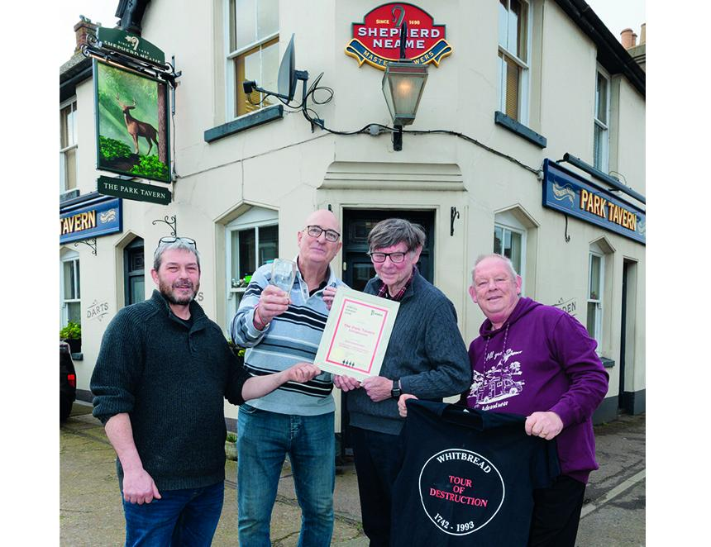

Swale branch members returned to the place where it all began – the Park Tavern in Sittingbourne, Kent – to mark its 50th anniversary. The group first met at the Park Road pub on 17 February 1976 and current members gathered to commemorate the milestone. Around 30 attended, including Paul Durkin, who was present at the founding meeting 50 years ago. The group enjoyed pints of cask Master Brew and Spitfire laid on by the pub’s owner Shepherd Neame. They also enjoyed period memorabilia including local press cuttings from the 1970s, Shepherd Neame artefacts and minutes from early meetings held in another pub, the Fountain (now named the Fountain of Ale), leading up to the group’s formation, which came five years after CAMRA was founded nationally. Members presented the Park Tavern’s current licensee Giovanni Demichele with a certificate. Swale's 50th anniversary co-ordinator John Kent said: “It was brilliant, we were very pleased with the turnout. We do actually have more members today than we did in 1976. “We wanted to revive cask ale and get people drinking beer in pubs – and we still have the same aim today.” The branch now meets monthly, choosing a different pub each time and organises various outings through the year. Pictured, from left, Giovanni Demichele, Swale branch chairman Steve Bury, Paul Durkin and John Sissons

