CAMRA renews stance on independence
20/03/2026 by Ash Corbett-Collins
Campaign

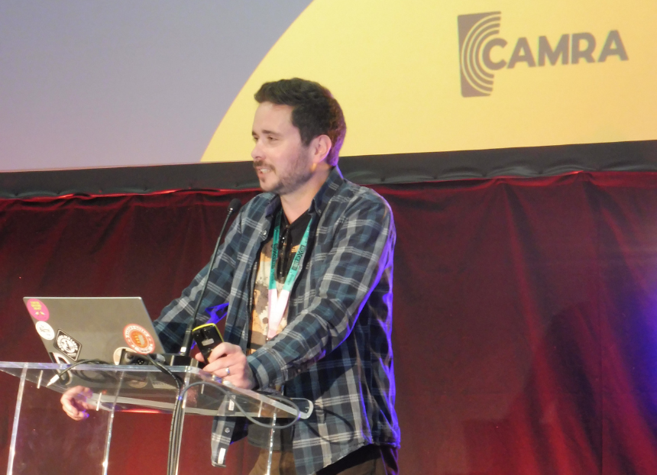

CAMRA chairman Ash Corbett-Collins talked at SIBA's BeerX about CAMRA’s continued commitment to campaign in support of independent brewers over global giants, and what the Campaign is doing to double-down on that promise. Hello everyone. Before I get started, I wanted to say a word about Des De Moor. Des was a part of our CAMRA family. He was kind, generous with his time and knowledge and always up for coming to CAMRA festivals and events, and not to mention the author of some our most awarded books. We’ll all miss him greatly. I unfortunately only had the briefest of interactions with Des, but the moving tribute in the Guardian from his partner Ian made me realise what a shame it was I never got to know him better. I’m very happy to be back here speaking to you, and I’m conscious that I’m the supporting act to the Indie Beer Awards. In that spirit, I’m going to keep this pretty brief, then hand back over to Andy [Slee] for any questions that you have for me. I’m not sure many of you follow CAMRA Conference closely. Between challenges such as energy costs, business rates and new regulations like EPR, I can’t imagine it’s your ideal way to spend your spare time. And I know I didn’t get into campaigning to deal with bureaucracy. But, for those who don’t know, last year our membership debated and passed a motion affirming our support for independent brewers. We also made clear our disapproval of the global brewers and property firms that control the vast majority of the UK beer market. It marked a clear indication that our members value the quality and craftsmanship that comes with independent beer over the “product” mass produced by international corporations. I hope this seems like an obvious statement: of course CAMRA supports independent brewers. It’s been in our DNA from the very beginning. Our founders fought against mass-produced bland beer in the 70s. We fought for Small Brewers’ Relief, and now, we are giving our vocal support to the Indie Beer Campaign. And it’s more important right now than ever before. I highlighted it when I spoke here last year. We need to tackle the hostile interests that control the UK beer market to the detriment of independent brewers, stressed publicans, and frustrated consumers. We need to make sure we protect the amazing pubs that serve quality beer. We need to break apart the status quo and safeguard access to bars for independent brewers across the UK. And we need to give consumers the knowledge to make empowered choices and decide to opt for local over global. Despite it always being a part of who we are, last year was also a really important time for us, CAMRA, to make our stance clear. I’m sure you’re all aware that we’ve had to make some tough decisions recently. When we faced hard financial times, we had to take action. Having clarity of purpose helped us make those decisions. We have weathered that storm, and now we are able to focus on who we want to be, what we want to achieve, and how we want to go about contributing to a better future for drinkers, publicans and brewers. Over the next few months, we’re going to be introducing a new strategy for the coming years, and with that comes fresh ideas and focus. We’re focusing on local and independent. We’re putting into action those things I spoke about last year and driving our campaigning and wider presence towards achieving them. Those actions must be tangible, and they must come from CAMRA grassroots campaigning to our conversations with government across the UK. A year on, we’re still no clearer on the outcomes of the access to market review, or the Pubs Code review for England and Wales. Both have the potential to open up the market, whether through guest beer rights or a fundamental investigation of how the beer market is, or more often isn’t, working for independent brewers and ordinary drinkers. We are demanding those outcomes alongside you, pushing the government to move forward and end the uncertainty of the current situation. We’re also looking ahead to May, and preparing for potential changes to the status quo in Scotland and Wales. Ahead of the Senedd elections, we’re asking that political parties and the next Welsh government don’t try and go it alone on a Wales-only deposit return scheme that includes glass, as this will lead to catastrophic reduction in consumer choice when independent brewers are forced to stop selling into the Welsh market. We need to the next Scottish government to finally ditch raconian plans for a ban on all alcohol sponsorship and advertising and to strengthen the Scottish Pubs Code so tenants can make use of their guest beer right without fear of repercussions from their pub-owning businesses. But, what does CAMRA’s support mean on a grassroots level, for SIBA members and independent brewers? It means we’re going to celebrate and promote independent beer first and foremost. We’re proud supporters of the Indie Beer campaign. We’ve integrated the pub supporter data into our website, and we’re working with our festival organisers to showcase the campaign at our events nationwide. One example is Leicester Beer Festival, which had independent beer as its focus, with dozens from brewers across the UK. We’re also continually improving our website to tell more people about what you do and to give you more ways to improve the accuracy of our data. It’s important that your data is up to date. It means that our members know where your beer is being served, allows them to score it as part of our competitions and ultimately means you can be voted for in our Champion Beer of Britain competition. Since our website relaunch in 2024, we’ve been adding to the information we show consumers, and that includes about your brewery and beers. Most recently, we’ve introduced a way for you to tell us when something changes, or if we need to make an update. If you look behind me, you’ll see you can submit updates on your brewery page. We can also help you find where your beers are being served right now. If you look behind me again, we’ve added places a beer has been spotted or scored to your beer profiles too. And we’re introducing new features all the time. If you’ve got ideas for improvements, we want to hear them. Grab me for a chat after this, or drop us a line through the website. As always, CAMRA and SIBA are working together, at board level and between staff teams. We’re speaking more than ever, especially on policy alignment and campaigning strategies, to get the best for brewers and consumers. And we want to make sure that our actions back up our words. For CAMRA, this means a few things. Firstly, we’re making sure we’ve got the input and advice from experts. I’ve already talked about board and staff collaboration, but it’s running deeper than that. Whether it’s Buster Grant from Jennings and Andy Parker from Elusive on our Technical Advisory Group, or brewers and publicans on our other national committees and taking part in our local branch campaigning. From Champion Beer of Britain, to local magazines and festivals, we’re showcasing what you do at every level of our Campaign. And we really want to show CAMRA members and the wider world what you’re doing. There’s a reason that nearly every single overall winner of Champion Beer of Britain has been independently owned. It’s because of the quality, the innovation involved, and the consumer demand for independently brewed beers. And to showcase that, we’re developing tools to help people discover cask beer, and find what they like. Last year, we launched CAMRA TasteMatch. It uses an algorithm to help people discover their flavour profile and then shows them the cask beers they might like. As people try more beers and rate them, it then fine tunes the profile and makes more suggestions. Of course, we also need to make sure we’re looking at the bigger picture. And really, the more I look around at the actions of global brewers, the more I know it was right for CAMRA to reiterate our support for local over global. We’ve been saying for years now that the beer market, and particularly the supply of beer in the on trade, needs constant monitoring by competition authorities. There’s more consolidation and new line agreements, and technologies. There’s brands being bought up, marketed as independent and brewed miles away from where they were founded. And with it comes job losses and the dismantling of our brewing heritage. Take Cornwall, home to Penzance Brewing Company, current winner of our Champion Beer of Britain, as well as Verdant and dozens of other independents. But it’s now no longer home to Sharps, where Molson Coors closed the brewery and is moving cask production of Doom Bar to an unspecified location. That’s another iconic regional brewery shut at the hands of a global giant that just doesn’t care about the heritage they’ve destroyed. That’s why CAMRA’s message is clear – if they’re closing the brewery, they’re severing ties with the South West and shouldn’t try and claim otherwise. Those beers shouldn’t be marketed as Cornish, and it’s insulting to both drinkers and independent brewers that are still there, to claim otherwise. This is the common ground that we share, where our aims align, and where CAMRA’s consumer perspective complements SIBA’s membership and your work. We’re on solid foundations already, and I only see them getting stronger. It’s from grassroots to board level, from the operational to the strategic, and it’s because we’ve got the same vision for beer and pubs in the UK. I recently read Christopher Hutt’s Death of the English Pub. It was written in 1972, which should hopefully come as no surprise that it was well before my time. At first, I was disheartened about talk of pubs being closed, cask lines being ripped out, local and regional brewers being bought and folded into the corporate machine by growing national brewers. It all felt very familiar. But then I realised that, actually, a lot of what threatened to pass had been averted. There are more independent brewers today than there were in the 1970s. Hardworking and knowledgeable publicans weren’t entirely replaced by corporate managers. Cask beer did not go extinct. It showed what can be achieved when we recognise a problem and fight against it. I first got involved in CAMRA simply because I’d found a beer style I liked and wanted to drink more of it. That involvement opened my eyes to the world of good beer, in both cask and keg. And through the friendships I’ve made and the people I’ve spoken to I’ve learnt about the trade, about the challenges publicans and brewers face, about ties and global brewers and line agreements. None of us are born experts at this, and this is where we – CAMRA – can really help. Educating drinkers about choice, and why they see what they do on the bar, about why it’s usually not the full story, and why it’s not usually a genuine choice. And it’s why we needed to say it again, and we’ll keep saying it. CAMRA supports independent brewers. Not just that, CAMRA support independent brewers over global brewers. CAMRA supports independent brewers because you are the true guardians of quality, of innovation and of our brewing heritage. CAMRA supports you. Thank you. Photo by John O'Donnell

