Fresh wind in brewery’s sails
20/03/2026 by WB Reporter
Industry

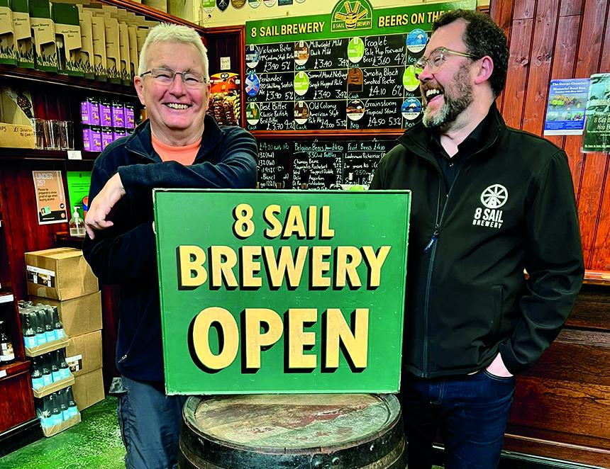

In the spirit of Victor Kiam and his purchase of Remington, the 8 Sail brewery in Heckington, Lincolnshire has been bought by a taproom regular who liked the beer so much, he bought the company. Edward Quigley completed the purchase of the microbrewery, located within the Heckington Windmill heritage site, from founder Tony Pygott, earlier this month. “The brewery has gone from strength to strength over the years and has earned a reputation for good quality beers,” said Pygott. “There is still a strong demand for well-crafted British real ales, which the team at 8 Sail brewery does extremely well. It's satisfying to know that the future has been secured so that the brewery can continue to supply the discerning drinkers of Lincolnshire.” Making the taproom a regular haunt since his move to the village earned it a place in Quigley’s heart: “Like many of the other regulars, my heart sank when I learnt that Tony was looking to sell the business. The thought of losing the taproom, or that someone who doesn’t know the business might come in and undo what Tony and the team created, filled me and many others with dread. I reached out to Tony in February 2025 to chat about the business, and fast-forward just over a year, it’s now up to me to ensure the brewery continues to thrive”. “I’m under no illusion – it’s a tough time for breweries and pubs across the UK. However, 8 Sail has a dedicated, knowledgeable and passionate team and we’ve shown that we can weather many storms since we launched in 2010. I’m confident we can build on what Tony has done and I can’t wait to be a part of the next chapter for 8 Sail.” The brewery employs several staff from its taproom and production premises in Heckington including head brewer Paddy Bauwens. Pictured, from left, Tony Pygott and Edward Quigley

