Pheasant flies again
19/03/2026 by Ian Hodge
Pub

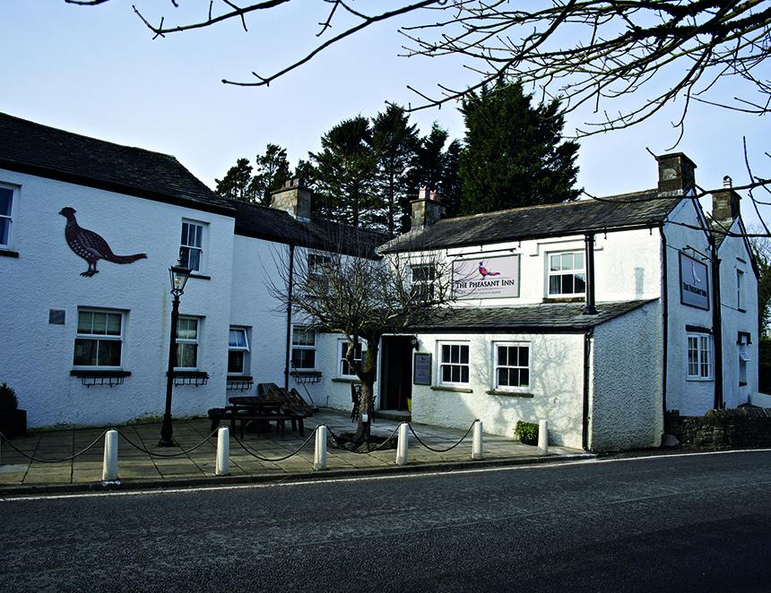

Despite many stories in the press about pub closures, a Cumbrian village has bucked the trend. Residents of Casterton in southern Cumbria were shocked to discover in December 2023 that the owner of their only pub – the Pheasant Inn – had applied for permission to convert it into housing. A group of locals, passionate about its survival, campaigned against the change of use and around 60 objections to the plans were lodged. The group registered the pub as an Asset of Community Value and formed a community benefit society to raise the money to buy it and run it as a community-owned pub. Shortly before an application for funding from the Community Ownership Fund (COF) was ready to be submitted the 2024 general election was called, leading to the suspension of the finance. Raising the money looked impossible and yet again the future of the Pheasant was in the balance. The pub’s situation remained in limbo for a further year with the planning application withdrawn and then resubmitted several months later, followed by a further 60-plus objections. The application got stuck in the system for months, but the pub was still trading, although its hours had become increasingly erratic. The planning process provided time for a sale to be agreed to a local couple and their business partners, who already own the Strawbury Duck in Entwistle, Lancashire. The new owners have just completed an extensive refurbishment and redecoration with new signage, extended bar area, remodelled restaurant, new flooring, seating and wood burners. They have recruited additional staff and are opening the pub and serving food seven days a week for the first time in more than a decade – and the pub is now thriving. There are currently four handpumps with regular and guest cask beers from local breweries: Settle, Black Sheep, Tirril, Kirkby Lonsdale and others.

