More cash for rural pubs
18/03/2026 by Timothy Hampson
Industry

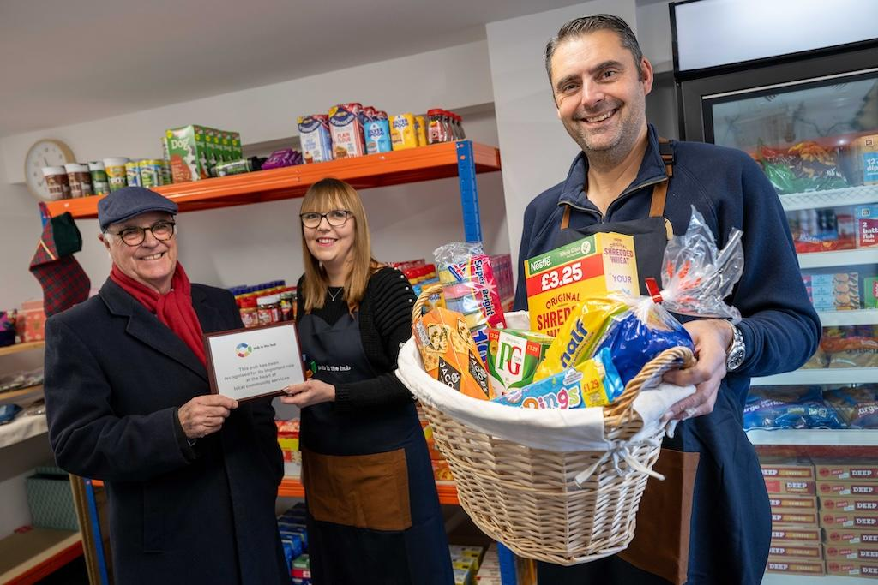

Pub is The Hub can now offer up to £6,000 to publicans in rural, remote or deprived areas who want to offer additional services in their pubs to help local communities. Pub is The Hub will be helping and advising more pubs to diversify their services and activities after getting access to government funding. The Department for Business and Trade has committed £440,000 to help Pub is The Hub deliver more than 40 projects in pubs across the country. Pub is The Hub chief executive John Longden said: “In isolated rural and deprived areas, adding a service can be a great way to support people living locally.” Publican Rhiannon Metters of the Halfway, Tal-Y-Coed, Wales has opened a village store and a marquee events space with help from Pub is The Hub. “We are in an isolated rural community with the pub being the hub of the area. It is so important that we support local people ensuring they do not feel isolated and alone. With the nearest supermarket being 20 minutes away the village store here is such a support to people,” she said. “The marquee has become a space where we run courses such as CPR and craft workshops to help bring people together. We have noticed there are a lot of new people, including women on their own, coming in to the pub, either using the village store or joining for classes.” People in the village of Alpington and its surrounding area can pop to the pub for their essential food items after the Wheel of Fortune opened its store. Naomi Shulver and Barry Gelder took over the pub in March 2022 after purchasing the freehold. They have worked hard to ensure the pub offers something for everyone, improving facilities such as the beer garden, children’s play area and opening two log cabins for overnight visitors. The pub has already become the hub of the community running events such as chatty cafe to help people overcome loneliness. It also recently won the South Norfolk Pub of the Year for its commitment to developing it as an all-round village asset. The Alpington shop is being run by trained volunteers and any profits are being ploughed back into community projects. Gelder said: “This is an important community service we are offering to people who live locally. We have a high number of elderly residents in the area and want to make sure there is somewhere for them to come for their food as well as having a safe space to meet. “We are planning to work in collaboration with other nearby businesses to make sure we stock more local produce. This is a pub for all people, and we want everyone to have a warm welcome.” Pub is The Hub’s Terry Stork said: “This is a pub that is really at the heart of its community. This important village store will support people living in the area and will also help them to overcome social isolation.” As well as helping the publicans to engage further with their local community, projects can also add social value to an area. For every £1 spent on a new project through the Pub is The Hub, £8.28 of social value is created. For more information see: pubisthehub.org.uk/news/are-you-a-pub-business-that-wants-to-diversify/ Pictured: Terry Stork with publicans Naomi Shulver and Barry Gelder

