Brewer revives classic Cumbrian pub
17/03/2026 by Timothy Hampson
Industry

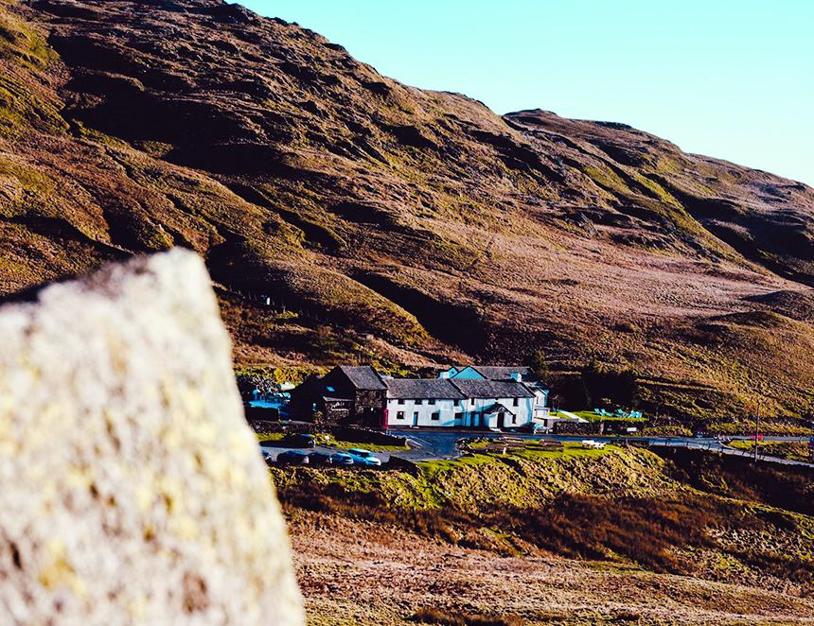

Kirkby Lonsdale brewery is to reopen the historic Kirkstone Pass Inn – the highest pub in Cumbria and the second highest in England – marking a significant expansion for the brewer. The 15th-century inn (above), established in 1496 and almost 1,500 feet above sea level, has been closed for nearly five years. The bar is set to reopen in late March following refurbishment. The acquisition gives the brewery control of one of the Lake District’s most recognisable hospitality sites – a destination venue that attracts walkers, cyclists and motorists travelling through the Lakes. Kirkby Lonsdale brewery, established in 2009, has grown into one of Cumbria’s best-known independent producers with beers including Ruskin’s, Tiffin Gold, Monumental and Jubilee Stout now poured in pubs and venues across the North West. Brewery owner Stu Taylor said the move aligns with the company’s long-term strategy of strengthening brand presence through destination-led venues. “We’ve been looking for the right pub for some time. It needed to be somewhere iconic, somewhere that aligns with our brand and our values. The Kirkstone Pass Inn is exactly that – it’s a destination site with incredible heritage and natural footfall.” The site’s scale, including a large beer garden and established accommodation offering under separate management, provides strong seasonal trading opportunities and appeal to tourism-driven customers as well as regulars from the area. “It’s a unique trading environment,” added Taylor. “You have built-in tourism, incredible visibility and a setting that’s genuinely world-class. The moment this opportunity came up, we knew it was the one. We’re incredibly proud to be bringing it back to life.” Refurbishment work is focused on aesthetic improvements ahead of reopening, with the brewery aiming to establish the Kirkstone Pass Inn as a key venue within its portfolio, joining the Royal Barn in market town Kirkby Lonsdale.

