CAMRA is 55 years stronger
16/03/2026 by Ash Corbett-Collins
Campaign

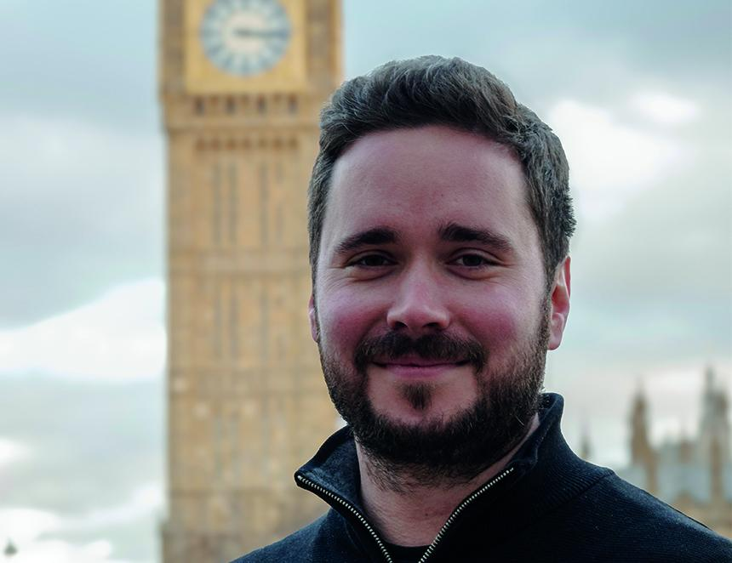

I look at the current state of the pub and beer sector and see our campaigning is needed now more than ever. I love going to the pub. It’s where I discovered great cask and independent beers and, from speaking to other members and volunteers over my 14-year membership, I know I’m not alone in feeling frustrated at not seeing more local beers on the bar. That’s because independent brewers need better access to the pub market. We talk about this a lot. Consumers deserve genuine choice and want to support their local brewers, but instead global giants have a stranglehold over our pubs, blocking independent brewers and cider makers from getting their produce on the bar. It’s critical work, being a voice for pubs, pints and people. And it’s CAMRA’s honour to help educate consumers on quality cask beer to make sure it gets the recognition it deserves so it can be served on bars and enjoyed by pubgoers for generations to come. Helping publicans get a fairer deal on tax and bills is essential. The government’s Budget bombshell was disastrous for pubs in England. While the U-turn will now see a 15 per cent discount on rates, it’s not the permanently lower business rates system we were promised. The devolved parliaments have since introduced similar reliefs for pubs. We’ll continue to campaign for a fairer system for all pubs in all nations so they can compete against online businesses and to slow the rate of closures, so they remain essential social hubs in all communities. Pubs in England are under a new threat – one we thought we’d patched up back in 2017. The government’s proposals to change the National Planning Policy Framework (policy HC6) would weaken protections for pubs, meaning only the last pub in the area would be protected from unwanted conversion into a house, shop or takeaway. This jeopardises all of CAMRA’s work to secure these protections and will impact campaigning groups’ abilities to save their pubs. We need the planning minister to think again and retain the current protections for all pubs, to stop more being lost forever. No pub should be lost to conversion or demolition. We’re not going to let pubs be destroyed by greedy developers without a fight. You can help us by asking your MP to urge the government to think again. Email your MP here. And it’s been a challenging year for both our campaigning and for us as an organisation. The National Executive faced our financial situation head on, acting quickly and decisively, which was incredibly tough but necessary. We made those decisions so we not only reached 55, but so that we can keep going for future generations of campaigners. We’re now looking forward. We’re renewing our focus, our campaigning, and trying new things. This year we launched free entry to CAMRA-run festivals for our members, where independent cask beers and real ciders and perries are guaranteed. Don’t worry if you’re not a CAMRA member, you can join here. So, if you find yourself at your local today or a festival this week, I hope you’ll join me in raising a pint to our incredibly hardworking volunteers and members who’ve helped shape CAMRA, and beer and pubs, over the last 55 years.

