Brewer takes over popular beer bar
13/03/2026 by Timothy Hampson
Industry

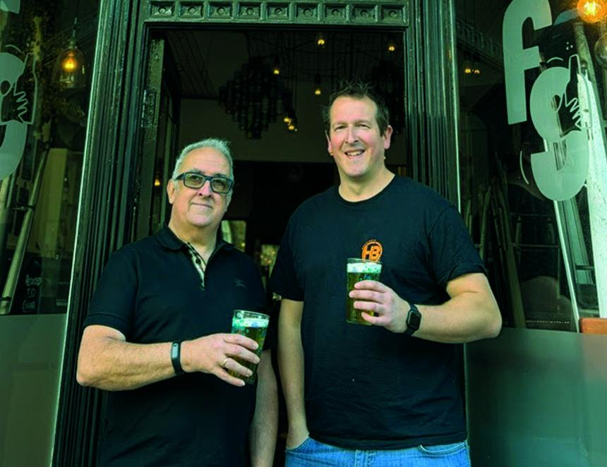

Horsforth brewery has taken ownership of the Fuggle and Golding beer bar in the heart of Ilkley, Yorkshire. The acquisition secures the future of one of Ilkley’s most established independent beer venues and marks Horsforth’s first permanent site in the town. The venue will continue to operate as a specialist craft beer bar. Horsforth founder Mark Costello said: “I want to thank George [Evans] for everything he’s built over the last three years and for making the completion process so smooth and quick. We’re proud to be building on the foundations he’s created. “We’re also excited to finally have a proper home for our beer in Ilkley. The town has a fantastic reputation for quality and community and we can’t wait to become part of that. “Hospitality is really struggling at the moment, but our commitment to sustainable growth rather than growth at all costs means we’ve been able to organically grow our business to the next level and are confident this will be a success.” Fuggle and Golding has built a loyal following and is known for its rotating craft beer lines and welcoming atmosphere. Under Horsforth’s ownership customers can expect continuity alongside new events and a broader selection of Horsforth beers. Pictured, from left, George Evans and Mark Costello

