MP steps in to Cock fight
12/03/2026 by Timothy Hampson
Pub

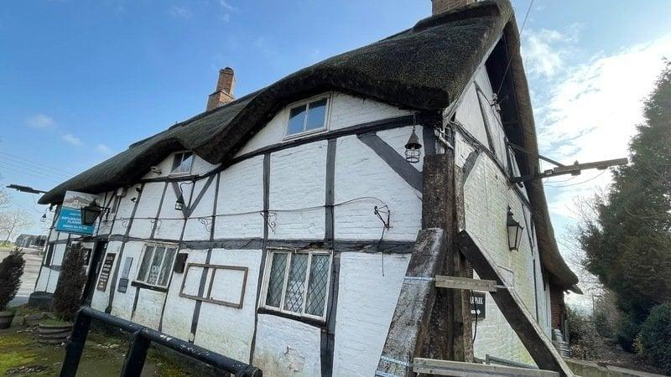

Growing concern is being voiced by residents over the continued closure and deterioration of the Cock Inn in Sibson, Leicestershire, one of the oldest pubs in England. The Cock Inn dates backs to 1250 and is widely regarded as among the oldest surviving inns in the country. The Grade II-listed building predates the Battle of Bosworth Field and is steeped in national folklore. Local tradition holds that the notorious highwayman, Dick Turpin, used the inn as a refuge. Despite its historic significance, the pub has remained vacant since November 2019, and residents say the building has visibly deteriorated during that time. The Cock Inn is owned by Star Pubs and Bars, the pub business of Heineken UK which pledged at a public meeting attended by more than 100 local residents that it intends to invest in restoration works and a major refurbishment of the site. However, local campaigners say a number of assurances about progress have not been fulfilled. Nearby residents have now organised a petition calling for urgent restoration of the pub, which has already attracted more than 2000 signatures. The building was registered as an Asset of Community Value (ACV), recognising its importance to the community. Campaigners say, while plans and commitments have been discussed in previous years, essential and urgent repairs required under planning permissions have not been carried out within the necessary timeframe. Hinckley and Bosworth MP Dr Luke Evans said: “The Cock Inn is a great community asset with so much history, I can see why the community has been fighting so hard for it. "I commend the parish council, Joshua Melen and all those in the community who are working to get this historic pub back to its former glory. The petition shows the strength of feeling from residents, and I hope it will help to focus minds. “I have not only met with everyone involved but visited the Cock Inn to try to help steer progress, and while I understand there have been encouraging words, I hope we can see definitive action that everyone is happy with. “Now is the time to make a real impact and get the resolution this historic pub deserves.” In February 2023, Save our Pub! was founded by members of the Sibson community with the aim of reopening the Cock Inn. County councillor Joshua Melen chairs this group, alongside representing residents in the Market Bosworth area. Melen said: “The Cock Inn is not just another village pub. It is a building of national historic importance and a treasured part of our local community. For centuries it has been a gathering place for residents and visitors alike. “Unfortunately, residents have heard many promises over the past six years about restoration and reopening, but those promises have yet to translate into visible progress. Meanwhile the building continues to deteriorate. “As the owner Star Pubs and Bars has a responsibility to safeguard this historic building. It is vital that urgent restoration works are now undertaken before further damage occurs. “Hinckley and Bosworth Borough Council is the local planning authority and has an important role in ensuring that necessary repairs are carried out to protect this Grade II-listed building. Residents rightly expect the council to use the powers available to it to compel action where required.” Local campaigners say they want to work constructively with both the council and Star Pubs and Bars to secure the pub’s future, but stress that time is running out for the historic building. For villagers in Sibson, the Cock Inn represents far more than a commercial property. It is a living piece of local and national heritage that witnessed events surrounding the Battle of Bosworth and the start of the Tudor era and which has served the community for nearly eight centuries. Residents say the priority now is simple: to ensure the building is properly restored and reopened so that it can once again serve as the social heart of the village. You can sign the petition here.

