Scottish craft brewer sold
11/03/2026 by Timothy Hampson
Industry

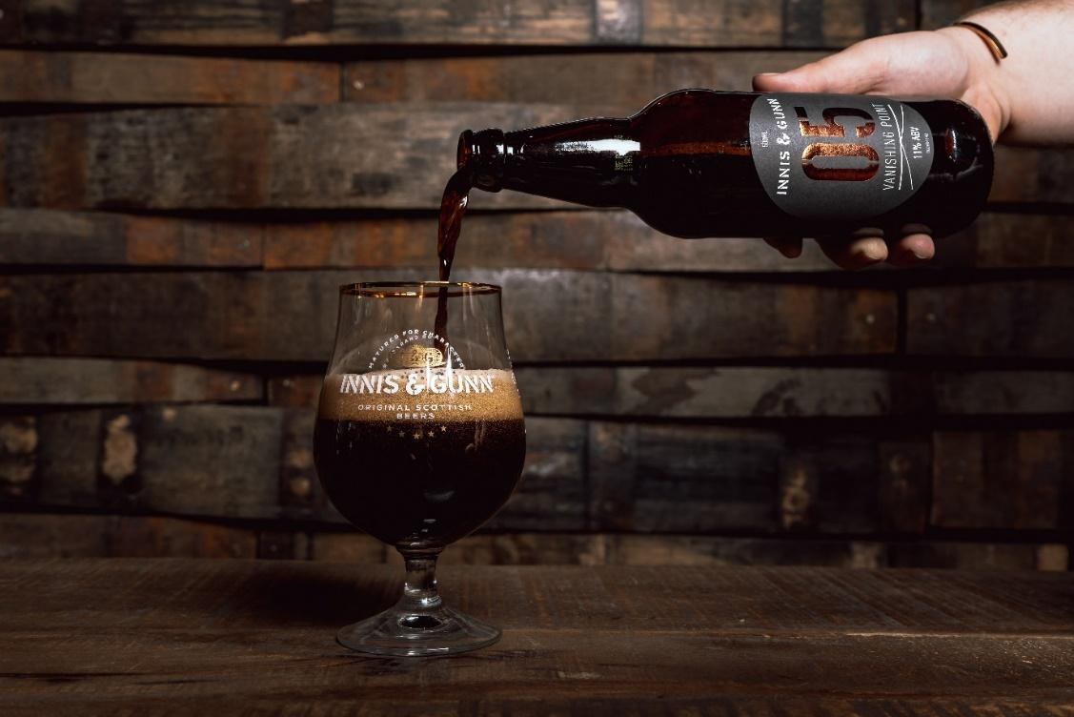

One of Scotland’s best known craft brewers has been taken over by the drinks giant behind brands including Tennent’s and Magners in a multimillion-pound deal. The loss-making Innis and Gunn, the Edinburgh-based firm behind a wide range of beers, has been acquired by the Dublin-based C&C Group in a surprise agreement worth £4.5m. According to the accounts for Innis and Gunn’s parent company, the single biggest shareholder was Dougal Sharp, who founded the firm in 2003 and held more than 35m ordinary A shares. It marks the second sale of a prominent Scottish brewer in the 10 days following the collapse and rescue deal involving BrewDog. With the latter firm being taken over by Tilray, a US-based beverage and cannabis company, it means neither brand is under Scottish ownership. The joint administrators who sold Innis and Gunn’s assets said it was with “deep regret” that redundancies will have to be made following the sale, with the firm’s brewery and three taprooms closed. They added the firm was no longer able to trade due to a range of factors, including rising costs and a decline in consumer spending. Like BrewDog, Innis and Gunn raised millions of pounds via multiple equity crowdfunding campaigns. It is unlikely investors will see a return in the wake of the sales.

