New looks for cask favourite
10/03/2026 by Timothy Hampson
Industry

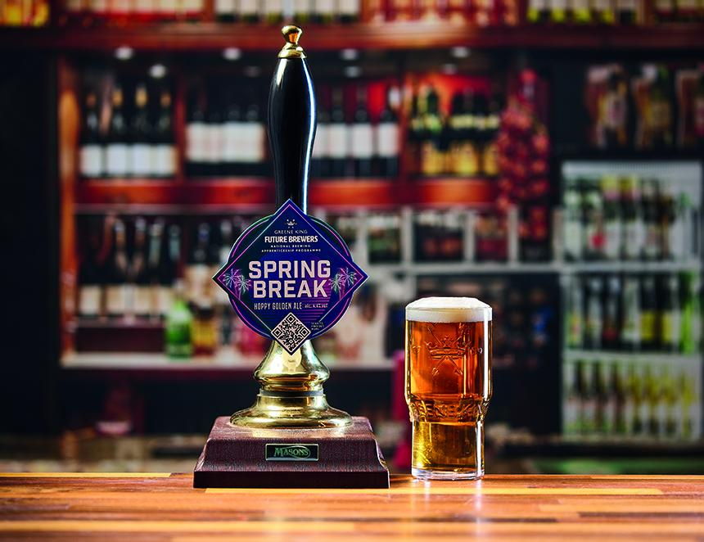

Greene King has unveiled the next instalment of its Fresh Cask Releases bringing back one of the most popular beers in the calendar backed by multiple pump clip designs. From March through to the end of April, Spring Break with its three pump clips will make its annual return. The 4.4 per cent ABV golden ale is described as hoppy and light with hints of peach, lychee and tropical notes. The two other releases are George and the Flagon (4.4 per cent) and Four Leaf (4.4 per cent). Greene King brand manager Amina Ali said: “Spring Break is always a favourite with our drinkers, and we appreciate they will be keen to enjoy the beer again. However, we have also considered that some pubs want to be able to showcase pump clips tailored to special occasions such as St George’s Day and St Patrick's Day. “By offering multiple pump clip designs, we’re helping our customers appeal to different audiences, while delivering the same golden cask ale that guests return for year after year.”

