Three B’s doubles up
09/03/2026 by Mark Bates
Campaign

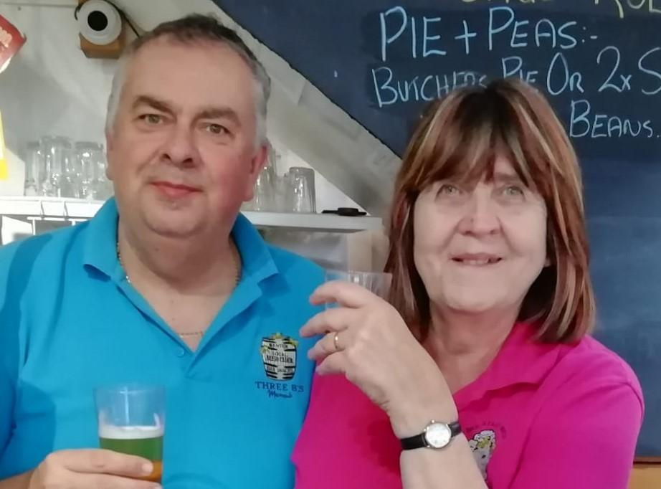

CAMRA’s Yorkshire Wolds branch has crowned Three B’s micropub in Bridlington not only its Pub of the Year but its cider favourite too. The pub beat competition from the other 69 cask beer pubs in the branch area to win the titles. The pub has previously won many CAMRA awards including being judged one of the top four in the UK in 2024. Second place for Pub of the Year went to the Old Ship and the Moon Tap was third, both in Bridlington. The Butchers Dog in Driffield was judged runner up in the Cider Pub of the Year competition. Branch chair Jonquil Beynon said: “These are important awards for CAMRA branches with the winners going forward to be judged in the Yorkshire and national heats. Congratulations to Three B’s and thanks to all our members who took part in the voting.” Mark and Cheryl Bates (pictured), owners of Three B’s said: “It is such a great honour to be judged by the local members of CAMRA as the Yorkshire Wolds Pub and Cider Pub of the Year. “It makes all the work into running the pub worthwhile and we thank the CAMRA members who have voted for our small friendly pub.”

