Old favourites return for birthday celebrations
08/03/2026 by Timothy Hampson
Industry

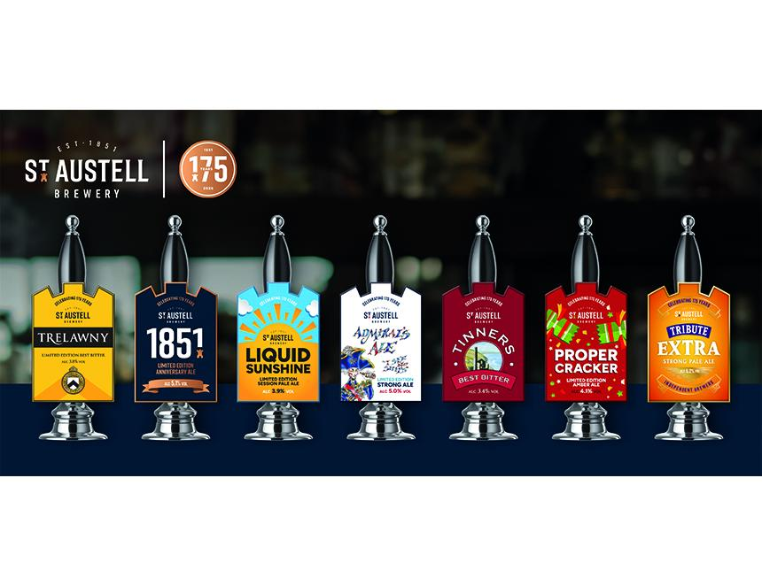

St Austell is raising a glass to its 175th anniversary with the launch of a limited-edition cask beer range for 2026, including several much-loved favourites, revived from the brewery’s archives. Classics such as Admiral's Ale (5 per cent ABV), first brewed in 2005 to mark the bicentenary of Nelson's triumph at Trafalgar will return, alongside best bitter Trelawny (3.8 per cent), named after Bishop Trelawny from Cornish folklore. The burnished-copper ale is still fondly remembered by beer fans. The final release in the eight-strong cask line-up is Tribute Extra (5.3 per cent), the big sibling of the brewery’s best-selling beer. Brewed with Cornish barley and Celeia and Willamette hops, the rich pale ale is bold, complex, and full of character. The collection forms part of St Austell’s wider programme of 175-year celebrations, which includes events, collaborations and a renewed focus on the business’s heritage pubs and regional roots. St Austell brewing director Georgina Young said: “Reaching 175 years is an extraordinary milestone, so it felt only right to celebrate by bringing some of our most cherished beers back to life. Our brewing archives are full of wonderful recipes – beers that meant something to the people who brewed them and to the communities that enjoyed them. “Revisiting classics, such as Trelawny and Tinners is a reminder of just how deeply our heritage runs, while giving us the chance to brew the beers with the quality and consistency made possible by modern techniques. As a team, we’re incredibly proud to honour our past while continuing to innovate for the beer drinkers of today.” The commemorative cask beer range will be available in St Austell pubs and available to order for its wholesale customers.

