Magpie steals top prize
05/03/2026 by Timothy Hampson
Campaign

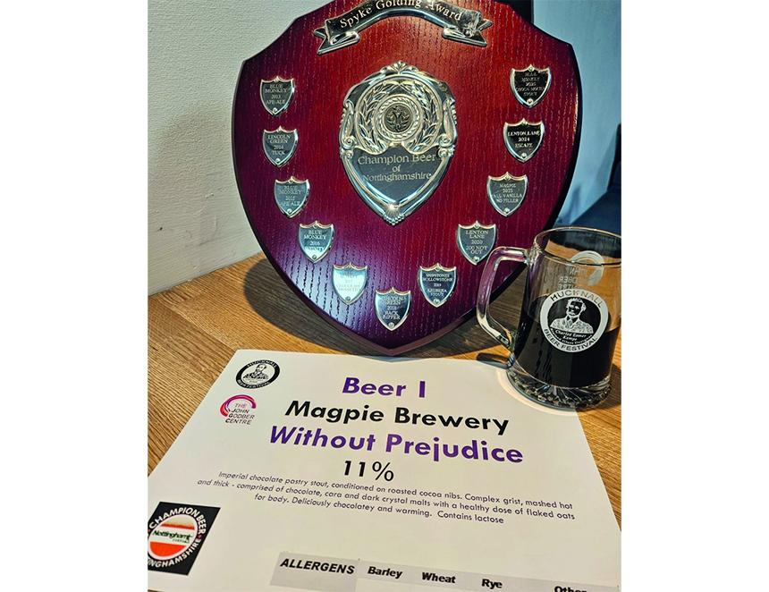

Magpie brewery scooped the Spyke Golding Challenge crown at the annual Hucknall Beer and Cider Festival supported by Nottingham CAMRA earlier this month. The festival was held at the John Godber Centre and hosted the challenge which saw 10 Nottinghamshire breweries submitting new and original beers which would be judged by visitors. Only the tasting notes and the ABV were provided with the brewery names being revealed on Saturday after the judging had been completed. Judges were asked to score how close the beer matched the tasting notes and would they buy the beer in a pub. After judging over two days the winner was Magpie’s Without Prejudice at 11 per cent ABV. The beer is an imperial chocolate pastry stout, conditioned on roasted cocoa nibs. With a complex grist, mashed hot and thick, the beer comprised of chocolate, cara and dark crystal malts along with flaked oats for body. The brewery said it is chocolatey and warming. Brewery manager Craig Sallabank said: “We’re absolutely thrilled to have won this year’s Hucknall competition, competing against some superb breweries from across the region. “To become custodians of the shield for the year ahead is a huge honour for our team. As ever, this beer was crafted with Magpie's patience, precision and integrity, which we're delighted to have had recognised so enthusiastically by the festival's passionate attendees. “Nottingham has a proud brewing tradition, and we're already looking forward to next time.”

