Community-owned businesses prove their worth
04/03/2026 by Timothy Hampson
Pub

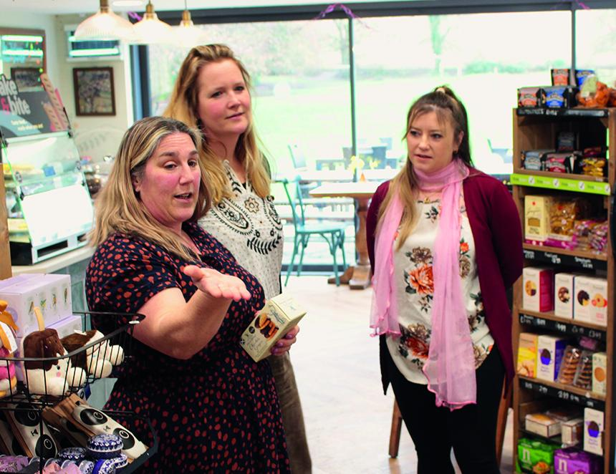

The social benefits of rural community-owned businesses shone through during a visit by Plunkett UK and Southern Co-op to Hampshire. At a challenging time for the retail and hospitality sectors the Boundary Shop and Cafe in St Mary Bourne and the Plough Inn, Longparish are proving how to make a success through community-owned businesses. Plunkett UK partnerships manager Hannah Barrett and Southern Co-op community lead Becky Longyear met committee members and staff plus saw the businesses in action. Barrett and Longyear discovered how both places create welcoming, socially connected hubs that offer jobs and volunteering opportunities while working hard to stay financially sustainable. The Boundary and the Plough Inn are members of national charity Plunkett, which provides specialist business advice for them and more than 850 community businesses across the country. As partners of Plunkett, Southern Co-op supports its work through the Cooperative Retail Societies Network – a collaboration that funds, shares knowledge, and strengthens the rural community business sector. The Plough Inn has been a fixture of the village of Longparish since 1721 and was saved from being sold to a property developer by the community, which celebrated owning the pub in 2021. After renovation and refurbishment, it has now been trading under community ownership for more than four years. Plough committee chair Andy Jolliffe said: “The biggest impact of the pub is that we regularly have a thriving, busy place with a great atmosphere, which is loved by locals and people from far away. “I think the biggest benefit since we’ve reopened is seeing so many locals here on a Friday night, catching up and strengthening that genuine sense of village community.” The Boundary Shop and Cafe has been trading in the picturesque surroundings of St Mary Bourne since 2022. Committee member Dave Burlison said: “As a community we have recently doubled the amount of car parking we’ve got and there’s a brand-new play area and a multi-use field. “People then come and use our shop. So, the whole thing works in unison between the pub, village centre, community shop and cafe, car parking and play area.” Shop manager Vicky Pettit shares duties alongside cafe manager Sandra Grunsell. Pettit said: “The atmosphere here is just amazing! It’s a happy environment. You get to catch up on people, chat and see how they’re doing.” Longyear said: “I think it’s incredible what they’ve managed to do here. The cafe part brings people together; the shop is supporting locals, and then you’ve got the post office, which is a very big thing for people where banks are closing. It’s a really good support for the community to come together and get what they need.” Barrett said: “The shop and cafe have 12 staff positions, but also another 45 to 50 volunteers. That’s bringing a huge amount to those local people and the local economy, providing residents with the opportunities to upskill, but also to socialise and to give back to their community.” Pictured, from left, Vicky Pettit, Hannah Barrett and Becky Longyear

