WB pioneer much missed
02/03/2026 by Roger Protz
Campaign

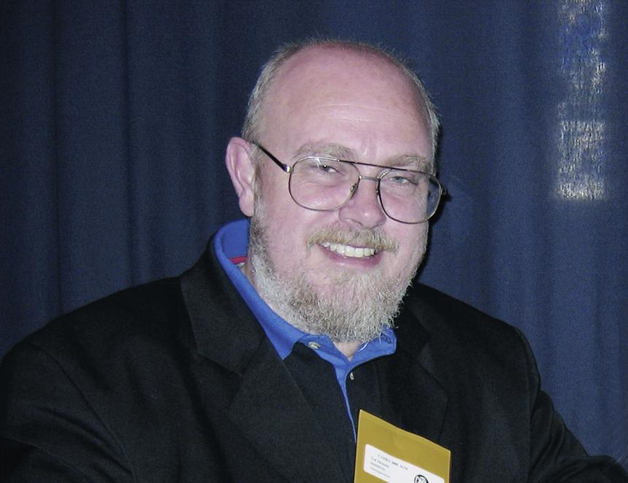

Ted Bruning, who has died aged 68, was a writer and journalist who played a pivotal role in turning What’s Brewing into an influential newspaper and a major source of information for CAMRA members. Ted was born in Wolverhampton. He studied at University College London and also went on a journalism course to learn the skills of the profession. He joined the Worksop Guardian as a reporter and then moved to the Morning Advertiser. The MA at the time was a daily printed newspaper that reported on pubs, beers and breweries. The paper was founded in 1794 by the Society of Licensed Victuallers as a voice for publicans. In the 19th century it could boast that one of its contributors was Charles Dickens and Ted was moving in illustrious circles. He rose through the ranks at the MA to become news editor and built what journalists call a strong contacts book – a list of useful people to speak to on a regular basis about events in the pub trade and brewing industry. As a founding member of the British Guild of Beer Writers in the late 1980s, Ted also developed a bond with fellow journalists writing about beer and pubs. When he left the MA, he came to work for CAMRA in the 1990s at its office in St Albans where he worked for 13 years as assistant editor and then editor of What’s Brewing. He was the model of a good reporter in the age of printed newspapers. He had impeccable Pitman shorthand and an easy and warm telephone manner that extracted information from often reluctant and even hostile brewers. What’s Brewing since its inception in the 1970s had been a 16-page monthly paper. But thanks to a major increase in advertising revenue in the 1990s it was possible for a team of just three – Ted, production editor Kim Adams and this writer – to produce 28, 32 and even 36-page papers. Kim and Ted had also worked together at the MA and had a strong working relationship. Kim says Ted was a gifted writer who always supplied his copy to deadline. Ted enlivened the small What’s Brewing office with his infectious laugh and great sense of humour. When I stood down as editor, Ted took over and continued in the role for eight years. He broadened the scope and appeal of What’s Brewing by adding regular coverage of cider. After his long stint at What’s Brewing, Ted threw himself into book writing on a variety of issues. His main work was the Microbrewers Handbook, a best-seller that ran over several editions. It was a mine of information for people thinking of building small breweries and guided them through the legal and health and safety aspects, as well as how to buy kit and raw ingredients. He went on to write books on homebrewing, cider and whisky. He produced a number of books on the history of pubs in both London and the wider country. They included books on historic inns and coaching houses. His Historic Inns of England won him a silver tankard award from the British Guild of Beer Writers in 2000. He met Liz, who became his wife, when they were both students at UCL. They settled in Bedfordshire and raised twins Robert and Isobel. When they divorced but remained on good terms, Ted moved to Cambridge where he continued his busy writing activity. Ted had been ill for some time. He had two heart attacks and had been in hospital since December. He will be mourned by his close friends and colleagues at What’s Brewing, the wider CAMRA community and all those who respect professional writing and journalism of the highest order. RIP Ted – it was good to have known you.

