CAMRA coming to a cinema near you
02/03/2026 by WB Reporter
Industry

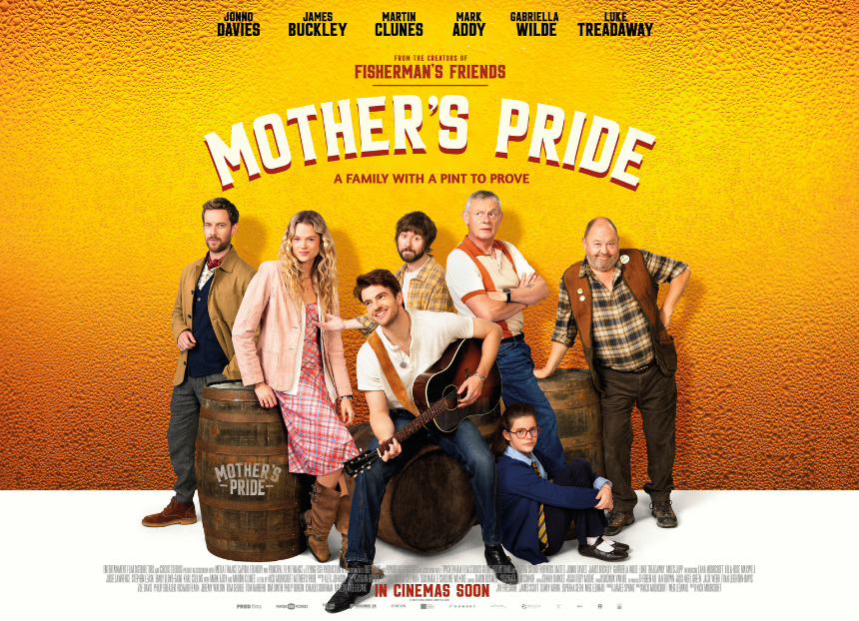

CAMRA features in a new film from the makers of Fisherman’s Friends. The heart-warming Mother’s Pride, set to hit cinema screens across the UK on Friday, is rooted in our pub culture, with a stellar cast including Martin Clunes, Jonno Davies, James Buckley, Josie Lawrence, and Mark Addy. The story sees a family, with just 14 days to save its ailing pub, start a journey into brewing cask beer as a last-ditch attempt to keep the doors open. What starts as a practical way to keep the pub running, the family soon enter the Great British Beer Awards, not only changing the characters’ lives but mending a grieving family and bringing a fractured village together. Featuring CAMRA’s Champion Beer of Britain competition, you may recognise where the filming took place and some of the people featured! Take a look at the trailer and we look forward to Disco Morris featuring at CAMRA festivals across the UK! The film shows what can be achieved by working together to protect pubs and the power of the people campaigning for their survival. It is a reminder that sometimes the smallest ideas can spark the biggest change. Reinvigorating pride in pubs, Mother’s Pride places the pub at the heart of the village reminding locals it is still the life and soul of the community. With UK pubs battling against a backdrop of rising costs, the film’s release couldn’t come at a better time to shine a spotlight on the day-to-day struggles they face. This timely film will appeal to CAMRA members while reminding the public of the power of the pub. Check cinema listings for dates! Watch the trailer here.

