PUBlic Affairs round up – February
28/02/2026 by Harri Knight-Davis
Campaign

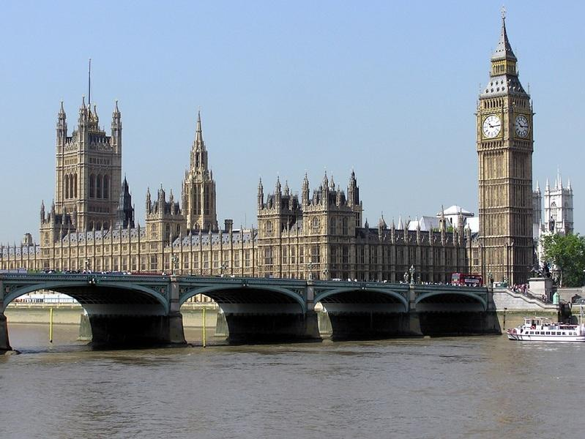

The regular series returns as the Campaigns and Communications team brings the latest updates on campaigning for pubs, pints and people across Westminster, devolved nations and local government. This February, the team has been busy campaigning for business rates changes for pubs and lobbying the government to reverse its planning laws proposal that risks thousands of pubs being lost forever. UK government and parliament Alcohol duty Alcohol duty increased by 3.66 per cent from 1 February 2026. Further details are available on the Treasury website here. In summer 2026 the Treasury will review the new alcohol duty system, which was introduced three years ago, including the draught duty rate charged on qualifying beer and cider served in the on trade. Alcohol labelling Last year the Department of Health published its 10 Year Plan which included proposals for health warnings on alcohol labels, as well as reviewing the threshold for products to be described as low-alcohol and no-alcohol. Campaigns and communications manager Paul Edgeworth attended an industry roundtable with civil servants on 27 January to discuss the proposals as part of the policy development process. No firm decisions have been taken on what health warnings may look like. Further details and a public consultation are expected in the autumn. Business rates [England] Following the Budget in November and engagement with MPs, ministers and civil servants, the UK government announced additional relief and further reform of the business rates system. Further details are below. CAMRA’s response to the announcement is here. The UK government will provide a 15 per cent discount on business rates bills for pubs from April 2026. This is on top of what has already been announced (a lower multiplier for retail, hospitality and leisure businesses and transitional reliefs to limit bill increases as a result of the revaluation). The Treasury stated that this is in recognition of the social and cultural value of pubs; it will mean 75 per cent of pubs will see their bills fall or stay flat in 2026/27; that bills will be “frozen in real terms” in 2027/28 and 2028/29; and that the pub sector as a whole will be paying eight per cent less in business rates in 2029 than it does currently. The full announcement is on the government website here. More details about the 15 per cent relief are here. This includes the suggested definition of a pub for the purposes of awarding the discount, although it will be up to local councils to interpret this and show flexibility where necessary. In the longer term, the government is going to review the Valuation Office Agency’s Fair Maintainable Trade method of calculating business rates bills for pubs. This process will be completed in time for the next revaluation period coming into force in April 2029. Drink drive limits [England] In January the UK government published its Road Safety Strategy for England. This included announcements on lowering the drink-drive limit for England from the current limit (80mg in 100ml of blood; 35µg (microgrammes) in 100ml of breath; 107mg in 100ml of urine). There is no specific alternative proposed although the strategy does reference the levels in Scotland (50mg in 100ml of blood; 22µg in 100ml of breath; 67mg of alcohol in 100ml of urine). The UK government documents conclude that: “Scotland lowered its limit but did not see a significant reduction in casualties. In Scotland, after the change in the limit in 2014 from 80mg to 50mg in 100ml of blood, an academic study showed that there was no impact on the drinks and entertainment industry through reduction of customs. It does, however, appear to have strengthened public attitudes against drink-driving and reinforced the behavioural change message of don’t drink and drive. The study also found that any reduction in the legal limit must be supported by stronger enforcement.” There is a public consultation on these proposals here. It runs until 31 March 2026 and asks respondents to say whether the limit should be reduced; and if so to what level. It also proposes even lower limits for novice drivers and those within a probationary period after passing their test. Licensing and World Cup pub opening hours [England and Wales] At the same time as announcing extra help with business rates for pubs in England, the government also confirmed that licensed venues in England and Wales will be able to open after midnight for home nations’ games in the later stages of this summer’s men’s football World Cup. The government is also bringing forward a consultation to allow them to open late for other big events such as Eurovision and will legislate later this year to increase the number of temporary events pubs and other hospitality venues can hold. Planning (England) National planning policy advisor Paul Ainsworth and Paul Edgeworth met with civil servants to discuss the government’s proposal to amend the National Planning Policy Framework to water down protections for pubs, so they only apply to “the last of its type in the area” instead of applying to all. Further information and case studies has been sent to civil servants. Campaigning resources and an MP e-lobby are available on this subject. CAMRA has had the issue raised in parliament through written parliamentary questions: Q: Ben Maguire (LD, North Cornwall): “to ask the secretary of state for housing, communities and local government, with reference to written statement UIN HCWS1187 on Planning Reform: Next Stage, what assessment his department has made on the impact of proposed changes to policy HC6: Retention of key community facilities and public service infrastructure on (a) pub closure rates and (b) the ability of communities to save a local pub from closure, conversion or demolition.” Q: Ben Maguire (LD, North Cornwall): “to ask the secretary of state for housing, communities and local government, with reference to written statement UIN HCWS1187 on Planning Reform: Next Stage, for what reasons the proposed revised National Planning Policy Framework changes policy HC6: Retention of key community facilities and public service infrastructure so that it applies only to facilities that are the last of its type in the area concerned.” These received the following shared answer: A: Matthew Pennycook (minister of state, MHCLG): “the government is currently consulting on a new National Planning Policy Framework (NPPF), which includes proposed policies to safeguard against the loss of key community facilities, such as public houses. This approach reflects common practice in local plans and is intended to support the government’s wider Pride in Place agenda. “Through the consultation we are seeking views on these proposals, including whether this safeguard should apply only to key community facilities and public service infrastructure which are the last of their type in the area concerned. The proposed approach is designed to avoid unreasonable restrictions being placed on proposals to change the use of existing premises. The consultation on changes to the NPPF is available on gov.uk and will remain open for responses until 10 March 2026.” At the same time as announcing extra support for business rates, the government confirmed its intention to consult on introducing a new permitted development right to allow pubs to turn rooms into accommodation or to extend the main parts of their premises in order to make businesses more viable. A consultation will be held later this spring. Northern Ireland assembly and executive Business rates A revaluation of business rates was due to come into force from April 2026 leading to increases in bills for pubs. CAMRA’s response to that announcement is here. Following pressure, the NI business rates revaluation has now been paused. The team is awaiting next steps from the minister for finance and is pushing for extra reliefs for pubs, and reform in the longer term to make the system fairer. Code of practice for licensed premises and registered clubs [Northern Ireland] A new code of practice came into force in Northern Ireland on 1 January 2026. The code, which has been produced by the Responsible Retailing Code Joint Industry Working Group on behalf of Hospitality Ulster, NI Federation of Clubs, NI Hotels Federation, NI Retail Consortium and Retail NI has been published on its website here. The code will provide guidance to licence holders and registered clubs’ officials on best practice and the basic standards expected in the industry regarding the display, sale, supply or promotion of alcoholic drinks on their respective premises. From 1 January 2026, a court must be satisfied that when applying for a liquor licence or club registration that prospective holders and registered club officials are aware of their responsibilities, and in the case of renewal applications, that they have been complying with the code. Licensing Review Discussions continue with MLAs and political parties to keep pressure on the communities minister to rethink his decision not to implement any of the recommendations of the University of Stirling’s independent review of the alcohol licensing system. Scottish government and parliament Business rates The Scottish government’s Budget on 13 January decided to reduce the 40 per cent discount on rates bills to 15 per cent. At the same time as bills are rising due to the rates revaluation this would have seen big increases in the coming years for pubs. Pubs in island communities will continue to receive 100 per cent relief on their business rates bills. Since the Budget announcement on 13 January, the SNP came to a deal with the Scottish Liberal Democrats in order to pass the Scottish government’s Budget. This included restoring the 40 per cent discount on business rates bills for pubs for the next three years. Further details are on the Scottish government website here. In January Scottish Labour announced a policy of overhauling the business rates system to rebalance it in favour of pubs, shops and other bricks-and-mortar businesses. CAMRA’s response to that announcement is here. The Scottish Conservatives are proposing exempting pubs from business rates in 2026/27. Welsh government and parliament/senedd Business rates The Welsh government’s Budget in January confirmed that the 40 per cent business rates relief for pubs in Wales will end in April 2026, at the same time as the business rates revaluation comes into force. This means pubs in Wales are set to see huge hikes in their business rates bills. CAMRA’s response to the Welsh Budget is here. Since the Welsh Budget, the UK government has announced extra financial support for pubs with their business rates bills in England. This means the Welsh government received extra funding. On 3 February, the cabinet secretary for finance announced Welsh pubs would get a 15 per cent discount on business rates bills in 2026/27. Pubs will still see increases and still be worse off than pubs in England even with this 15 per cent discount. The Campaign’s response to this announcement is here. CAMRA is continuing to campaign for the Welsh government, and whoever makes it up after May’s senedd elections, to introduce more support and commit to fundamental reform of the business rates system in Wales. Minimum unit pricing (Wales) On 3 February, the Welsh parliament approved extending minimum unit pricing in Wales beyond Spring 2026. The minimum unit price is being increased from 50p to 65p. This follows a consultation in 2025. CAMRA’s response to that consultation is here.

