CAMRA wants 'pasty' protection for Cornish beer
27/02/2026 by WB Reporter
Industry

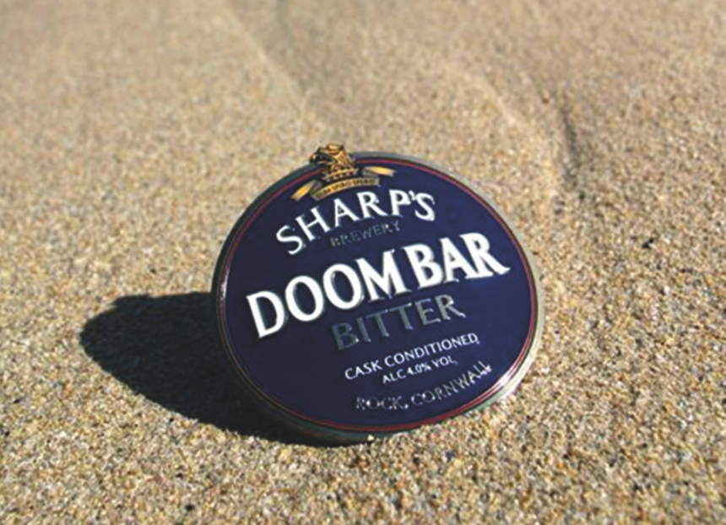

Beer drinkers and pub campaigners in Cornwall are calling for pasty-style protection for local beers to prevent them being marketed as Cornish when brewed elsewhere. The push comes after the news that Molson Coors is shutting the Sharp’s brewery at Rock and will move all production, including Doom Bar, elsewhere. CAMRA Cornwall has issued a stern warning to the global brewing giant, telling it that any attempts to market Doom Bar, and Sharp’s award-winning beer range, made outside the Duchy as a Cornish product will be met with a robust response. CAMRA fears the brewing giant could follow in the footsteps of Carlsberg, which markets Wainwrights as a Lake District Original despite brewing it more than 100 miles away in Wolverhampton. CAMRA Cornwall vice chairman Vince Curtis said: “Although we were expecting this eventually, it doesn’t make the announcement any less devastating. Whether it’s the staff that have lost their jobs, or Cornish locals losing more of our proud brewing heritage, this is just another blow during a tough time for brewers and publicans across the Duchy. “Our message to Molson Coors is clear. If you’re shuttering the brewery, you can’t keep claiming that Doom Bar is a Cornish beer. It’s misleading for consumers and insulting to Cornwall’s brewing legacy. Molson Coors has chosen to sever ties with brewing in the South West, and shouldn’t try to suggest otherwise. “We also want the government to change the law to stop misleading practices from global brewing companies implying a beer is Cornish if it is brewed miles away. That’s already the case with our pasties; it should be the same for our beers too.” CAMRA Cornwall will be writing to Molson Coors stating its position. The pasty has protection under UK law requiring it to be made in Cornwall for it to be called Cornish.

