What we’ll be debating at CAMRA’s first hybrid Conference
27/02/2026 by Ellie Hudspith
Campaign

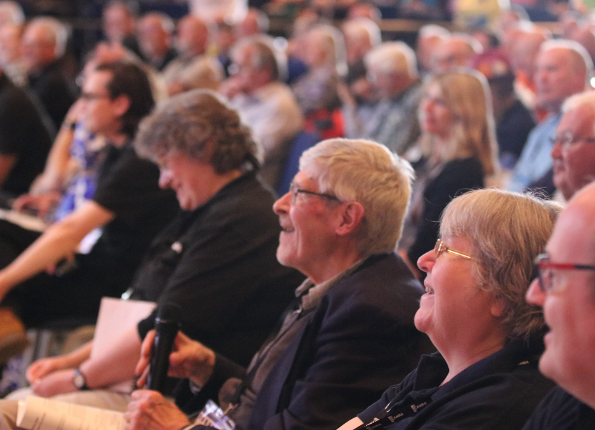

The Order Paper for CAMRA’s 2026 Conference has been published, showing the motions that are up for debate as part of Members’ Weekend. For the first time members can take part in-person, at the Alban Arena in St Albans, or they can watch debates and vote on Conference business online from home. Motions for debate 1 This Conference agrees to adopt the Policy Documents presented for adoption at Conference 2026, subject to any amendments to policy decided at this Conference. National Executive 2 This Conference instructs the National Executive to prioritise motions for debate in the Members’ Weekend schedule, and wherever possible all motions shall be adequately debated on the Saturday of Conference. Bradford 3 This Conference instructs Conference Procedures Committee to amend section 6.1.5 of the Remit and Procedures to give, wherever feasible, higher precedence to motions, classified under sections 6.1.5.2 and 6.1.5.3, which have been submitted by two individual members or by regions or branches, over those submitted by National Committees and the National Executive. Bradford 4 This Conference instructs the National Executive to change the title of the National Pub of the Year to reflect the year that the award is presented, if that differs from the year that judging took place. South Herts 5 This Conference instructs the National Executive to develop a financially sustainable business model for the printed version of BEER Magazine, working with the editors of CAMRA’s cost-neutral branch magazines. South Herts 6 This Conference instructs the National Executive to produce bilingual membership application forms and other promotional materials for use in Wales.Wales 7 This Conference instructs the National Executive to bring proposals to the 2027 Members’ Weekend to restore the Great British Beer Festival at the earliest opportunity. Roger Protz and Iain Loe Now the Order Paper has been published, members can submit amendments to motions and emergency motions for consideration by Conference Procedures Committee. Amendments will only be accepted during debate at Conference in exceptional circumstances. Emergency motions are defined as those where the situation requiring the motion arose after the deadline for submission or ordinary motions (for 2026 Conference, Friday 13 February 2026) and could not have been anticipated before the deadline. Both amendments and emergency motions should be submitted for consideration at the Conference Procedures Committee meeting on the eve of Conference, (7pm, Friday 17 April 2026 at the Quakers Meeting House, Upper Lattimore Road, St Albans. Please note this is a 5-10-minute walk from the Alban Arena). Where possible, please submit these in advance of the meeting to Ellie Hudspith, secretary to Conference Procedures Committee on cpcsecretary@camra.org.uk) Registration details, the motions, Standing Orders (which set out the processes we follow for debating and voting) and more Members’ Weekend information is here. Discussion threads for each of the motions will be set up on Discourse, CAMRA’s online discussion forum.

