Interested in shaping debate at CAMRA Conference?
26/02/2026 by Ellie Hudspith
Campaign

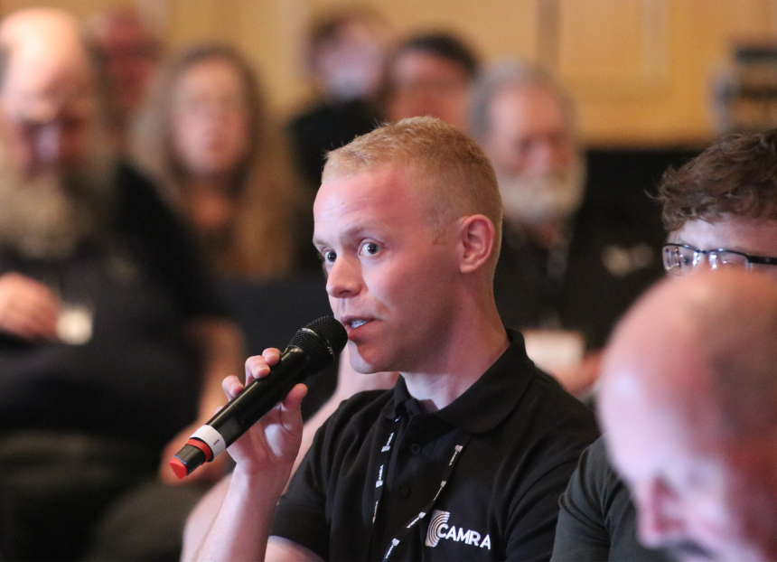

The Conference Procedures Committee (CPC) is looking for a member to join it for the 2026/28 term. Following the annual election process, one nomination was received for two two-year vacancies on the committee. Nick Boley has been elected to the committee once he stands down from the National Executive following this year’s AGM. This leaves one vacancy for the other two-year term. Interested CAMRA members are now being asked to apply for the vacancy on the committee, which plays an important role in CAMRA’s policy-making process. If you are a die-hard Conference-goer with an interest in helping members propose and debate policy, this could be the volunteering opportunity for you. Members of CPC are expected to attend CAMRA Members’ Weekend, which Conference is a part of, help the chairman to apply the Standing Orders and make important decisions in the run-up to Conference, including: providing drafting advice for members, branches and committees considering submitting motions for debate

setting the Order Paper (motions for debate) and the Standing Orders (rules for how debate at Conference is run)

hearing appeals on rejected motions and receiving and assessing emergency motions and amendments to motions. To apply send a supporting statement of no more than 300 words to cpcsecretary@camra.org.uk, detailing why you want to join the committee and any relevant experience. The committee will consider applications and expect to make a co-option at its meeting at Members’ Weekend on Friday 17 April. More information on CPC, including its full remit, is on the CAMRA website at camra.org.uk/cpc

