Plan your next festival trip
26/02/2026 by Matthew Rogers
Campaign

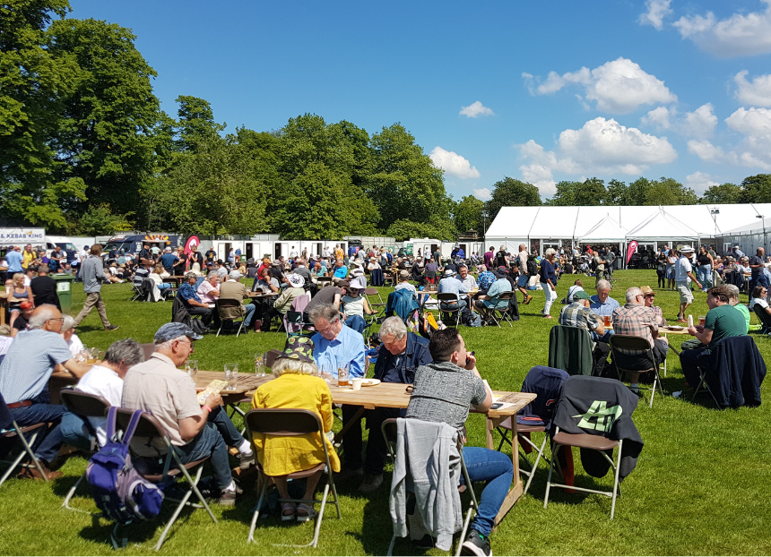

For your next festival trip look no further than the tempting list below. To see all upcoming CAMRA events visit the events webpage. Bradford Beer and Cider Festival, 26-28 February Victoria Hall, Victoria Road, Shipley, BD18 3JS bradford.camra.org.uk/3398-2/ Gosport Winterfest XXXII, 27-28 February Thorngate Halls, Bury Road, Gosport, PO12 3QX pseh.camra.org.uk Andover Tap at the Lamb and CAMRA North Hampshire, 27 February-1 March 21 Winchester Street, Andover, SP10 2EA hantsnorth.camra.org.uk/viewnode.php?id=277468 Loughborough Beer Festival, 5-7 March Polish Club, True Lovers Walk, Loughborough, LE11 3DB loughboroughcamra.co.uk/beer-festivals/49th-loughborough-beer-festival Wigan Beer Festival, 5-7 March Robin Park Sports and Tennis Centre, Wigan, WN5 0UH https://beerfestival.wigancamra.org.uk/ Burton and South Derbyshire Beer and Cider Festival, 19-21 March Burton Town Hall, King Edward Place, Burton on Trent, DE14 2EB burtoncamra.wordpress.com/beer-festival North Sussex Spring Equinox Beer and Cider Festival, 20-21 March Horsham Drill Hall, Denne Road, Horsham, RH12 1JF northsussex.camra.org.uk/equinox Darlington Beer Festival, 20-22 March Hopetown, McNay Street, Darlington, DL3 6SW dbfestival.my.canva.site Coventry Beer Festival 2026, 27-28 March Coventry Rugby Football Ground, Butts Park Arena, Coventry, CV1 3GE coventry.camra.org.uk/viewnode.php?id=54470 Larbert Real Ale and Cider Festival, 3-4 April Dobbie Hall, Main Street, Stenhousemuir, FK5 4BL facebook.com/events/1806397750065166 CAMRA Isle of Man Beer and Cider Festival, 9-11 April Villa Marina Royal Hall, Harris Promenade, Douglas, IM1 2HP iombeerfestival.com Newcastle Beer and Cider Festival, 15-18 April Northumbria Students Union, 2 Sandyford Road, Newcastle upon Tyne, NE1 8SB nclbcf-tynland.camra.org.uk/wordpress Farnham Beerex, 23-25 April The Farnham Maltings, Bridge Square, Farnham, GU9 7QR farnhambeerex.org.uk/index.html Bexley Beer Festival, 7-9 May Dartfordians Community Sports Club, War Memorial Ground, Bourne Road, Bexley, DA5 1LW bexley.camra.org.uk/beer_festival.html Biggleswade Beer and Cider Festival, 7-9 May Biggleswade and District Conservative Club, St Andrew’s Street, Biggleswade, SG18 8BA biggbeerfest.org Clitheroe Beer Festival, 14-16 May St. Michael & St. John's Parish Centre, Lowergate, Clitheroe, BB7 1AG clitheroebeerfestival.co.uk Yapton Beerex, 15-17 May Yapton and Ford Village Hall, Main Road, Yapton, BN18 0ET westernsussex.camra.org.uk/viewnode.php?id=277409 Cambridge Beer Festival, 18-23 May Jesus Green, Victoria Avenue, Cambridge, CB4 3AX cambridgebeerfestival.com Lincoln Beer Festival, 21-23 May Southside, Colegrave Street, Lincoln, LN5 8DW https://lincoln.camra.org.uk/lincoln-beer-festival/ Stratford Upon Avon Beer and Cider Festival, 5-6 June Stratford On Avon Racecourse, Luddington Road, Stratford-upon-Avon, CV37 9SE shakespeare.camra.org.uk/festival Chester Beer Festival 2026, 5-6 June Chester Town Hall, Town Hall Square, Chester, CH1 2HQ westcheshire.camra.org.uk/beerfestival KESR Railway Real Ale and Cider Festival, 5-6 June KESR Railway, Tenterden, TN30 6HE afrm.camra.org.uk/viewnode.php?id=278100 GWR Ale and Steam Weekend Festival, 12-14 June Winchcombe and Toddington GWR Stations, Winchcombe and Toddington, GL54 5LD gwsr.com/whats-on/rail-ale-festival Stockport Beer and Cider Festival, 18-20 June Masonic Guildhall, 169-171 Wellington Road South, Stockport, SK1 3UA stockportfestival.org.uk Totnes Beer and Cider Festival, 2-4 July Totnes Civic Hall, Market Square, Totnes, TQ9 5SF southdevon.camra.org.uk/viewnode.php?id=231333 Harbury Beer and Cider Festival, 4-5 September Harbury Village Hall, South Parade, Nr Leamington Spa, CV33 9JE how.camra.org.uk/?page_id=79

