Plans for Jennings site revealed
25/02/2026 by Timothy Hampson
Industry

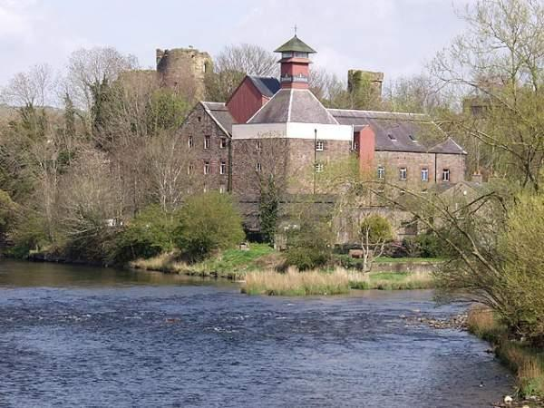

Big plans for the redevelopment of a Cockermouth landmark could see the former Jennings brewery site transformed into an arts and retail space complete with a hotel and residential accommodation. A public consultation has been launched on early proposals to regenerate the historic site, inviting residents, businesses and stakeholders to have their say on the future of one of the town’s most important heritage locations. The site, at the meeting point of the River Derwent and the River Cocker (above) beneath Cockermouth Castle, has played a central role in the town’s economy and identity for centuries. The proposals “aim to safeguard this legacy while bringing the site back into active, everyday use for the community”. Led by Stone Circle Developments Cumbria, a local development company with a focus on bringing heritage sites back into use for communities, and working closely with Jennings brewery and Haigh Architects, the emerging plan is to create a mixed‑use destination centred around a working brewery. Key elements being explored include: – retaining and celebrating the working brewery at the heart of the site – reuse of historic and listed buildings, including the Grade-II-listed maltings – new public spaces and improved walking routes – event, education and heritage spaces linked to the brewery’s history – workspaces, hospitality and visitor accommodation – residential accommodation and retail units as part of a balanced, mixed‑use development – flood‑resilient design and enhanced biodiversity along the rivers. “The proposals have been shaped by the site’s heritage, conservation status and flood history, with an emphasis on sustainability, safety and long‑term viability,” said a project spokesman. “This is an early consultation stage, and no final designs have been agreed. Feedback from the local community will play a key role in shaping how the proposals develop. “Residents are encouraged to view the consultation boards and complete the survey by scanning the QR code displayed on the boards or by contacting the project team directly.” Have your say here: Jennings Redevelopment Public consultation boards.

