Cycling to good beer and health
22/02/2026 by Geoff Strawbridge
Campaign

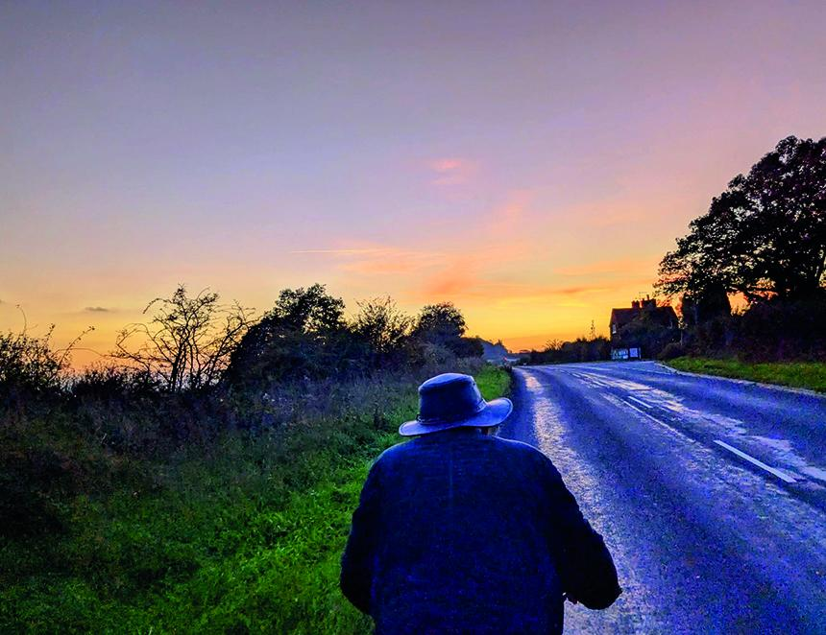

At an invigorating strategy meeting of our national Pub and Club Campaigns committee at the Vat and Fiddle in Nottingham last November, we recognised that we should get out more and encourage other people to do so too. To that end, I offered to share a love of cycling in seeking out or simply discovering our wonderful pubs. The CAMRA South West London Cycling Section came into being before the Covid pandemic, when we thrived on cleaner air and quieter roads during the lockdowns and associated restrictions. Several pubs and breweries offered cask beer and real cider or perry in takeaway containers. With very few of us on any particular ride, social distancing was easily observed in single file. More recently, keener cyclists have joined us and we’ve visited more places and covered greater distances. Always taking it gently though, as well as drinking responsibly, we average no more than 10 miles per hour and no fewer than 50 miles per gallon. Excursions are recorded and aspirations shared among a WhatsApp group that anyone may join. Starting and finishing near Wimbledon, some of our shorter circular tours have targeted the changing pub of the year winners entered for the Greater London regional competition. Other destinations have included: – Queen’s Head at Downe and Orpington Liberal Club (though Downe would more accurately be named Uppe)– The annual wassailing and apple-pressing events organised by our regional cider co-ordinator, Ian White at One Tree Allotments, Honor Oak– South-East London micropubs out as far as Crayford (any half dozen or so of more than 30, depending on their opening times)– Gidea Park micropub; Hop Inn, Hornchurch; Upminster TapRoom– Little Green Dragon, Winchmore Hill; Antwerp Arms, Tottenham; Chesham Arms, Hackney– Walthamstow and the breweries along Blackhorse Lane– Epping Ongar Railway beer festival at North Weald– Land of Liberty, Peace and Plenty at Heronsgate, beyond Uxbridge, in dry weather mostly along the Grand Union Canal towpath, then back via the Masons Arms in Teddington– Chobham, out across the bosky Surrey Heath– Windsor: historic pubs and now three microbreweries– Pilgrim, Dorking and DropKick breweries plus King William IV at Mickleham. Three of us enjoyed two longer rides during 2025:– a one-way journey on Good Friday to the Easter beer festival at Downton brewery, nine hours on the road with one-hour refreshment stops at the Watership Down Inn, Freefolk; John O’Gaunt, Horsebridge; Cuckoo Inn, Hamptworth– leisurely pub tour round Reading in the autumn, then back via the aptly named Elusive brewery. Cycling stalwart Robin Wootton has recorded GPS tracks for all 30 of the routes taken by SWL Cycling Section since he joined in 2023. These are compiled on the accompanying map, which also shows the refreshment points surveyed along the way. If you are intersted in joining the CAMRA South West London Cycling Section, contact Geoff Strawbridge at geoff.camra@gmail.com

