London Brewing’s Streets ahead
19/02/2026 by WB Reporter
Campaign

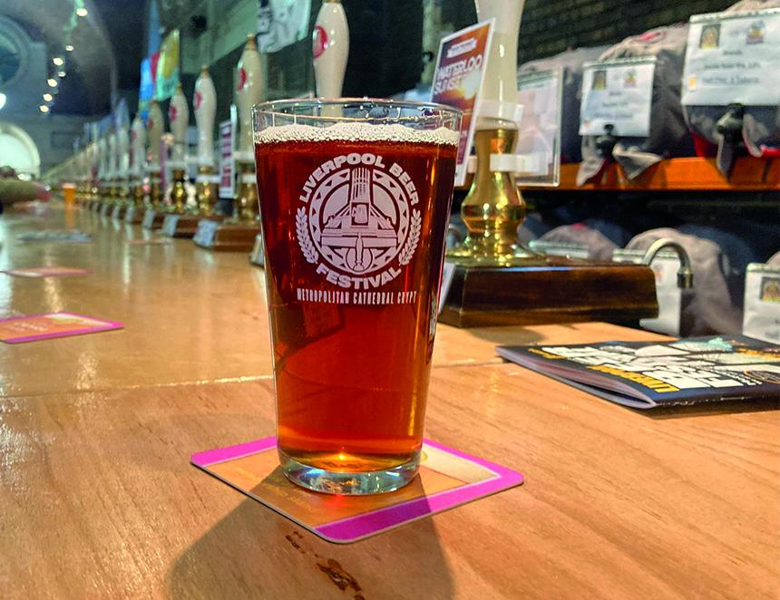

Beer Street (4 per cent ABV), an amber bitter with rye by London Brewing has won CAMRA’s Champion Winter Beer of Britain title at Liverpool Beer Festival today. After a year of local and regional blind judging heats, the Campaign’s winter winners have been crowned. The category winners now go forward to the final judging in May at CAMRA’s Cambridge Beer Festival where they’ll battle it out to take the crown of Supreme Champion 2026. Cairngorm’s session stout, Black Gold (4.4 per cent), took home silver, and Green Jack’s Baltic Trader Export Stout (10.5 per cent) won bronze. Judges were blown away by the winner, with judging panel coordinator Christine Cryne describing Beer Street as: “A sparkling golden amber bitter, with spicy rye and a roasty nose, sweet biscuit on the flavour, where the spicy rye notes increase and linger in the dry and slightly bitter finish. Very easy drinking.” The judging and announcement took place at Liverpool Beer Festival, in the Lutyens Crypt at Liverpool Metropolitan Cathedral. Competition beers are available at the festival while stocks last. CAMRA’s awards director, Shelly Bentley, said: “Our Champion Beer of Britain competition is the only truly independent beer contest in the UK. Brewers can’t simply enter their beers, they have to be nominated by beer lovers or expert tasting panels. “London Brewing is an incredibly deserving winner of the winter crown, and everyone taking home a category win or top three placement should be proud that their beers have been declared the cream of the crop by expert judges.” Runner-up Black Gold is a black session stout with red hues and oyster head. Aromas of black treacle and faint hits of dark fruits. Caramelised fruits on a sweetish chocolate base with some plums create a moreish stout. The dry finish is slightly sweet with some spicy notes. Third-placed Baltic Trader Export Stout was described as a dark, ruby brown imperial stout, with aromas of sweet black treacle with some damsons. A rich. smooth mouthfeel with bitter black chocolate, sweet molasses and damsons. The finish is sweet, smooth with bitter roasty notes remaining. Very warming. Who won what Overall: Gold: London Brewing, Beer Street, 4 per cent Silver: Cairngorm, Black Gold, 4.4 per cent Bronze: Green Jack, Baltic Trader Export Stout, 10.5 per cent Brown Ales, Red Ales, Old Ales and Strong Milds: Gold: Harvey’s, Old Ale, 4.3 per cent Silver: Elmtree, Nightlight Mild 5.7 per cent Bronze: RedWillow, Sleepless, 5.4 per cent Session Stouts and Porters: Gold: Cairngorm, Black Gold, 4.4 per cent Silver: Green Jack, Lurcher Stout, 4.8 per cent Bronze: Blackjack, Manchester Stout, 4.8 per cent Strong Stouts and Porters: Gold: Green Jack, Baltic Trader Export Stout, 10.5 per cent Silver: Ramsgate, Gadds’ Black Pearl, 6.2 per cent Bronze: Five Kingdoms, Dark Stout, 6.9 per cent Barley Wines and Strong Ales: Gold: Driftwood Spars, Alfie’s Revenge, 6.5 per cent Silver: Grainstore, Nip, 7.3 per cent Bronze: Holden’s, Old Ale, 7.2 per cent Speciality, Differently Produced: Gold: London Brewing, Beer Street, 4 per cent Silver: Papworth, Koura, 5.7 per cent Bronze: Dorset, Jurassic Dark, 5.9 per cent Speciality, Differently Flavoured: Gold: Farm Yard, Hoof, 4.3 per cent Silver: Titanic, Cappuccino Stout, 4.5 per cent Bronze: Cerne Abbas, Gurt’s Rum Coconut Stout, 6.7 per cent

