Don&#039;t miss steel and synth city celebration
19/02/2026 by Dave Pickersgill
Industry

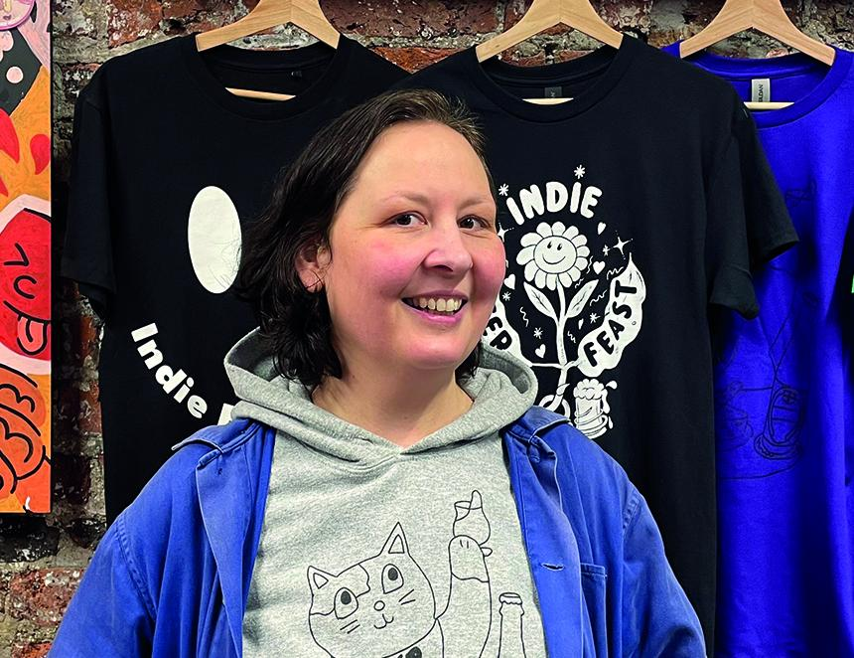

Sheffield Beer Week is back for 2026 (6-15 March) with a week-long celebration embracing the city’s brewers, musicians and International Women’s Day. It has its roots in 2013 when Jules Gray opened “a labour of beery love”, the multiple award-winning Hop Hideout – one of the first drink-in beer shops in the UK. Originally based in a former Yorkshire Penny Bank on Abbeydale Road, 2019 saw a move to the Kommune food hall in the centre of Sheffield. Five years later, after Covid, she brought another relocation to the Grade II-listed, Leah’s Yard when it reopened after restoration. Brought up in County Durham, her journey to Sheffield included a bar job in a local working men’s club, study at Sheffield Hallam University, time in both Birmingham and Manchester and after several other positions, working in technical support for a multinational brewing company in Burton on Trent. Jules also runs the annual Sheffield Beer Week (SBW, sheffieldbeerweek.co.uk). This takes place during the second week in March, coinciding with International Women’s Day (8 March). Organised by Jules and her colleague, Claire Tollick, the first incarnation in 2015, saw 10 or so venues, with events spread over the week. Recent years have had more than 40 venues. Jules said: “SBW was inspired by the early days of my newly launched beer business. I was getting excited by the independent beer sector. I noticed that there were lots of beer weeks in America, and also Norwich City of Ale was happening in the UK. It was joined up with the frustration of hearing a lot of people talk about nearby cities like Manchester or Leeds and not mentioning Sheffield. And living in the city and seeing it, a tangible beer history, culture, brewers I was getting quite frustrated as to why people were not talking about Sheffield. And I thought wouldn’t it be great to shout more about the beer scene in the city that I had made my home. “After the first year, people saw the economic benefits: increased footfall; heightening awareness and celebrating venues, breweries, and culture, but also attracting people to visit Sheffield to discover the wonderful things that we sometimes take for granted. I just love it. I want people to get that joy and excitement across to other people. On the flip side you do need a bit of a cheerleader to raise awareness and join up the dots of the community. There is a tipping-point. You need more than one, it becomes a trail.” The main aim of this independent, beer-focused event is to bring additional footfall. The first three years coincided with Sheffield hosting the annual SIBA conference, providing a ready source of beer-interested visitors. When the conference moved to Liverpool, Jules was both humbled, and reassured, by the local demand for SBW to continue. It was something people thought was really valuable. She recalled: “At the time it felt like the council wasn’t valuing the culture, community and historic value of the brewing and beer sector, the businesses which were driving visitor footfall. This has definitely changed: momentum has grown. That momentum has led the Sheffield Inspires campaign to include ‘the Craft of Brewing’ as one of its five main strands. It’s been a gradual positive relationship development.” In 2020, SBW was the last large beer event in the UK before lockdown. The following year saw a virtual event. This year brings the 12th incarnation celebrating the region’s brewing landscape. Collaboration is key with Sheffield’s bars, pubs and restaurants joining forces with both local organisations and breweries of all sizes to host a variety of events. Dave Pickersgill led his first SBW pub heritage walk from Fagan’s in 2017. This year in collaboration with historian, John Stocks, a talk and a walk will concentrate on Little Chicago. SBW starts with Indie Beer Feast, a two-day celebration of independent craft beer, brewery bars, street food, low-intervention wines and fine cider. Until 2020, this took place at Abbeydale Picture House. After a break due to Covid, 2022 saw a move to the 1930s industrial space of Trafalgar Warehouse. As usual, 2026 will see several collaborative brews, all focused on the theme of Sheffield synth city: a tribute to the pioneering electronic music which the city has produced. For example, St Mars of the Desert is hosting a local band while relatively new breweries Duality and Ticking Clock are working together. Designed by Lewis Ryan, the visual map for the event is taking inspiration from the 1981 Human League album, Dare, while the botanical-inspired artwork has been designed by local illustrator, Sanpo. There is also input from beer writer Pete Brown, who at an event hosted by Hop Hideout, will be interviewed by music and culture writer Daniel Dylan Wray about matching beer and music. As Jules put it: ‘‘Sheffield synth city allows us to blend the creativity of our independent breweries with the ground-breaking spirit of our electronic music pioneers. It’s powerful to showcase how innovation thrives across all creative industries in the Steel City. “It’s an umbrella event. It’s something customers love, it really chimes with them, it creates a good buzz and excitement. There are lots of positives: learning and knowledge transfer. From both a trade and customer perspective, customers love it.” Beer tourism is a crucial cog in Sheffield; the footfall and financial benefit is a win-win for the local hospitality and brewing industries. Sheffield Beer Week is a crucial part of this jigsaw. Pictured: Jules Gray at Hop Hideout (c) Dave Pickersgill

