Write now to save our pubs
17/02/2026 by WB Reporter
Campaign

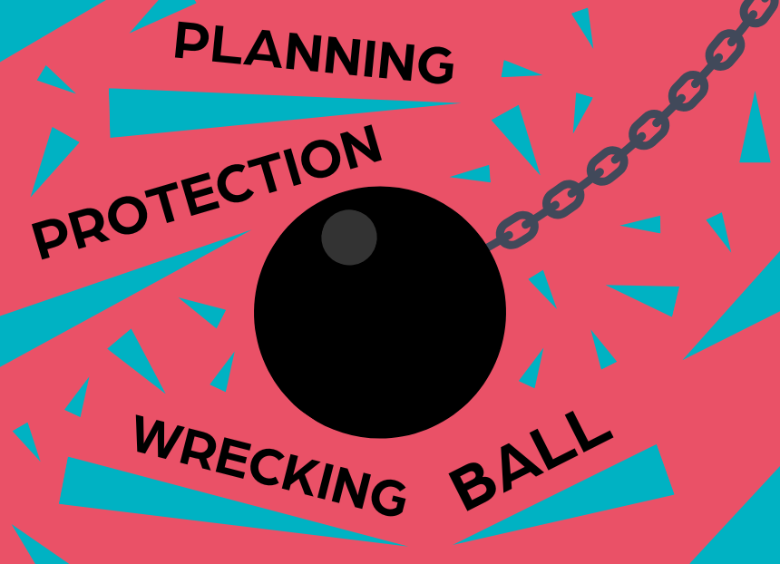

CAMRA is calling on members to email their MP, asking them to halt government plans to water down vital planning protections for pubs in England. The government is proposing to change national planning rules, so a pub is only protected from conversion or demolition if it is the last one in an area instead of the restrictions applying to all locals. If the plans succeed it will make it easier for greedy developers to convert pubs into houses, shops or takeaways and to demolish them entirely. When the Campaign asked members to email their MPs about unfair changes to business rates, supporters responded in their thousands and helped to get the government to think again. Now CAMRA needs your support again to make sure pubs are properly protected and can’t be converted or demolished against the wishes of local communities. CAMRA national planning policy director Paul Ainsworth said: "If the level of planning protection that pubs have is severely weakened in this way, councils will find it difficult to refuse applications to change the use of pubs or to demolish them altogether. Objections by local people won't be given the same consideration as they are now, because the application to redevelop or demolish will be in line with the new national planning policy which local decisions need to follow." Emailing your MP to save planning protections for pubs only takes a minute with CAMRA's simple elobby tool. Take part in the campaign here.

