Pub snack perfection
15/02/2026 by Christian Gott
Opinion

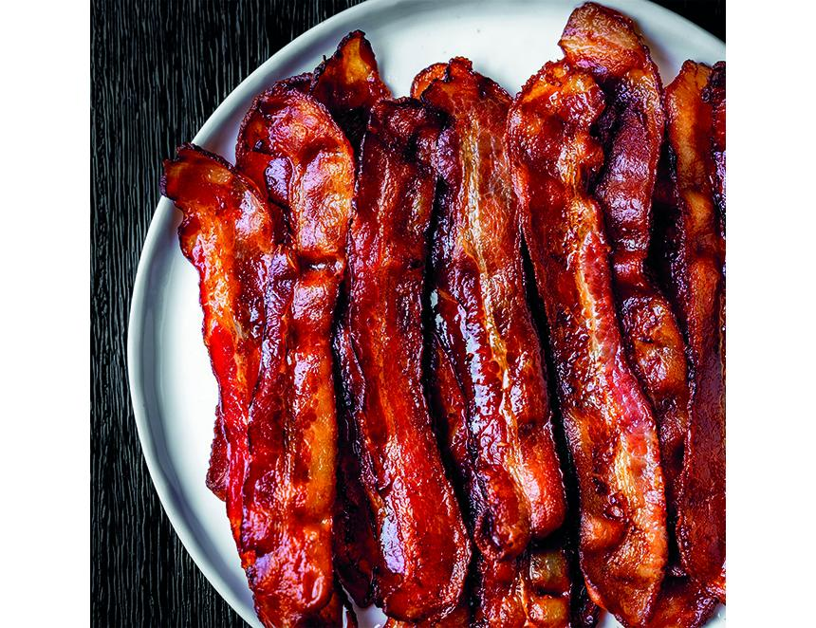

So, I was sat recently in my local with a good pint and a packet of a popular, crunchy, bacon-flavoured snack, which by the way is suitable for vegetarians, and I started considering that I must be able to do better. What’s your favourite pub snack? Hand-raised pork pie? Pickled egg? Hand-cooked Kettle crisps or artisan salami? Personally, I’m a sucker for anything packed with umami, the delicious, mouth-watering, salty-sweet fifth taste. Umami was first identified in 1908 by a Japanese scientist and roughly translates as “pleasantly savoury”. It’s abundant in Parmesan, anchovies, and Worcestershire sauce. And there you were wondering why everyone always goes mad for a Caesar salad. You can also find umami in roasted mushrooms, tomatoes and more importantly cured meats and bacon. My local is a lovely little boozer and asking for a cocktail would be met by a quizzical, perfectly arched barmaid’s eyebrow and a politely worded but very firm rebuttal, but I was a man on a mission suddenly thinking about those over-the-top Bloody Marys you get in America, garnished with gherkins, shrimp, celery sticks, olives, and candied bacon. Something salty, sweet and bacon-based looked like a winner to me. When something is candied it is usually simmered in a sugar syrup as a method of preserving. But what if we upped the ante and made the syrup with beer? I wanted to use a stout as you need robust flavours to match those of the bacon. I thought I would do my bit for the newly rescued Black Sheep brewery and use its rather delicious milk stout. Milk stouts are so named due to the inclusion of lactose, a sugar found in milk. Unlike most other sugars in brewing lactose is not fermented by yeast and is used to add body and sweetness to balance the bitter notes from darkly roasted malts. Black Sheep Milk Stout (4.4 per cent ABV) is creamy, smooth, with a velvety texture. It is brewed in Masham’s original maltings building in the heart of the Yorkshire Dales. With hints of coffee and vanilla, Black Sheep Milk Stout is great with chocolaty desserts and brilliant for cooking with bacon. Back home and a couple of trial batches in the kitchen later, I added a touch of Dijon mustard for a little kick and chose smoky bacon to add another layer of flavour. Beer-candied bacon is great added to burgers and salads, stacked up high with American-style pancakes and crumbled over macaroni cheese and even glazed doughnuts, most of all it is perfect with a pint in the pub. Black Sheep Milk Stout candied bacon 450g thick-cut smoked streaky bacon 125g dark brown sugar 150ml Black Sheep Milk Stout 2tsp Dijon mustard Freshly ground black pepper Preheat your oven to 350F/180C/Gas Mark 4. Combine the brown sugar, mustard and beer in a small pan and bring to the boil. Reduce by half and set aside. Line a baking sheet with silver foil and place a cooling rack over the top. Lay out the pieces of bacon on top of the rack, and place in the oven and bake for 10 minutes. Carefully remove the tray from the oven and brush one side of the bacon strips with the beer syrup. Turn the bacon over with tongs and brush the other side with more syrup, then return to the oven for another 10 minutes. Remove from the oven and repeat the process again, continuing to glaze and cook the bacon in this way until it is crispy and dark in colour. In total around 40-50 minutes. Once the bacon is cooked and crispy, transfer to another baking rack and allow the candied bacon to cool then transfer to an air-tight container lined with baking paper. Repeat the cooking process with any remaining bacon. The bacon is ready to eat but be warned it won’t last long.

