New threat to pubs from planning law changes
13/02/2026 by WB Reporter
Campaign

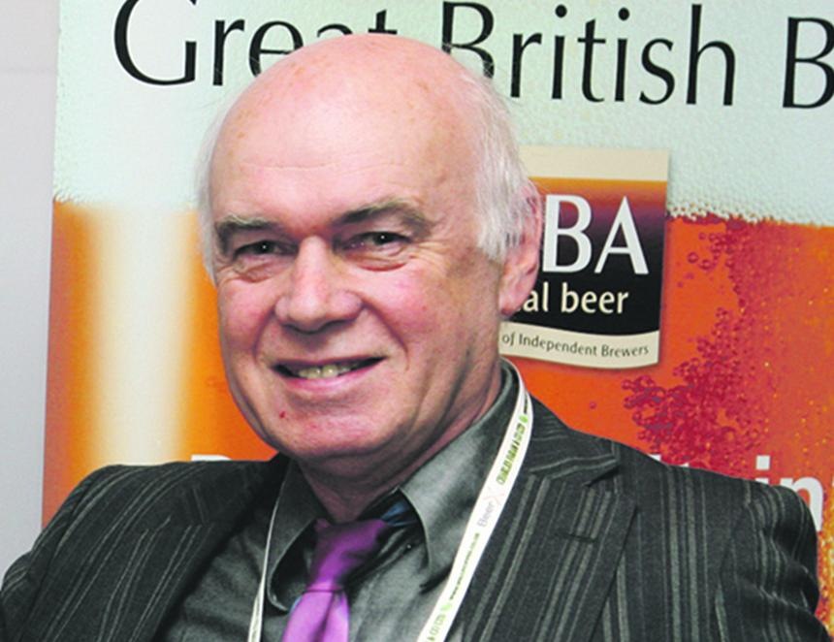

CAMRA is calling on the government to rethink plans to weaken protections in the planning system in England, which it believes could lead to thousands of pubs being lost. The Ministry of Housing, Communities and Local Government is consulting on plans to change the National Planning Policy Framework. Existing rules mean councils have to protect all pubs, as they are considered vital community facilities. Pubs are offered protections including the need for planning permission to be granted before a pub can be demolished or converted into houses, shops or takeaways. But under the government’s new plans, protections would only apply if a pub were the last one in the area. The Campaign is warning that this could see thousands of pubs converted into flats, houses, shops or takeaways by greedy developers even when local people want to save it as a community local. The proposal comes shortly after a government rethink on business rates bills increases for pubs in England which threatened thousands of locals across the country. CAMRA argues it doesn't make sense for the government to give help with business rates bills to stop closures and then change planning rules which could lead to more pubs being lost forever. CAMRA national planning policy advisor Paul Ainsworth (above) said: “We strongly object to these plans which could spell the end for thousands of viable pubs across England. “Strong planning protections are needed to give people the right to try to save their pub if it is under threat of demolition or conversion. Crucially, this must apply to all pubs so communities can save their local even if there are other pubs in the same area. “Without protections for every pub, we risk seeing greedy developers cash in and try to turn pub buildings into other uses like houses, shops or takeaways. This would be devastating for communities who would lose a vital part of their social fabric. “CAMRA wants government ministers to rethink this proposal and keep strong protections for all pubs in the planning system so our locals can keep serving their communities instead of being lost forever.”

