Your Campaign needs you!
06/02/2026 by WB Reporter
Campaign

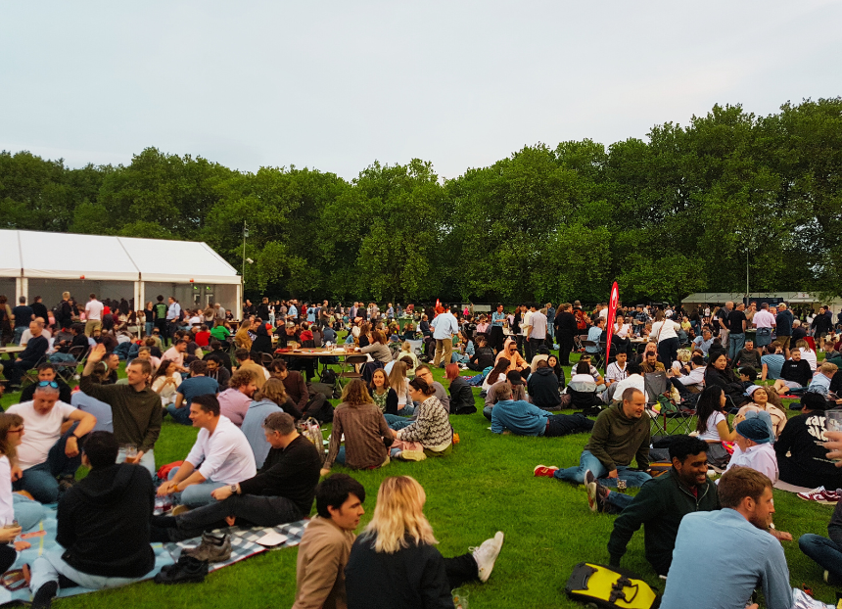

Recruiting new members is key to CAMRA’s success and now the Campaign is looking to train volunteers in this vital role at festivals. Currently, events recruitment officer Laura Coles visits around 20 festivals a year helping volunteers to recruit members at CAMRA events. She cannot attend all the festivals and CAMRA is now seeking to train volunteers in effective recruitment so they can undertake this important role at their own festival or others near them. The marketing team is looking for volunteers who are presentable, comfortable interacting with the public and who are aware the role may require quite a lot of standing or moving about. Location is not a barrier as they can come from anywhere in the UK including Wales and Scotland. The team is planning to attract members to attend face-to-face or online training with Laura on how to recruit new members in a festival environment. Following the training, the team will then assist those who may want to take on a recruitment role at a festival. There will be two face-to-face sessions, one at Cambridge Beer Festival in May and a second at the Peterborough Beer Festival in late August. There will be an online session scheduled in between these dates. If you are interested in the Cambridge and online sessions email Laura (laura.coles@camra.org.uk) by the first week of April. If you’d prefer the Peterborough training get in touch by the end of July. The team will assign people to the online session once we know numbers and locations.

