‘Three lives’ at the Bull celebrated
05/02/2026 by Timothy Hampson
Industry

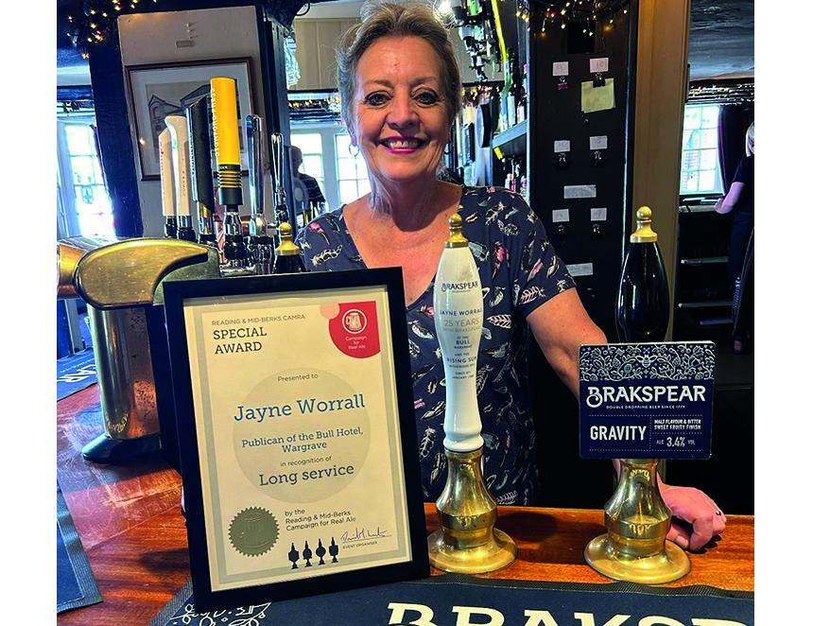

A Berkshire licensee from Wargrave has become Brakspear’s longest-serving landlady after 46 years at the helm. Jayne Worrall, who runs the Bull Hotel in High Street, started at the pub in January 1980, having made the move from cabin crew for BOAC (now British Airways). Worrall, who lives with husband Graham, said she is in her “third life” at the pub having made a move to a nearby Brakspear pub the Rising Sun in Witheridge Hill in 1984. She returned to the Bull again in 1998, staying for 10 years before making the move to south Devon. But not for long as in 2013 she returned to the Bull. Her impressive long service has been marked by Reading and Mid-Berks CAMRA with a special award. After nearly half a century in the trade, Jayne said she has no imminent plans to call time, despite the mounting pressures facing the pub trade. “The Bull draws me back whenever I leave,” she said. “It’s a wonderful pub supported by an amazing community and I’ve had such happy times here. “The affection local people have for the pub has seen us through many ups and downs, including Covid, when we were closed. “I was selling 70 takeaway portions of fish and chips on Friday and Saturday evenings and 100 roasts on Sundays.” She said the pub industry has changed “beyond recognition” in her tenure. “In the 1980s everyone went for a pub lunch and that usually included at least one beer. “We were regularly serving 40 lunch covers which seems unbelievable today when most people are grabbing sandwiches to eat at their desks.” Changes she has made over the years include moving the ladies' toilets inside the pub which was originally a 15th-century coaching inn. The Bull continues to do a steady trade, which Jayne attributes to support from the local community support, fostered during her four decades at the helm.

