Top supermarket backs Indie Beer campaign
04/02/2026 by Timothy Hampson
Industry

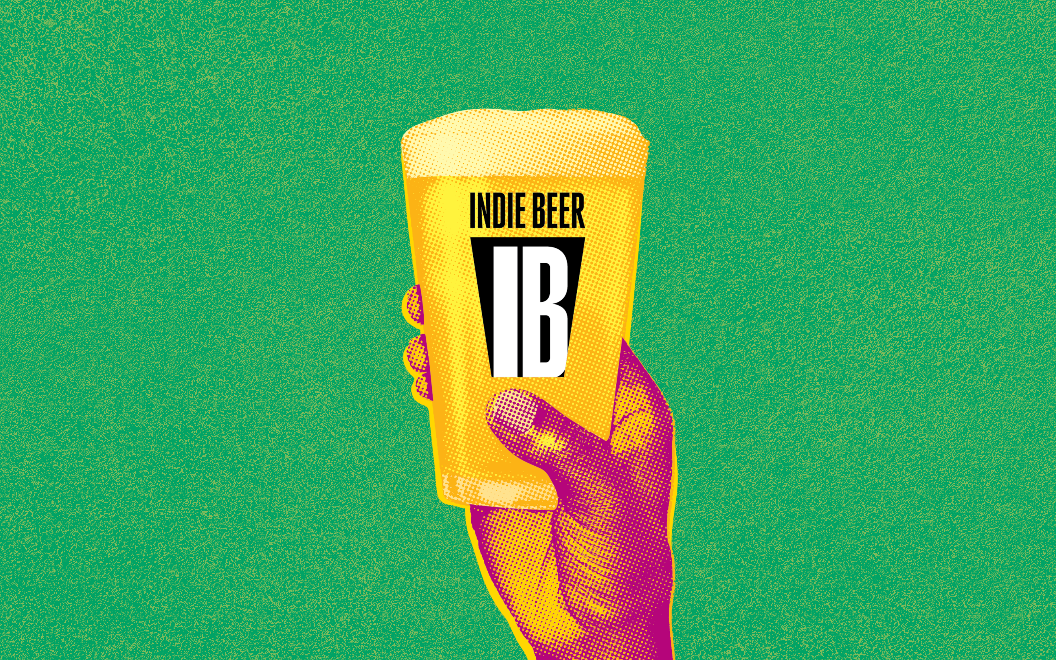

Supermarket chain Waitrose has thrown its weight behind the campaign to promote beer from independent breweries with a new Indie Beer section online and in-store promotions. The Indie Beer section on the online store excludes craft beers produced or owned by global beer companies. The move coincides with the launch of an expanded beer range from Waitrose including a focus on independent breweries. SIBA’s Neil Walker said: “It is fantastic to have Waitrose backing the Indie Beer campaign and making it easier for shoppers to buy beer from indie brewers. “Not only has it extended the number of local independent breweries that it sells, with a focus on quality and flavour, but the dedicated Indie Beer section of the Waitrose website makes it clear to shoppers the beer they’re buying is the real deal." Waitrose also plans to run in-store promotion of the new range to coincide with Indie Beer Week, 10-19 April. Waitrose's beer and cider buyer Jourdan Gabbini said: “I am delighted that we will be the first UK supermarket to officially support the Indie Beer campaign. “Our beer-loving customers are always looking for new beers from innovative, high-quality and exciting independent breweries. This signposting allows us to champion those producers who do it so well.”

