Plan your your next festival trip
03/02/2026 by Matthew Rogers
Campaign

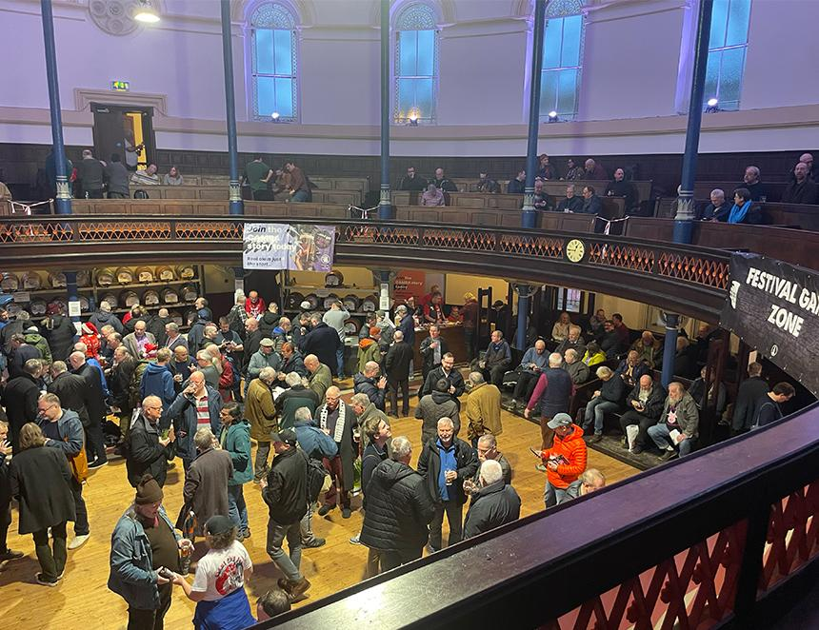

This year promises some amazing festivals to enjoy. To see all upcoming CAMRA events visit the events webpage. Tewkesbury Winter Ales Festival, 5-7 February The Watson Hall, Barton Street, Tewkesbury, GL20 5PX tewkesbury.camra.org.uk/viewnode.php?id=264798 Dorchester Beerex, 6-7 February The Corn Exchange, High East Street, Dorchester, DT1 1HF beerex.co.uk Ely Winter Beer Festival, 6-7 February The Maltings, Ely, CB7 4BB ely.camra.org.uk/viewnode.php?id=242277 Chesterfield CAMRA Winter Beer Festival, 6-7 February Winding Wheel Theatre, 13 Holywell Street, Chesterfield, S41 7SA chesterfield.camra.org.uk Hucknall Beer Festival, 12-15 February John Godber Centre, Ogle Street, Hucknall, NG15 7FQ johngodbercentre.co.uk/hucknall-beer-festival Liverpool Beer Festival, 19-21 February Lutyens Crypt, Metropolitan Cathedral, Liverpool, L3 5TQ liverpoolcamra.org.uk/index.php/lbf Bradford Beer and Cider Festival, 26-28 February Victoria Hall, Victoria Road, Shipley, BD18 3JS bradford.camra.org.uk Gopsort Winterfest XXXII, 27-28 February Thorngate Halls, Bury Road, Gosport, PO12 3QX pseh.camra.org.uk Andover Tap at the Lamb and CAMRA North Hampshire, 27 February-1 March 21 Winchester Street, Andover, SP10 2EA hantsnorth.camra.org.uk/viewnode.php?id=277468 Loughborough Beer Festival, 5-7 March Polish Club, True Lovers Walk, Loughborough, LE11 3DB loughboroughcamra.co.uk/beer-festivals/49th-loughborough-beer-festival Wigan Beer Festival, 5-7 March Robin Park Sports and Tennis Centre, Wigan, WN5 0UH https://beerfestival.wigancamra.org.uk/ Burton and South Derbyshire Beer and Cider Festival, 19-21 March Burton Town Hall, King Edward Place, Burton on Trent, DE14 2EB burtoncamra.wordpress.com/beer-festival North Sussex Spring Equinox Beer and Cider Festival, 20-21 March Horsham Drill Hall, Denne Road, Horsham, RH12 1JF northsussex.camra.org.uk/equinox Darlington Beer Festival, 20-22 March Hopetown, McNay Street, Darlington, DL3 6SW dbfestival.my.canva.site Coventry Beer Festival 2026, 27-28 March Coventry Rugby Football Ground, Butts Park Arena, Coventry, CV1 3GE coventry.camra.org.uk/viewnode.php?id=54470 Newcastle Beer and Cider Festival, 15-18 April Northumbria Students Union, 2 Sandyford Road, Newcastle upon Tyne, NE1 8SB nclbcf-tynland.camra.org.uk/wordpress Farnham Beerex, 23-25 April Bridge Square, Farnham, GU9 7QR farnhambeerex.org.uk/index.html Biggleswade Beer and Cider Festival, 7-9 May Biggleswade and District Conservative Club, St Andrew’s Street, Biggleswade, SG18 8BA biggbeerfest.org Cambridge Beer Festival, 18-23 May Jesus Green, Victoria Avenue, Cambridge, CB4 3AX cambridgebeerfestival.com GWR Ale and Steam Weekend Festival, 12-14 June Winchcombe and Toddington GWR Stations, Winchcombe and Toddington, GL54 5LD gwsr.com/events/rail-ale-festival Stockport Beer and Cider Festival, 18-20 June Masonic Guildhall, 169-171 Wellington Road South, Stockport, SK1 3UA stockportfestival.org.uk Totnes Beer and Cider Festival, 2-4 July Totnes Civic Hall, Market Square, Totnes, TQ9 5SF southdevon.camra.org.uk/viewnode.php?id=231333

