PUBlic Affairs round up – January
31/01/2026 by Tori Wood
Campaign

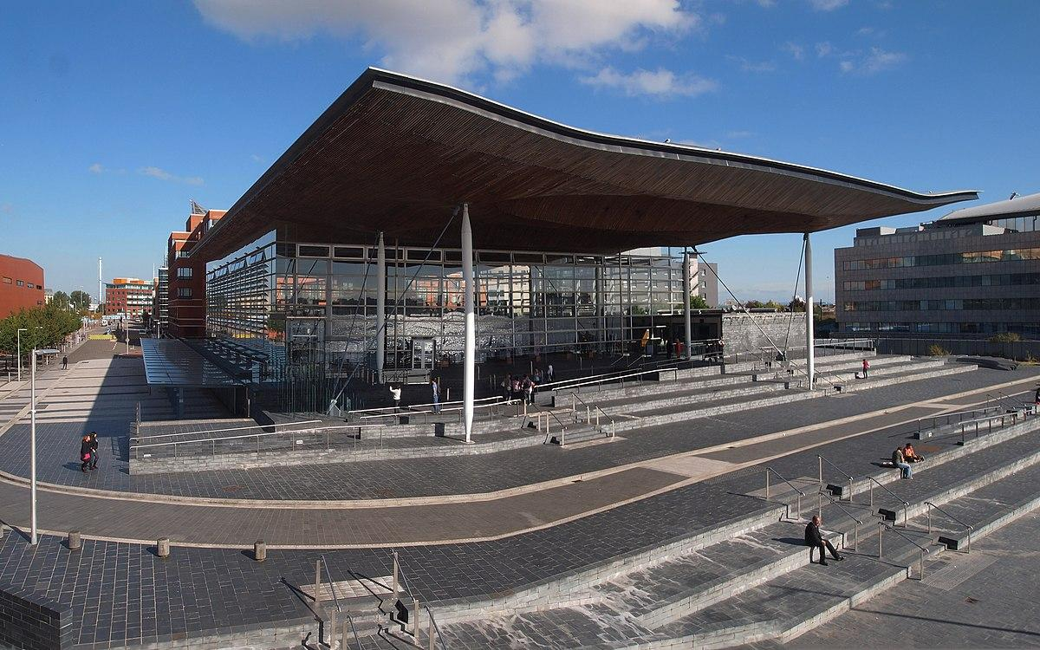

The regular series returns as the Campaigns and Communications team brings the latest updates on campaigning for pubs, pints and people across Westminster, devolved nations and local government. The team has been busy campaigning for business rates changes for pubs, kicking off the new year with reports of a government U-turn. Westminster Business rates [England only] The chancellor announced a “permanently lower” business rates system for pubs at the Budget, which appeared to be a positive step. Although the tax rate for retail, leisure and hospitality was lowered, it’s being introduced at the same time as a rates revaluation and when the 40 per cent discount will be removed so most pubs would pay more than they do now. CAMRA worked with parliamentarians, political parties and other industry organisations to make sure the government understood how disastrous huge increases in business rates would be for pubs. More than 3,500 people took part in our business rates e-lobby to put pressure on the government for a rethink. On 27 January the Treasury announced a package of support for business rates. Short term, all pubs will get 15 per cent off their bills, on top of already announced transitional reliefs coming into effect in April. Further down the line, 75 per cent of pubs’ bills will fall or remain the same in 2026/27, with bills “frozen in real terms” in 2027/28 and 2028/29. By 2029, the Treasury calculates that all pubs will pay eight per cent less than they do now. In the longer term, the government is planning to complete a review of the Valuation Office Agency’s “Fair Maintainable Trade” method of calculating business rates bills. CAMRA will work with the Treasury and Valuation Office Agency to push for a fairer system of assessing pub businesses for rates. Read the Campaign’s response here. Alcohol duty At the Budget it was announced that alcohol duty will increase across the board. A 3.66 per cent rise will come into force from 1 February. Alcohol labelling The Department of Health published its 10-year plan in July last year. It proposes that alcohol labels contain health warnings and a review of the ABV threshold for low-and-no alcohol drinks. The Campaigns and Communications team has discussed the proposals with the Department for Health which will be issuing a public consultation later in the year when plans around what these warnings will look like have been confirmed. Cask beer UNESCO heritage listing Last year, CAMRA announced its support on the Craft Beer Channel’s Keep Cask Alive campaign. As a result of its parliamentary petition to get cask beer UNESCO heritage status, the government responded saying it would welcome submissions on cask to its UK Living Heritage under the UNESCO Intangible Cultural Heritage programme, which opened in December. CAMRA will be working with other industry campaigners to make a submission. Planning [England only] The government announced a consultation on revising its National Planning Policy Framework in December, legislation that CAMRA secured protections for pubs in England. A proposal to alter “HC6: Retention of key community facilities and public service infrastructure” would remove protection for most pubs, with it only applying to a pub that is “the last of its type in the area” instead of all pubs. The team will respond to the consultation, which runs until 10 March. As part of the government’s announcement on extra support for pubs on Tuesday, it will consult on giving pubs in England a permitted development right to expand a main room or make extra guest accommodation. CAMRA’s national planning advisor Paul Ainsworth met with civil servants to discuss these plans and the team will be pushing the government to make sure there are no loopholes which could lead to back-door conversions of pubs into other uses. Licensing and World Cup pub opening hours [England and Wales only] The Home Office announced a consultation on extending pub opening hours in England and Wales during the men’s football World Cup 2026. This will apply if any home nations reach the quater-finals, semi-finals or final. The government confirmed during its announcement on extra support for pubs that this will go ahead, as well as introducing new national licensing policies so pubs can open later. Scottish government and parliament Business rates [Scotland] The Scottish Budget was on 13 January. While CAMRA lobbied the Scottish government asking for pubs’ 40 per cent business rates discount to remain, it was announced this will be slashed to 15 per cent in April. The team contacted Scottish government ministers and ahead of the Budget, while promoting CAMRA’s e-lobby so people could write to their representatives asking for support for pubs. As a result of the extra support the UK government is giving to pubs in England, the Scottish government will receive extra funding. CAMRA is pushing the Scottish government to use this money to give more support to pubs with their business rates bills. You can read the Camapaign’s response here. Scottish Pubs Code adjudicator The Scottish Pubs Code adjudicator published its framework on 16 December. The document outlines how the adjudicator will work with the Scottish government on carrying out their duties under the new statutory Scottish Pubs Code. The Scottish Pubs Code came into force 31 March 2024, with tied tenants’ guest beer right and market-rent-only provisions quickly following. Welsh government and senedd Cymru Business rates [Wales] The Welsh government’s final Budget was on 20 January, which stated pubs’ 40 per cent business rates discount will be axed. Ahead of the Budget, the Welsh government confirmed the discount would be removed in April. As in England, a rates revaluation is set to come in when the discount ends, resulting in Welsh pubs seeing their business rates hiked. As well as members taking part in our e-lobby, to ask MSs to support pubs in the Welsh Budget, the team spoke with MSs and Welsh government ministers, including finance secretary Mark Drakeford MS. After the minister announced a permanently lower business rates system for small shops, CAMRA asked for this to be extended to pub businesses, but he refused. As a result of the extra support the UK government are giving to pubs in England, the Welsh government will receive some extra funding. The team is pushing the Welsh government to use this money to give more support to pubs with their business rates bills. You can see our response here. Northern Ireland executive and assembly Licensing review The University of Stirling carried out an independent review of Northern Ireland’s alcohol licensing system last year. NI’s outdated surrender principle stifles consumer choice and forces licences to be surrendered before a pub, micropub or taprooms can open. In November, the NI minister for communities published the report and his recommendations which rejected most of the review’s suggestions. Since then, CAMRA has been working with MLAs, political parties and other organisations to push for a rethink. Business rates [Northern Ireland] As in other nations, a business rates revaluation has taken place with the result that pubs are facing big increases in bills. You can see CAMRA’s response here. CAMRA has written to the finance minister to ask for a rethink and for support to be offered to pubs.

