Catholic club clinches top title
30/01/2026 by WB Reporter
Campaign

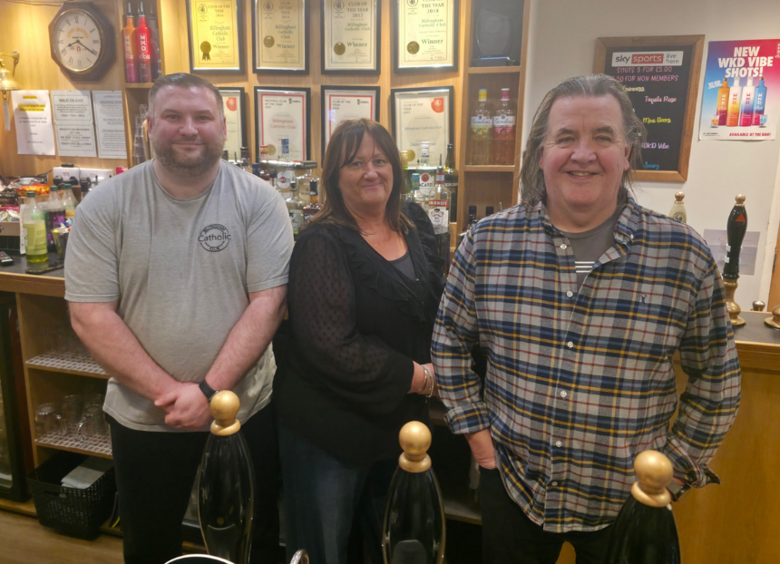

Billingham Catholic Club is CAMRA’s Club of the Year 2025. Run in partnership with Club Mirror, the award recognises the best social clubs in the UK. Clubs are judged on their atmosphere, welcoming surroundings and, most importantly, the quality of their cask beer plus real cider and perry. The former Roman Catholic school in Billingham, County Durham has featured in CAMRA’s Good Beer Guide for almost two decades. Its dedicated volunteers make sure the club’s reputation remains the best, serving 150 beers a year and offering three well-kept cask beers at a time with eight on offer during the club’s regular bank holiday beer-and-music festivals. Renowned for its vibrant R’n’B and rock scene, the Victorian mansion, which has no connection to the Catholic church, has been significantly refurbished over the years. It now boasts a function room and a beer garden covering a quarter of an acre with decking, marquee, stage and three handpulls on its outdoor bar. Bar manager Sean Rowbottom, events coordinator and licensee Lisa Moody and cellarman Tony Hill (above) said: “We are absolutely thrilled to win the CAMRA Club of the Year. We always hoped we might have been in with a chance, but never thought we would win, especially with the other three great clubs in the final. Our little club in the North East of England is a lot of things to a lot of different people and this award is for us all.” CAMRA Club of the Year coordinator Phil Gregg said: “The competition saw well over 100 entries across the country, from Scotland to Cornwall, with the final being the closest I have known for a number of years. "Billingham’s commitment to community and quality cask beer plus real cider and perry makes the team a very worthy winner. Make sure to visit this cracking club and raise a pint to the team’s success! Social clubs are amazing venues and I would urge everyone to visit their local to experience these welcoming spaces for yourself.” CAMRA Yorkshire regional director Kevin Keaveny said: “Lisa, Sean and Tony have done a fantastic job making Billingham Catholic Club a welcoming space for CAMRA members, groups and the wider community. Their commitment to serving 150 beers a year showcases the many independent brewers the industry has to offer. Cheers to the dedicated volunteers that has made the club such a vibrant welcoming space and an award-winning club.” Billington Catholic Club fought off Appleton Thorn Village Hall in Cheshire, Cheltenham Motor Club in Gloucestershire and Orpington Liberal Club in London. Find out more about the award here. Pictured, from left, Sean Rowbottom, Lisa Moody and Tony Hill

