Hooky doubles up
29/01/2026 by Timothy Hampson
Industry

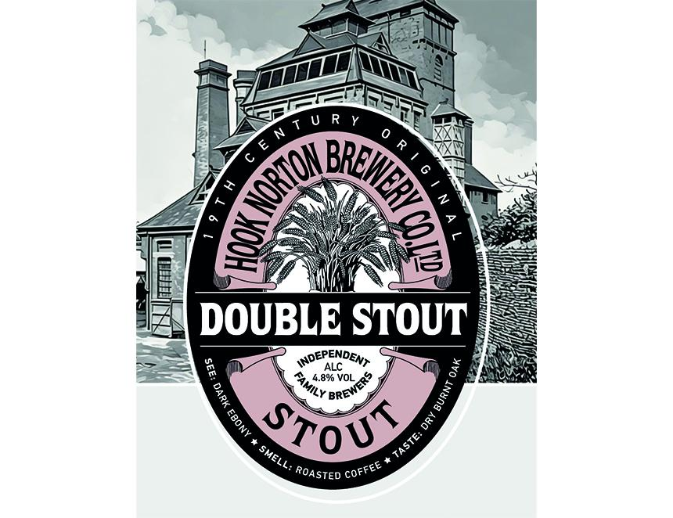

Hook Norton is set to launch its first seasonal cask beer of the year this week – Double Stout created from the brewery’s original 1898 recipe. A blend of black and brown malts gives Double Stout, at 4.8 per cent ABV, its distinctive character. Black malt enriches the beer with its deep ebony colour and delivers toasted notes alongside hints of chocolate, coffee, and caramel, while the brown contributes a satisfying dryness. Hook Norton will officially launch Double Stout at a special event at the Bell, Adderbury on Thursday 29 January from 7-8pm, where brewers will be on hand to offer free samples and share the story behind this historic stout. Double Stout will be available in Hook Norton pubs and free houses across Oxfordshire, Gloucestershire, Northamptonshire, Warwickshire and Worcestershire. The beer will be available in cask during February only. For those who miss it, Double Stout is also available in bottles all year round from the brewery shop hooky.co.uk and retailers.

