Help for pubs ‘short-term and short-sighted‘
28/01/2026 by WB Reporter
Campaign

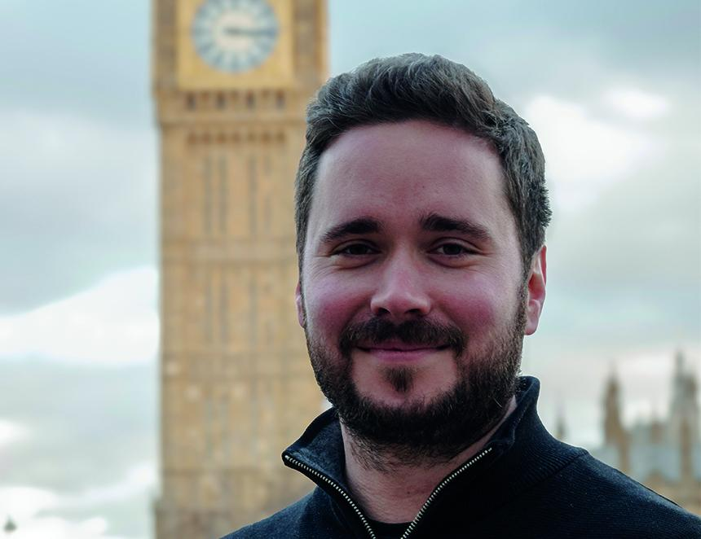

Responding to the Treasury’s announcement of extra help for pubs in England with business rates CAMRA chairman Ash Corbett-Collins (above) said: “This short-term announcement is not the ‘permanently lower business rates’ that pubs were promised. While it is positive that the chancellor has listened and announced extra discounts for pubs facing the threat of closure, it is short-sighted to think that today’s statement will give publicans the certainty they need. “The plan to review the unfair way pubs are assessed for business rates is welcome, but this leaves them in the same situation as they have been for years – still facing a long wait for promised and fundamental reforms to make the system fairer. “CAMRA will keep campaigning to get the government to support great pubs and independent breweries so they can compete against online businesses and cheap supermarket booze.” On changes to licensing hours and relaxation of planning rules, Ash said: “Letting pubs stay open for longer or extending their premises is not going to solve the fundamental problem where otherwise viable businesses face being taxed out of existence. Licensees are already limiting their opening hours and can’t afford to invest in their buildings. The government should fundamentally review the tax burden on pubs and independent breweries from things like VAT and alcohol duty to see if those systems can be made fairer, to give our locals a fighting chance against cheap supermarket alcohol.” On the impact on pubs in Scotland, Wales and Northern Ireland, Ash added: “CAMRA is urging governments in Scotland, Wales and Northern Ireland to ringfence any money they get off the back of this announcement to also provide extra support specifically for pubs in those nations who are also facing the threat of closure from huge increases in their business rates bills too.”

