Brewery responds to emergency call
27/01/2026 by Timothy Hampson
Industry

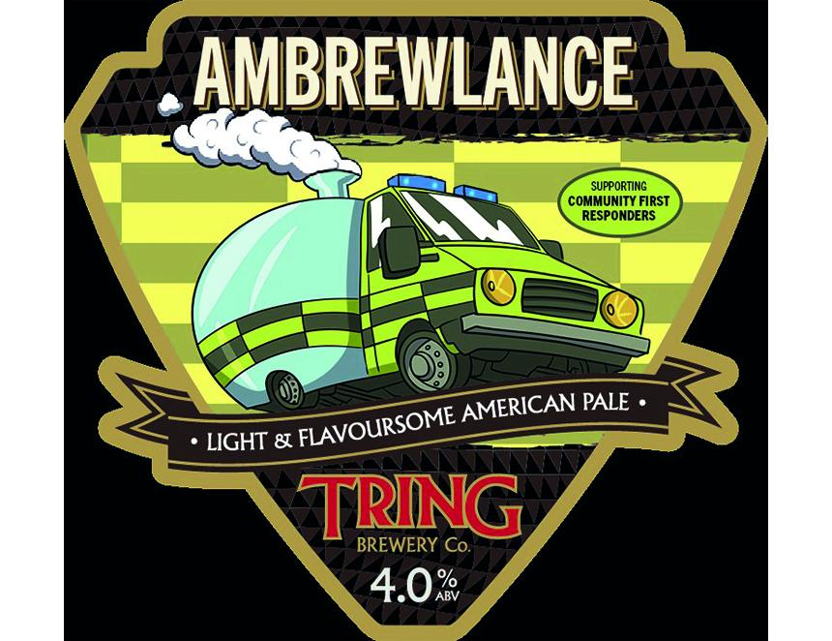

Tring brewery is raising money and awareness for Berkhamsted and District Community First Responders throughout 2026. The Community First Responders (CFRs) scheme was established in 1994, training volunteers to attend emergency calls, offering life-saving care in the vital minutes before an ambulance crew arrives. Tring will be joining forces with its local branch Berkhamsted and District, which was established in 1998 and is trained by the East of England Ambulance Service NHS Trust (EEAST). Tring will produce monthly special beers to raise awareness for the group and plans to host fundraising events throughout the year. Each monthly beer will enjoy namesake and imagery inspired by health services finished with a roundel that has been based on the local branch. Beers set to feature include Shock Horror brewed for Halloween and a quaffable Christmas tipple titled Holly and The IV. Covering Tring, Northchurch, Berkhamsted and surrounding villages the group’s CFRs are on call for an average of 15-20 hours a week answering an average of one call during that time. Aiming to provide support 365 days a year, volunteers also work to raise funds for the cause and offer defib/first aid courses to groups in the area. Group spokesperson Peter Bryant said: “We are delighted and grateful Tring brewery has chosen to partner with us. “Its support will significantly improve our ability to have more of our volunteers on call more often affording vital early medical assistance. This partnership is a brilliant example of a key local business brewing up something special for the community. “The East of England Ambulance Service Charity relies on the generosity of supporters to go above and beyond what NHS funding can provide. “Funds generated through the partnership could go towards vital emergency response kits equipped with monitoring and treatment equipment, defibrillators, as well as communication and navigation devices. “Donations to the charity help to care for volunteers, staff, patients, and communities across the east of England, enabling vital work that simply wouldn’t happen without the backing of public fundraising.” Tring communications manager Jared Ward said: “The team is thrilled to partner with our local CFR group, supporting volunteers who are quite literally lifesaving. “Talks with the group were established through local CFRs who just so happened to be patrons of the brewery. This community crossover has set a strong foundation for efforts to come. We can’t wait to start championing Berkhamsted and District CFR group.”

