NI pubs need more help with business rates
24/01/2026 by WB Reporter
Campaign

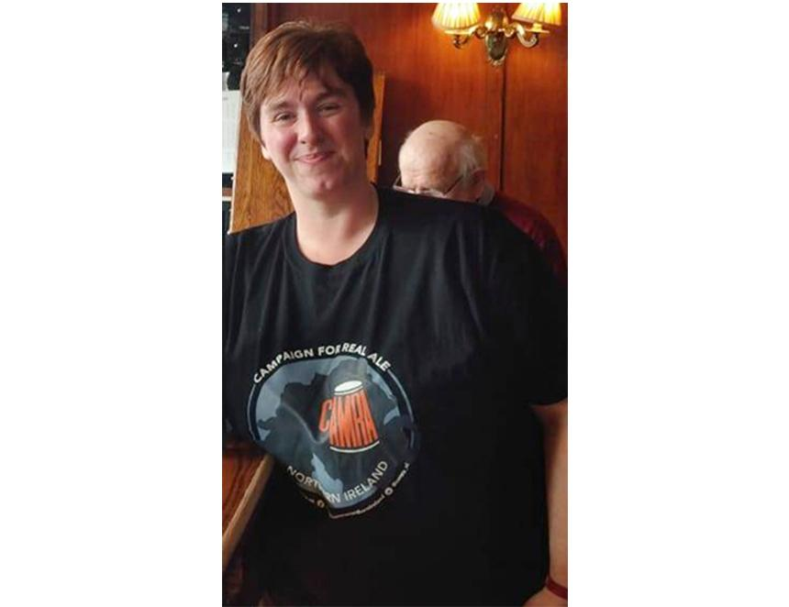

CAMRA is calling on the Northern Ireland executive to provide support with rising business rates to help save pubs which are a “force for good” in society. The Campaign said Northern Ireland can’t afford to see existing pubs close as outdated licensing laws and the surrender principle means a closing local’s alcohol licence is usually transferred to a supermarket or off-licence instead of being used to open a replacement. The price of a pint may also have to increase to cover the extra costs, said the Campaign. The recent revaluation list from Land and Property Services suggested pubs will face big hikes in the business tax from 1 April 2026, with a 47 per cent increase in total valuations. In recent weeks governments in other parts of the UK have been forced into offering extra help with rising business rate bills to prevent hundreds of otherwise viable pub businesses being forced to close. An announcement from the UK Treasury on extra support for pubs with business rates is expected in the coming days, which may release extra funding for the Executive which must be used to help support local pubs. CAMRA NI director Ruth Sloan (above) said: “It is almost impossible to open a new pub in this country because of our ridiculous, archaic alcohol-licensing system. The very last thing we need is the pubs we already have to be forced to close due to a huge hike in business rates which they can’t afford. “Ministers need to recognise that pubs are a force for good in society and deserve support so they can survive and thrive. Not only are they a safe place to enjoy a pint rather than drinking cheap supermarket booze at home, but they create jobs, support local economies and are vital community hubs bringing people together to tackle loneliness and social isolation. “At a time when costs like alcohol duties, employers’ National Insurance contributions and energy bills are still rising, a big hike in business rates bills is the last thing our pubs need. The price of a pint is already far too high here due to our outdated licensing system and customers can’t afford any extra rises to cover these business rates hikes. “The UK government has been forced into a U-turn to provide more help with business rates for pubs in England. The executive needs to do the same to make sure that this revaluation doesn’t lead to the loss of more pubs here.”

