Beerex celebrates branch birthday
22/01/2026 by Timothy Hampson
Campaign

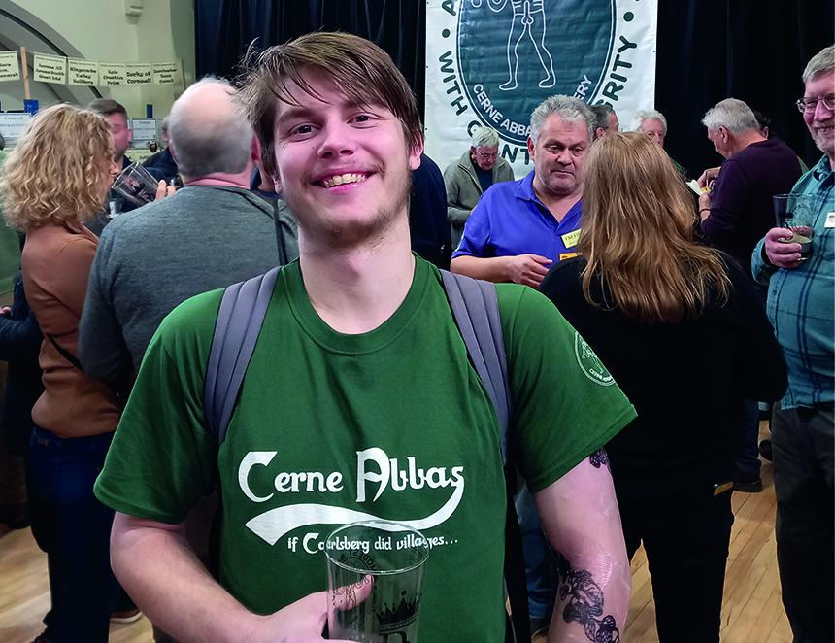

Dorchester’s sell-out Beerex is back in the town’s Corn Exchange and this year celebrates the local CAMRA branch’s 50th birthday. The event is organised by the Campaign’s West Dorset branch and Dorchester Casterbridge Rotary Club over the 6-7 February weekend. To coincide with the branch’s 50th anniversary year, Dorset brewers have been busy brewing one-off celebratory ales that will feature among the 84 cask beers alongside more than 20 traditional ciders and perries. Cerne Abbas brewery is back for the fifth time as the 2026 main sponsor and will be providing a selection of its beers alongside some special brews including Gurt 50th, a rich, dark winter warmer in celebration of West Dorset CAMRA and Ale To The Chief in memory of Victor Irvine (Vic) original partner and brewer at Cerne Abbas brewery. Other beer highlights will be Copper Street brewery’s potent Dorchester Imperial Stout celebrating West Dorset CAMRA and Be Victorious in memory of Vic Irvine. Palmers will be supplying its 5.3 per cent ABV Celebration Ale to celebrate the branch milestone as well as Small Paul’s from Gillingham with 5@50. For cider drinkers there will be a selection of all styles including Dorset producer Isaac from Beaminster with Anti-Gravity, Somerset’s Flash Harry’s Mango and Lime and Dorset Nectar’s Pineapple Lane. From Kent Dudda’s Tun will be providing a blackberry cider while Sussex producer Bignose and Beardy will be supplying a 7 per cent Ugly Dog. Festival committee and branch chairman Bruce Mead said: “Everything is coming along nicely and we can’t wait to welcome you all on the Beerex weekend. Having been to many festivals, I can honestly say that this year’s selection of beer and cider is one of the best I have ever seen – something for everyone.” Alongside promoting some of the best breweries and cider producers in the UK, the festival has always raised money for local causes and 2026’s main charity beneficiary will be People First Dorset (PFD). PFD project worker Kerry Martin said: “I am very happy the beer festival has chosen us as its charity for next year. It means a lot to us and I’m already looking forward to helping out. Please come over and say hello if you see me.” Tickets are now on sale at £12 and include commemorative glass, colour programme with tasting notes plus two free half-pint drink tokens. CAMRA members get an extra free pint. Tickets outlets include: Dorchester: Convivial Rabbit, Copper Street Brewery Tap, Tom Browns. Poundbury: Brace of Butchers. Weymouth: Globe. Or buy online via Beerex.co.uk Pictured: Danny England of event sponsor Cerne Abbas brewery. (Credit Richard Gabe)

