Winter winner to be revealed at Liverpool fest
20/01/2026 by WB Reporter
Campaign

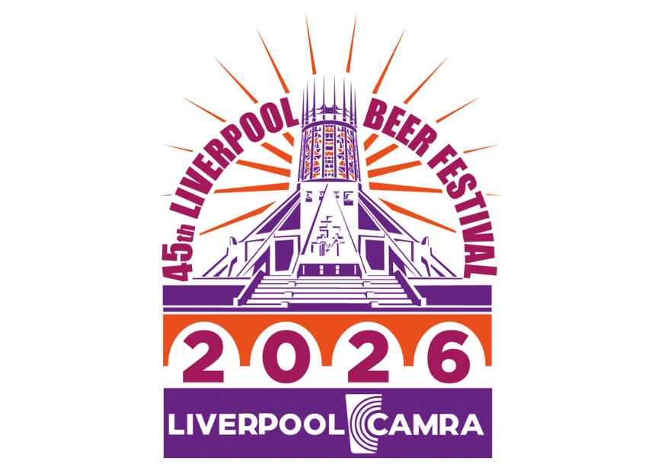

A unique Liverpool Beer Festival returns, hosting the winter stage of CAMRA’s Champion Beer of Britain in the Metropolitan Cathedral Crypt from 19-21 February, CAMRA members who book ahead can get free entry, with prices for non-members from just £4 depending on the session. As the festival hosts the Champion Winter Beer of Britain competition among the 200 cask beers and real ciders on offer, visitors will also have a chance to try some of the very best that the UK has to offer with the 50 shortlisted brews available. Judging for the Champion Winter Beer of Britain takes more than a year starting with local blind-tasting panels and regional heats, with the final round of judging taking place at the festival. The category winners from the winter competition will be entered into the overall Champion Beer of Britain competition later this year. The winner will be announced on the Thursday. There will be a bar offering the competition beers for festivalgoers while stocks last. The overall Champion Beer of Britain is announced in the summer. With both the competition and festival beers on offer, the festival will showcase a formidable range. There will be porters and stouts, brown, red and black ales, old ales, strong milds and speciality beers covering anything from lagers, rye beers, wheat beers, and beers brewed with different yeasts such as Kviek to flavoured beers (plums, coffee, ginger and honey). Starting in 1974, Liverpool Beer Festival is one of CAMRA’s longest running and is just 10 minutes’ walk from Liverpool Lime Street station. There is no entrance charge for CAMRA members but they will need to buy a ticket that includes refundable beer tokens worth £10, programme and glass. Don’t leave it too long as tickets sell out fast. The festival will be open for five separately ticketed sessions: – Thursday 19 February (6-10pm) – Friday 20 February (midday-4pm) – Friday 20 February (6-10pm) – Saturday 21 February (midday-4pm) – Saturday 21 February (6-10pm) – includes entertainment (act to be announced). Wheelchair access is available but contact organisers by email at access@liverpoolbeerfestival.org.uk ahead of the festival to ensure quick and smooth checking in. All tickets include: – an admission charge which varies depending on the session and ticket type. CAMRA tickets have no charge but are limited to one per member per session and visitors need to log on before they can be purchased – £2 for a glass (non-refundable) – £2 for a programme (non-refundable) – £10 in vouchers (refundable in person at the session for which they’re issued). * No ticket refunds will be given so only buy what you can use. No under 18s will be admitted. If you are lucky enough to look under 25 then come with proof of age as you may be asked to produce it at the door. For more information go to: liverpoolbeerfestival.org.uk

