Nut Brown Ale and onion soup
17/01/2026 by Christian Gott
Uncategorised

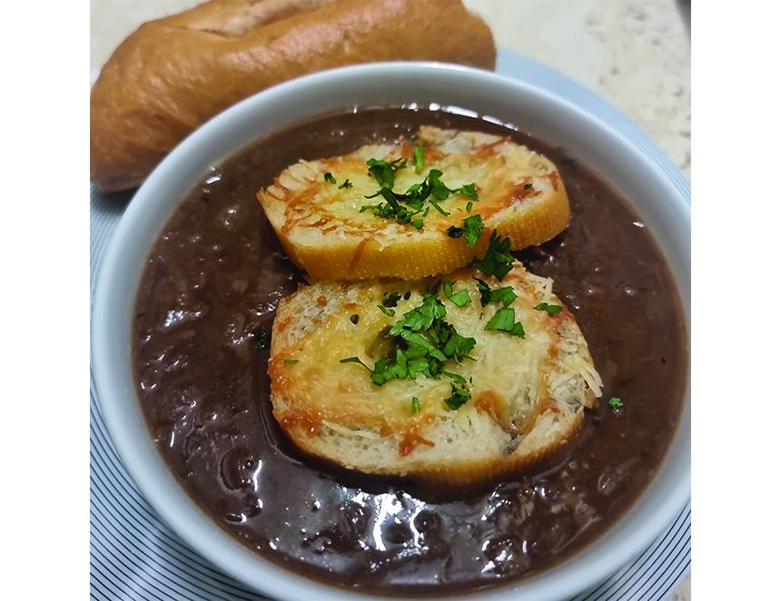

If you regularly read my recipes, you will already know how I think beer is more versatile than wine in adding flavour to dishes and this is a most excellent example. Onion soup dates as far back as the Romans, but the classic dish we see in bistros and restaurants today, topped with a croute or toasted piece of bread and cheese, first originated in 18th-century France. Alexandre Dumas, the celebrated author who created the Three Musketeers and the Count of Monte Cristo also wrote Le Grand Dictionnaire de Cuisine. He noted the dish was introduced to the French royal court by Louis XV’s Polish father-in-law who had enjoyed it while staying at an inn and had asked for the recipe. I like to make my onion soup with brown ale as it is not too dark or bitter. The nutty, toasted, caramel flavours perfectly complement and even enhance the flavours of the onions. It is better than any wine! My personal preference is for the slighter less sweet northern style of brown ale, and my favourite is Samuel Smith’s Nut Brown Ale (5 per cent ABV). Brewed in Tadcaster, using water from the brewery’s own well and yeast, it is top fermented in traditional Yorkshire stone squares. The finished result is packed with aromas of toffee, dark rye bread and with the flavours of almond and walnuts. When you first start preparing the recipe don’t be put off by the amount of onion, as they will cook right down as you start to caramelise them. One of the secrets ingredients in this dish is time, this is not a recipe you can rush as you want to get the onions lovely and brown and, contrary to watching TV chefs make things in minutes, you are going to need at least 45 minutes. The second secret ingredient is a good splash of red wine vinegar to provide some acidity to balance the natural sweetness of the cooked onions. The last key ingredient, apart from the onions and beer, is some good beef stock. The chefs among you might make your own stocks and bone broths but you can buy perfectly good ones now at supermarkets and good butchers. Nut Brown Ale and onion soup 1.5kg large white onions, peeled and finely sliced 12 slices French bread 1ltr good quality beef stock 550ml Nut Brown Ale 100ml olive oil 100g butter 60g plain flour 50g grated Parmesan 50g grated cheddar 1-2tbs red wine vinegar 1/2tsp sea salt 1/2tsp dried thyme 1/4tsp white pepper 1 bay leaf In a large heavy-bottomed pan melt half the butter and when it starts to bubble and turn golden-brown add the flour. Stir and cook the roux over a medium heat until the mix starts to brown. Remove from the heat immediately and empty from the pan. Set aside. Carefully wipe out the pan with kitchen paper and add half the oil, the remaining butter and the onions. Slowly cook the onion, stirring regularly with a wooden spoon to achieve an even, rich brown colour. Make sure you stir across all of the bottom of the pan to prevent burning, Once the onions are a light toffee brown colour, stir in the roux then gradually add the beer and stock stirring continuously. Add the vinegar, herbs, salt and pepper and bring to the boil. Simmer for a further 20 minutes. Check the seasoning and keep warm. To make the cheese croutes place the baguette slices on a baking tray and toast on both sides until lightly golden. Drizzle with the remaining oil and top with a mix of both cheeses. Return to the grill and cook until melted. Ladle the soup into bowls and carefully top with the toasted croutes. You can add more cheese if you want or serve with some in a bowl.

