Conference 2025 motions update
16/01/2026 by Ash Corbett-Collins
Campaign

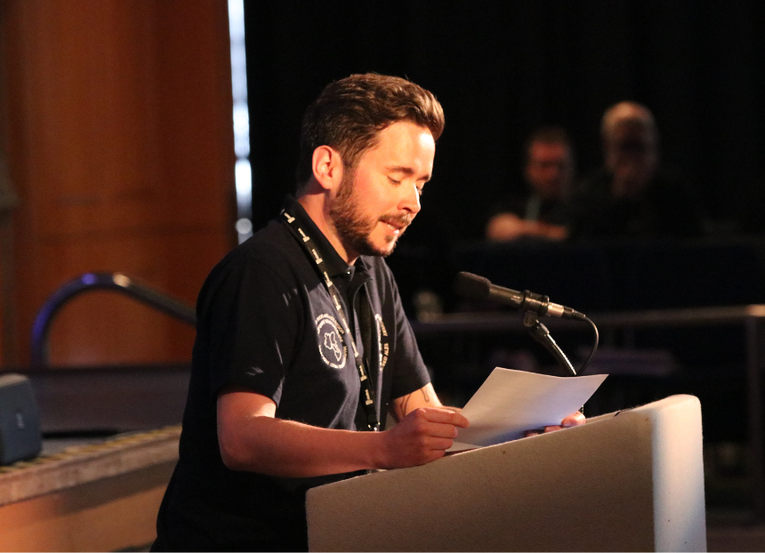

With the 2026 Members’ Weekend fast approaching here’s what’s happened with the motions that were passed and remitted in Torquay. Motion 1 – passed This Conference agrees to adopt the Policy Documents presented for adoption at Conference 2025, subject to any amendments to policy decided at this Conference. Proposed by the National Executive We updated the Policy Documents, approved in Torquay, on the website in May. We’re now consulting on changes to the documents for 2026. Details on the consultation and the current documents are on the website here (login required). Motion 2 – passed This Conference agrees the Annual Membership Subscription rates will increase by £3.50 from 1 July 2025 to the following: single membership (British Isles and Overseas) Direct Debit £34, Non-Direct Debit £36

single concessionary membership (British Isles) Direct Debit £25.50, Non-Direct Debit £27.50

joint membership (British Isles and Overseas) Direct Debit £42, Non-Direct Debit £44

joint concessionary membership (British Isles) Direct Debit £33.50, Non-Direct Debit £35.50. Proposed by the National Executive Changes to membership rates have been implemented. Motion 3 – passed This Conference agrees that UK beer lovers have been badly let down by the lack of leadership and imagination shown by the multinational brewers and large property firms that, between them, control the UK beer trade. Conference therefore instructs the National Executive to ensure that all relevant CAMRA publications and communications pledge preferential support to beer producers and suppliers that are independent of the influence of the multinational brewers, and to make the case persistently for this stance. Proposed by Real Ale, Cider and Perry Campaigns Committee (now called Beer and Cider Campaigns Committee) Beer and Cider Campaigns Committee is working on simple guidance on what we mean by “independent” to help volunteers campaign. We have also worked with SIBA (Society of Independent Brewers and Associates) to flag independent brewers and their beers on the website using the SIBA INDIE BEER mark, and we’re looking at more ways to showcase independent beers, and the pubs that serve them, through the website and our wider communications channels. Motion 4 – passed This Conference instructs the National Executive to establish a self-funding opt-in Beer Group for members, to study and discuss all aspects of beer, viewed from the consumer perspective. The group should be of interest to consumers and the wider beer and pub trade. Proposed by Real Ale, Cider and Perry Campaigns Committee (now called Beer and Cider Campaigns Committee) Beer and Cider Campaigns Committee is working on a proposal and costing for a group. This will need to be assessed against our current budget and, if approved, we expect to recruit volunteers to help. Motion 5 – passed This Conference instructs the National Executive to investigate the logistics and funding of a specialist training course about the nature of beer in all its forms, the structure and ownership of the UK brewing industry and retail beer trade, the nature of real cider, and an introduction to the UK club trade, viewed from the consumer perspective. This should be self-funding and open to all. Proposed by Real Ale, Cider and Perry Campaigns Committee (now called Beer and Cider Campaigns Committee) Beer and Cider Campaigns Committee has worked on an outline proposal, but with the current financial situation and recent staff restructure, this needs to be assessed against current budgets and capacity before more work takes place. Motion 6 – passed This Conference instructs branches to use the National Beer Scoring System as a significant factor when determining which pubs are considered for inclusion in the Good Beer Guide, from the 2027 edition onwards. Proposed by Commercial Committee Commercial Committee has developed the 2027 guide selection guidance and asked Beer Scoring Advisory Group to develop an example process for using beer scores as part of a Good Beer Guide selection. Those were published in November 2025 and are on the website here (login required). Motion 8 – remitted This Conference agrees the National Executive should take steps to ensure complaints and disciplinary processes and procedures, as well as the Code of Conduct, are clear and easily accessible to all members. The distinction between complaints and disciplinary matters must be clarified, particularly at what stage a complaint might become a disciplinary matter that needs escalating. At all times Branches and Regions to have autonomy and authority, with Regional Director (RD) guidance, to deal with issues locally in the first instance and determine whether and when a complaint needs to be escalated. Branches and Regions to be empowered to impose commensurate penalties at a local level, but within strict guidelines, and as agreed with RD. Proposed by Bradford Branch Member and Volunteer Experience Committee has set up a Disciplinary Review Group to look at our complaints and disciplinary processes, including the Member Code of Conduct. That includes reviewing our current suite of documentation and engaging with members through a branch survey. An outline proposal for online training has been put together and has initial approval from Member and Volunteer Experience Committee. The group’s work continues and we will provide more updates when appropriate. Motion 9 – remitted This Conference instructs the National Executive to publish the final submissions for all National, Regional and Branch festival business plans, with confirmation as to whether these were approved or rejected (with reasons provided where appropriate), on an appropriate part of the CAMRA website accessible to members. Proposed by Bradford Branch After discussion, Events Committee has decided that we will not publish full business plans for festivals, due to commercial sensitivity. Festival organisers and RDs will always be told when business plans are approved or given reasons for rejection. Template plans covering different sizes/types of festival are in development so that volunteers can see examples of what a good business plan looks like. Members’ Weekend 2026 Want to join us in St Albans in April? Members’ Weekend takes place at the Alban Arena and across the city from Friday 17 to Sunday 19 April. Registration is open now and is free for members to attend. More details and registration here. Got a motion you want to take to Conference? Submit it for consideration before Friday 13 February here. Pictured: CAMRA chairman Ash Corbett-Collins at Torquay

