Bostin’ six-year pub tour!
15/01/2026 by Laura Hadland
Campaign

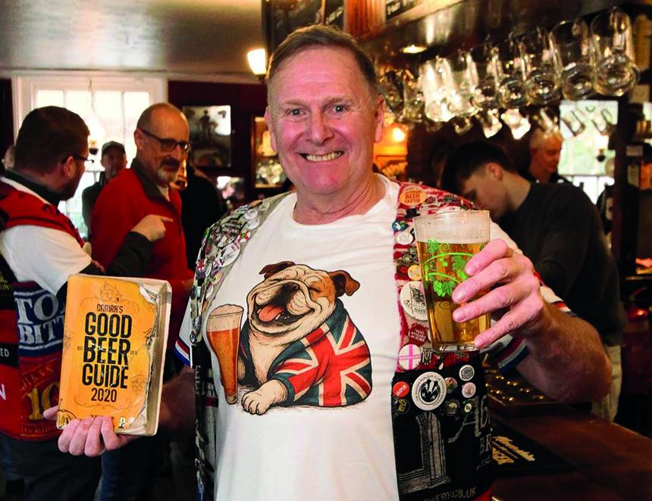

Veteran pubgoer Peter Hill is celebrating the completion of an epic journey to visit all the 4,429 pubs in the 2020 Good Beer Guide this week. Peter, an active member of Dudley and South Staffordshire CAMRA since 1990, began his pub extravaganza when the GBG 2020 was launched in late 2019. Now, just over six years later, he is winding up the adventure with a pint of one of his favourite beers – Oakham Citra – in his final pub tick, the Mermaid in St Albans. “What an achievement!” said Oakham Ales off trade and marketing manager, Nick Jones, who gave Peter a Citra T-shirt. “We’re absolutely thrilled that Peter completed his epic tour with a pint of Oakham Citra – a champion achievement celebrated with our champion beer.” Nick’s sentiments were shared by the pub team, licensees John Cusworth and Mark Powell, as well as general manager Grace, who commended Peter’s taste in beer. “We’re thrilled the Mermaid has been chosen as Peter’s final stop on his GBG pub journey – it’s a huge honour,” Grace said. “It feels especially fitting that he’s finishing with his favourite beer, a pint of Oakham Citra, as it’s our best-selling real ale and one we take huge pride in. We can’t think of a better way to celebrate such an extraordinary achievement.” Peter’s travels are self-funded, and he never has less than a half pint in each pub. In each pub he visits, Peter asks licensees to contribute a £1 charity donation. Many have kindly given him more than that and so, across the six-year GBG adventure, Peter has managed to raise more than £7,000 for the West Midlands Air Ambulance. Peter has impressive form when it comes to serial pub ticking. In 1984 he created a group of fellow travellers called the Black Country Ale Tairsters which began visiting and recording pubs. Armed with a map of the 250 Banks’s and Hanson’s pubs and the 1984 edition of the Good Beer Guide, he began making notes about the pubs he visited. Since then, Peter has drunk nearly 58,000 pints in more than 24,000 pubs – the Mermaid was number 24,460. He has travelled 400,000 miles and raised £35,000 for charity. The journey has encompassed the coastline of Great Britain and Northern Ireland, including all 69 islands that have a bar or pub. Peter’s documentary archive of his experiences amounts to 300 lever-arch files which contain 100,000 photos, business cards, menus and other ephemera that he collects from each pub he visits, alongside 26 books of signatures of the licensee or staff member that he diligently collects. But no matter how far they travel, the Tairsters’ adventures have always brought them back to their West Midlands homelands. Their first pub visit was to the Yew Tree at Greets Green in West Bromwich, and they marked their 40th anniversary in 2024 with a visit to the Bottle and Glass at the Black Country Living Museum in Dudley. Dudley and South Staffordshire chairman John Corser said: “The branch is delighted at Peter's achievement. As one of the Black Country Ale Tairsters we were delighted to welcome him as one of the judges at the Dudley Winter Ales Fair in November. He has also helped the branch with driving minibuses on branch outings over many years.”

