Pub-saving superheroes in the spotlight
14/01/2026 by WB Reporter
Campaign

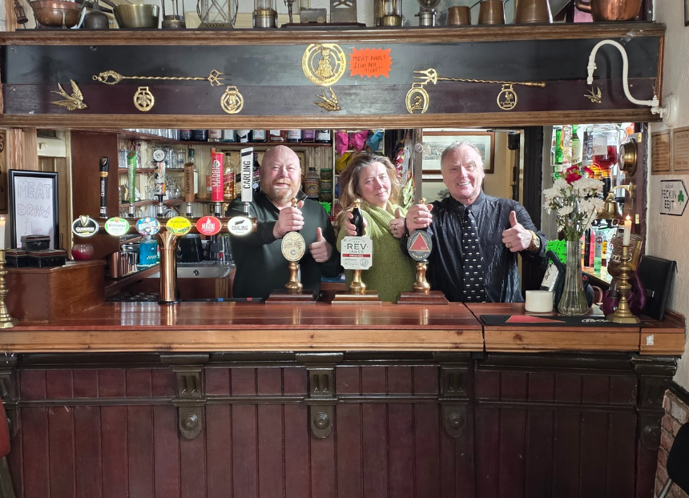

CAMRA has named the Hull Community Pub Society, which saved the New Clarence in Hull, as the first city winner of its Pub Saving Awards 2025. The Campaign also revealed the Victorian Vine (above) in Pittshill, Stoke-on-Trent as the Heritage Award winner. The Pub Saving Award runner-ups were Ashton Hayes Community Hub, which rescued the Golden Lion in Ashton Hayes, Chester and the George Community Pub (Wickham Market) which campaigned for the George in Wickham Market, Suffolk, while the Crown Inn in Stockport was runner-up for the Heritage Award. The Pub Saving Awards celebrate communities which have rallied to fight for their local, and saving the pub from a grim fate of conversion or demolition. The awards put these campaigns in the spotlight aiming to inspire others to investigate community ownership for their local.
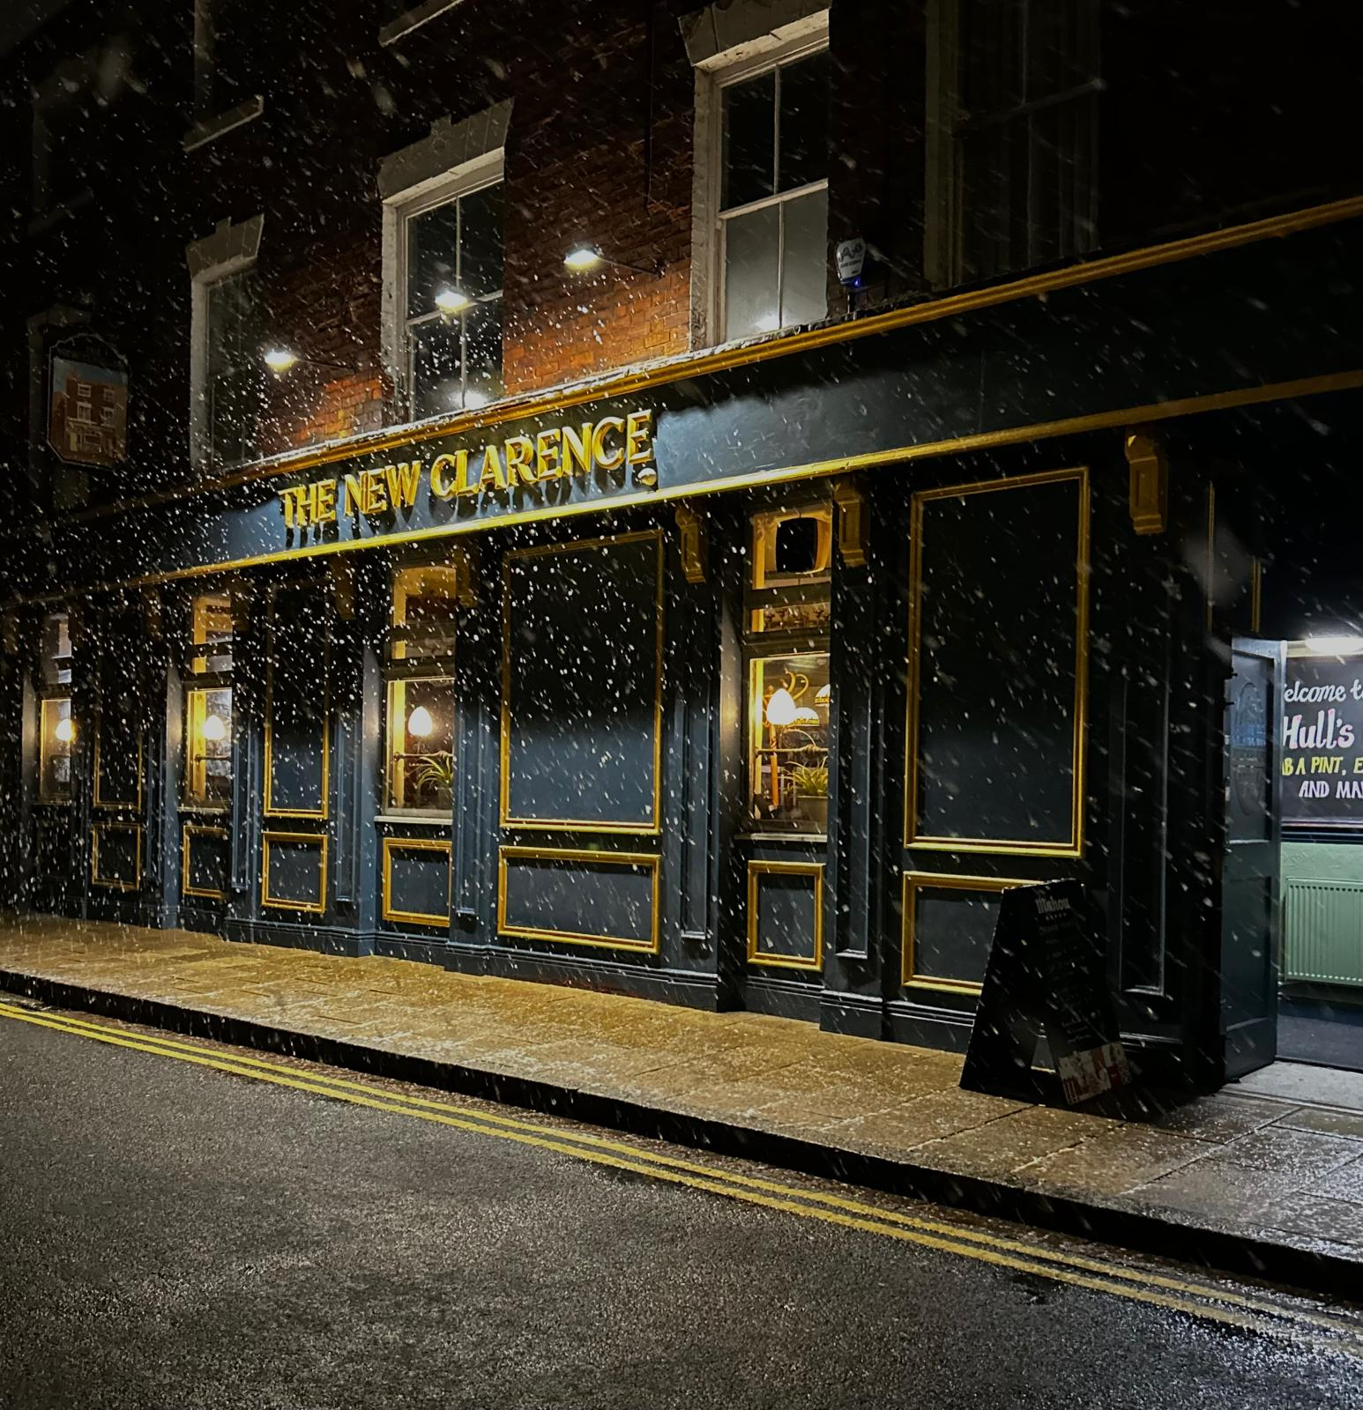
The New Clarence (above) is Hull’s first community-owned pub. The high land value in high streets and city centres makes pubs an enticing target for greedy developers and, as a result, much harder for campaigners to save than their rural counterparts. The judges were impressed with the group’s achievement. After closing in 2023, a developer submitted planning applications to convert the New Clarence to a multiple-occupation house. The Hull Community Pub Society was formed, fighting off the applications and subsequent appeals. It then raised almost £250,000 plus £300,000 from the now discontinued Community Ownership Fund to buy the pub in February 2025. Vital structural work to the roof was needed to make the building safe before opening, plus the kitchen and cellar were rebuilt, accessible toilet installed and beer garden transformed. The New Clarence reopened on 6 September 2025 serving eight cask beers and real ciders. The group is now looking to raise money to bring the function room back in to use and double its size, to give community groups a space to meet and hold events. Society chair Simon Berry said: “We are absolutely delighted and still a bit surprised to have won CAMRA’s Pub Saving Award. The journey to get here has been a very interesting one – occasionally chaotic, often exhausting, but always worth it – and our vision finally became a reality in September when we threw the doors open to everyone. “What’s been truly staggering is just how many people bought shares and got behind the whole concept. The support has been incredible. Without the Community Ownership Fund, our share buyers, generous donations and loyal shareholders, this simply would not have been possible. “Now here we are serving great beer, good wines and proper food, in a pub that’s alive again. And none of it would work without the amazing team running the place day in, day out. It is something special. “Thank you to everyone who believed in it, backed it, and keeps coming through the door. Turns out saving a pub can be a team effort.” Hull and East Yorkshire CAMRA chair Andy Currie added: “Branch members are delighted that the New Clarence has won this award. It is the result of a determined effort from local residents and the wider pub-going community. The innovative approach of offering membership was taken up by a huge number of supporters, many of them CAMRA members, who saw the merits of being part of Hull’s first community-owned pub. In fact, the success of the objection to the proposed conversion of the pub was aided by the terrific support from CAMRA members at the local planning meetings.”
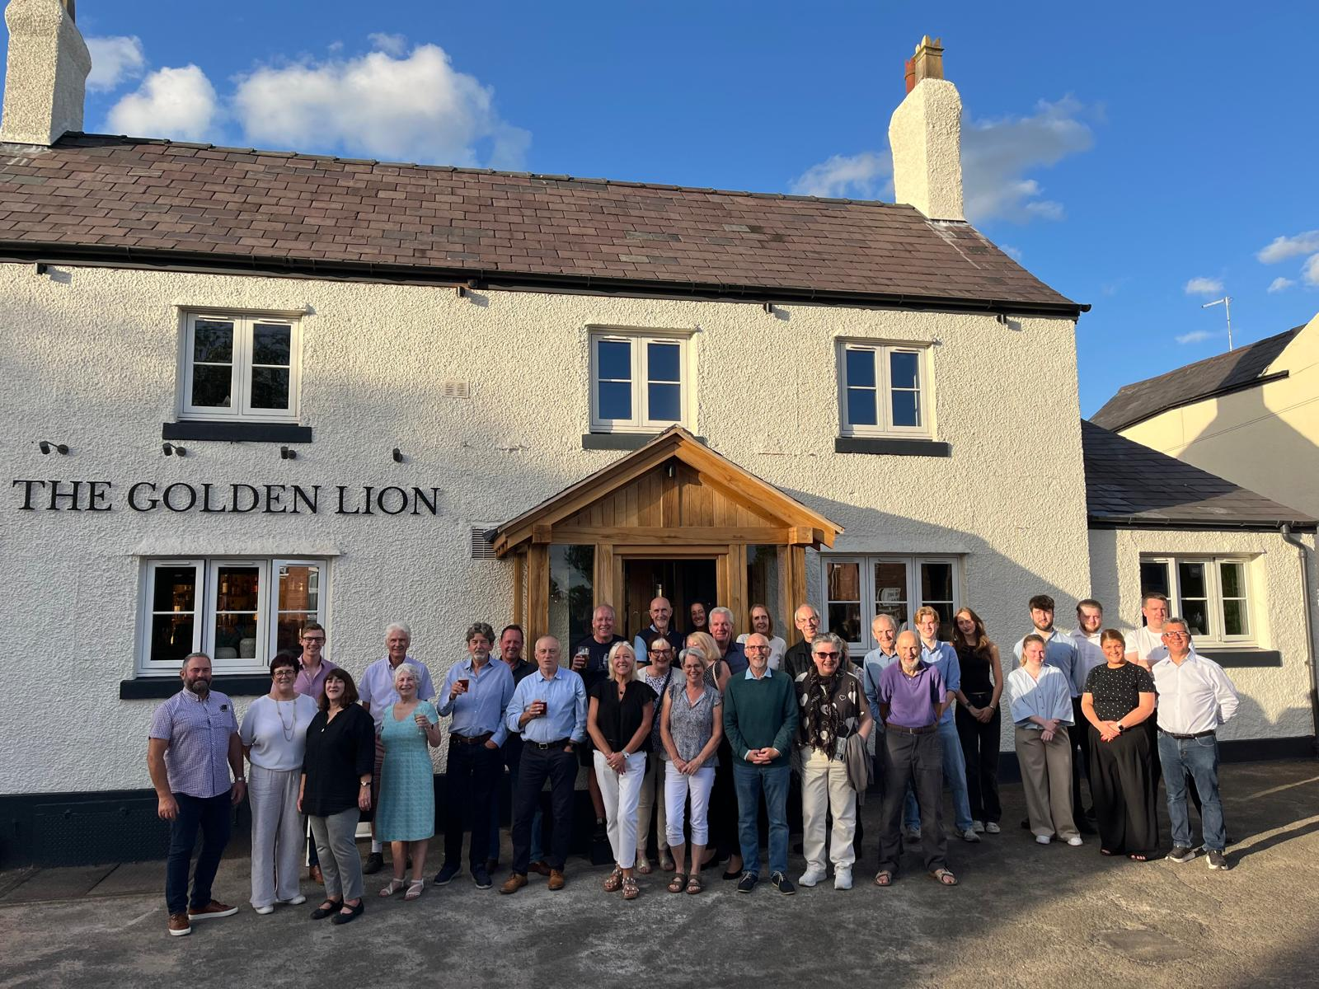
The Ashton Hayes Community Hub (AHCHL), which saved the Golden Lion (above) in Ashton Hayes, Chester is the joint runner-up in the Pub Saving Awards. The only pub in the village of Ashton Hayes was at risk of being turned into housing when the previous owner of the 300-year-old building closed it in early 2013 and neglected the pub for 12 years. The local community applied for the pub to be registered as an Asset of Community Value (ACV) and has spent more than a decade campaigning to save it. By raising almost £250,000 and £360,000 from the Community Ownership Fund, the community completed the purchase in June 2024. The next year was spent undertaking a mammoth renovation of the pub including solar-panel installation and uncovering a hidden cellar. The Golden Lion reopened on 7 August 2025 and is once again the centre of the village. AHCHL chair Hugo Deynem said: “This recognition reflects the collective commitment, hard work and determination shown by everyone involved in preserving the Golden Lion as a valued community asset. The pub now continues to serve as a social hub, supporting local life and bringing people together.” Golden Lion tenant Lance Warburton added: “I feel truly honoured to be part of such a committed and supportive community and to play a role in ensuring the pub remains a welcoming place at the heart of village life.” West Cheshire CAMRA branch chair Brian Vardy said: “The Ashton Hayes Community Hub has worked very hard for a long time to save the Golden Lion. The owner had closed the pub and was trying to demolish it. The group obtained an Asset of Community Value and campaigned to have the pub reopened. It raised the finance, bought the pub and renovated it, creating an excellent community local for the village. This was a tremendous achievement and the recognition by CAMRA is well deserved."
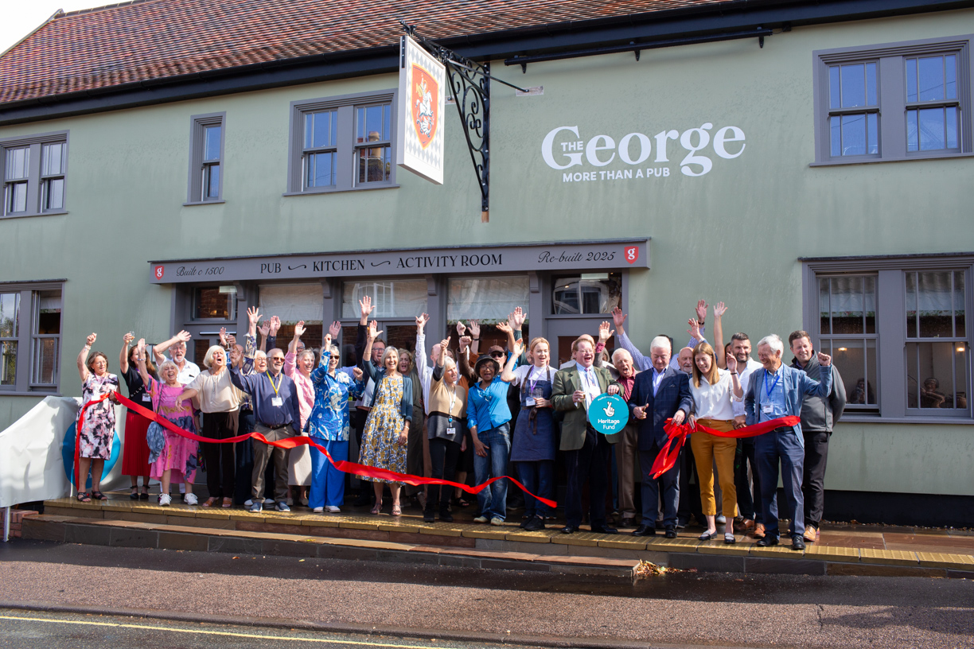
The George Community Pub (Wickham Market) which saved the George (above, photo by Alex Seinet) in Wickham Market, Suffolk was the other runner-up. The last remaining pub in the village, the George is a 500-year-old Grade II-listed pub which was badly damaged by fire in 2013. The burnt-out pub was in danger of being demolished by a developer, which triggered an epic 12-year campaign to restore and reopen it as a community-owned pub. Funding came from 450 shareholders who invested more than £400,000, £1.5m from the Lottery Heritage Fund alongside other grants including one from the Community Ownership Fund, meant the restoration project was given the go-ahead in July 2023. The pub reopened on 7 June 2025 and has been fully modernised yet retains character from the original building. The local community describe the George as “more than a pub”, with it now hosting multiple social, educational and cultural activities to promote wellbeing and combat loneliness and isolation, such as dementia cafes and toddler groups. Pub manager Edward Leigh said: “We would like to thank CAMRA for this award and recognition. Reopening pubs in this climate is a very challenging undertaking and their backing is incredibly valuable. We are lucky to have fantastic support from our local community and look forward to many years of happy trading.” CAMRA East Anglia regional director Andrea Briers said: “This was a long campaign and it shows what hard work and determination of a community can achieve. Well done to those involved in saving the George and I hope it will now be there for everyone to enjoy for years to come.” Ipswich and East Suffolk CAMRA branch chairman Gordon Taylor said: “This is a fantastic achievement and worthy of recognition for all involved with getting the George up and running again, as a successful community pub. I remember attending a launch event at the village hall a few years back and it was clear then that the enthusiasm was there. I look forward to visiting.”
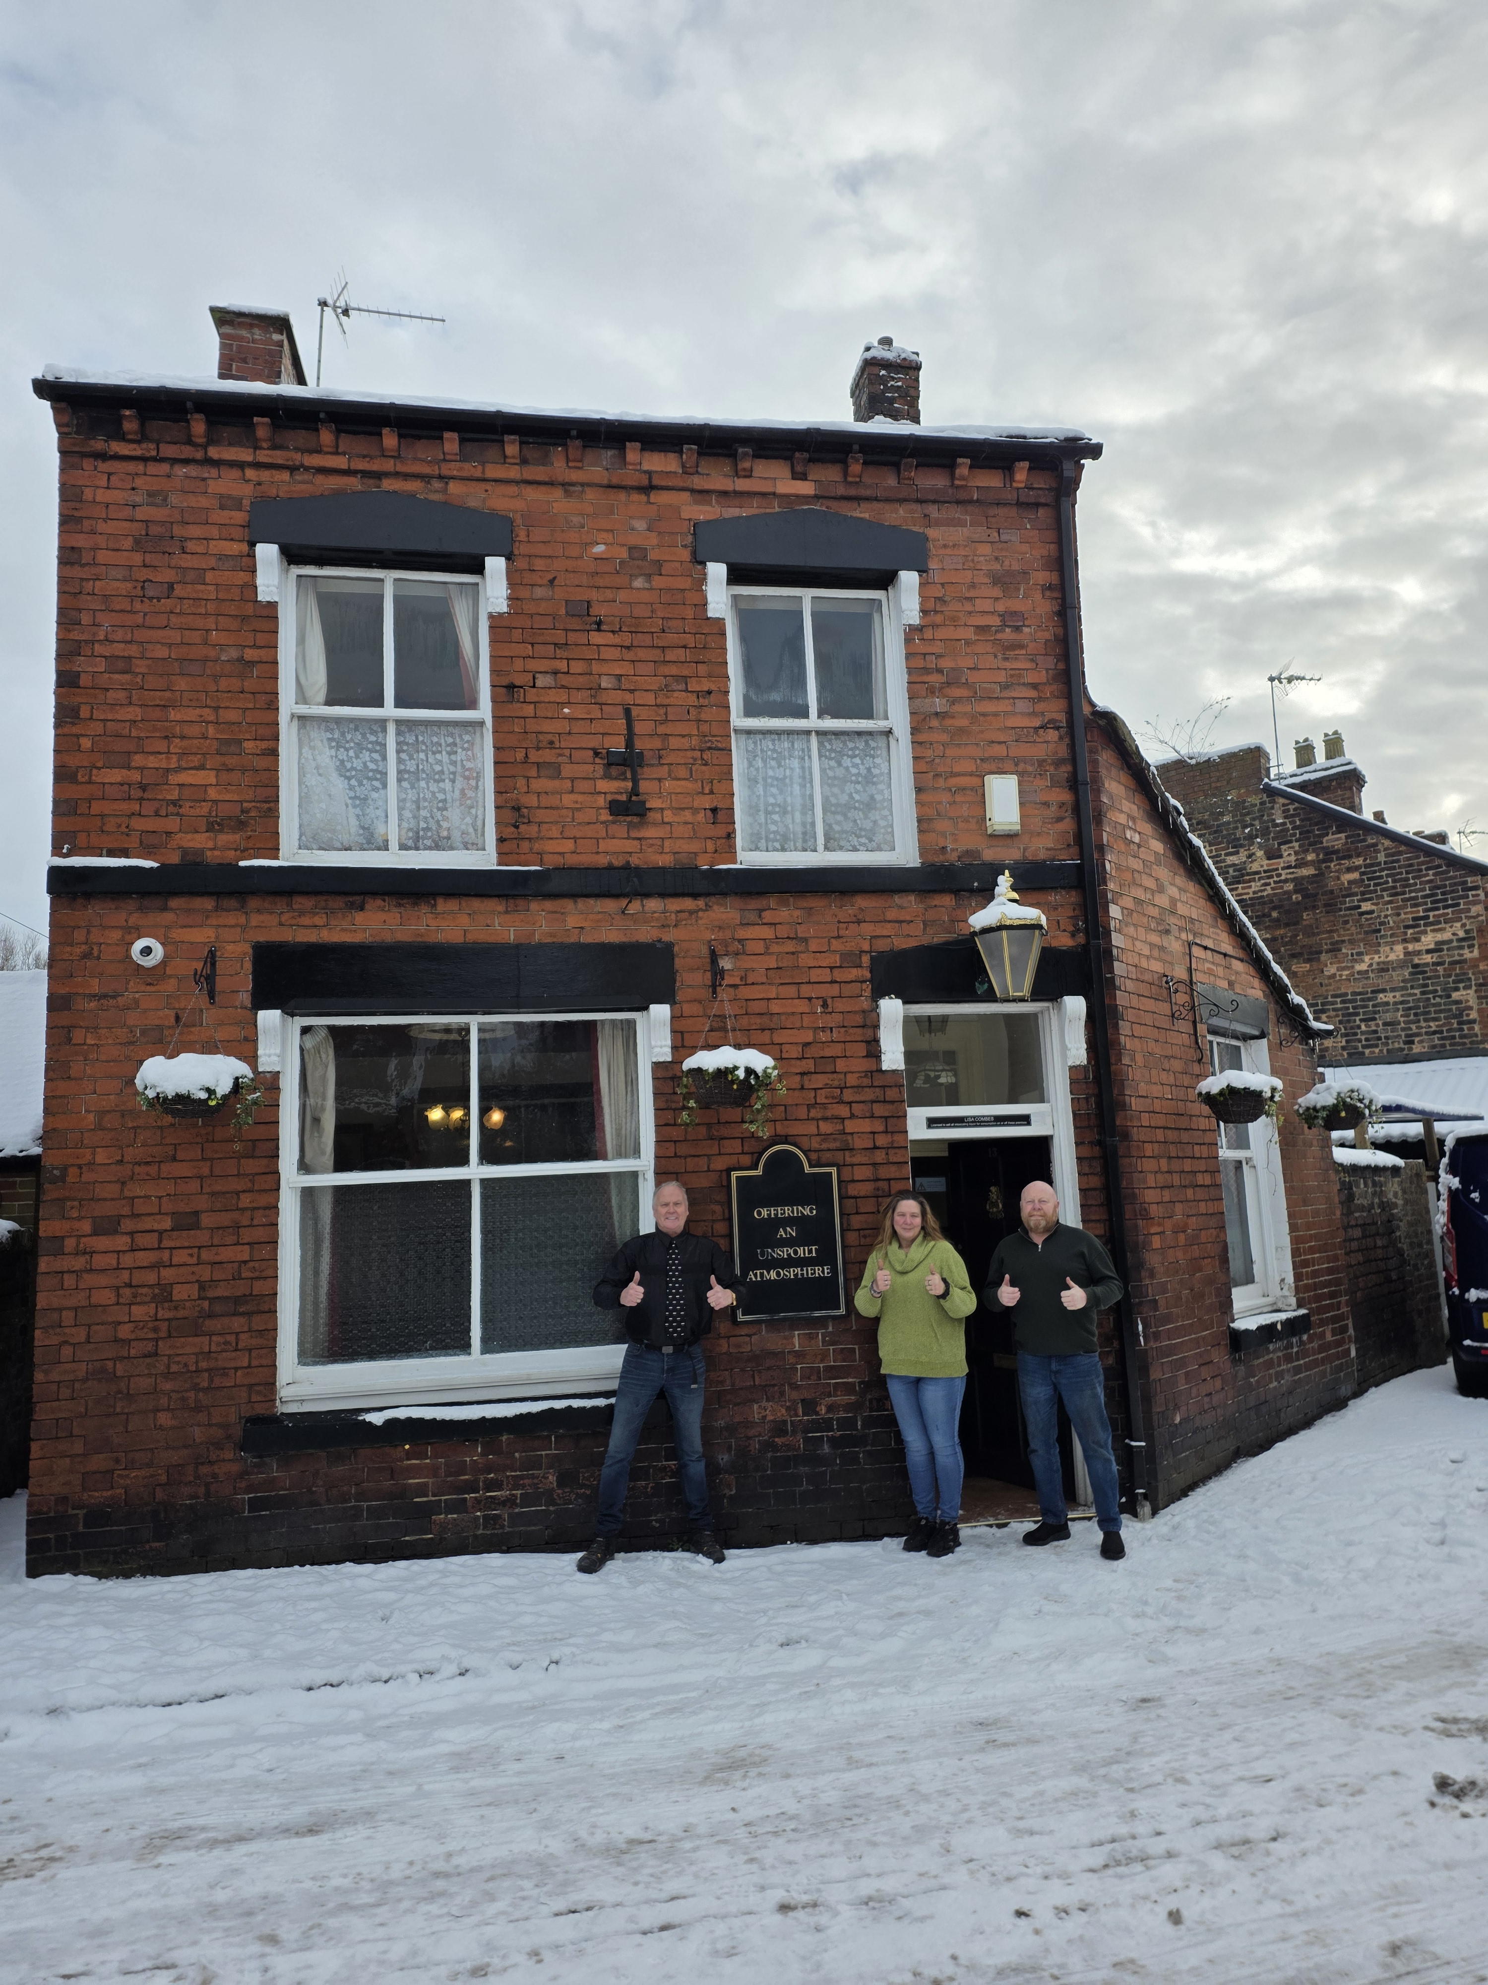
Steve Burke and Lisa Combes, owners of the Vine (above, from left, Steve Burke, Lisa Combes, David Oakley) in Pittshill, Stoke-on-Trent are the Heritage Award 2025 winners. From grand Edwardian gin palaces to preserved inter-war gems, the Heritage Award is open to all pubs on CAMRA’s National Inventory of Historic Pub Interiors. To promote and preserve the interiors of historic pubs, the award highlights people that have saved or have carefully revived a heritage pub. The Vine is a perfect example of a back-street, Victorian local, hidden away in the terraced streets of Tunstall, with an interior of outstanding national historic importance. The Grade II-listed pub showcases classic features such as a partly glazed, partition wall, off-sales hatch with an intact rising sash window and a 1950s tiled fireplace. However, the pub’s doors closed during the covid pandemic, following the passing of the previous owner, leaving the community fearing this historic local might be lost for good. In 2025, self-confessed cask beer fanatic Steve Burke of Interplan Investments, with his business associates and his partner Lisa Combes, bought the Vine at auction with the clear aim of bringing the pub back to its former glory while respecting its heritage. The team carried out significant repair work, renovating and restoring the roof, basement and beer yard. Taking care to protect its original character, the layout of the pub has been preserved to keep the small rooms and snug as they have been for many years. Steve Burke said: “We are truly honoured to receive this recognition. Reopening and restoring our listed pub has been a labour of love, made possible by the incredible support of our local community. This award belongs as much to them as it does to us, and we are proud to see the pub recognised as a living part of our community once again.” Potteries CAMRA branch chairman Andy Parkin added: “We are extremely pleased for the team at the Vine, which has done what it set out to do ‘be a pub of the community, that encourages them to want to keep coming in’. In October it won a deserved merit award from the branch in our Pub of the Year 2025 members’ vote. I am sure the Vine will continue to do extremely well.”
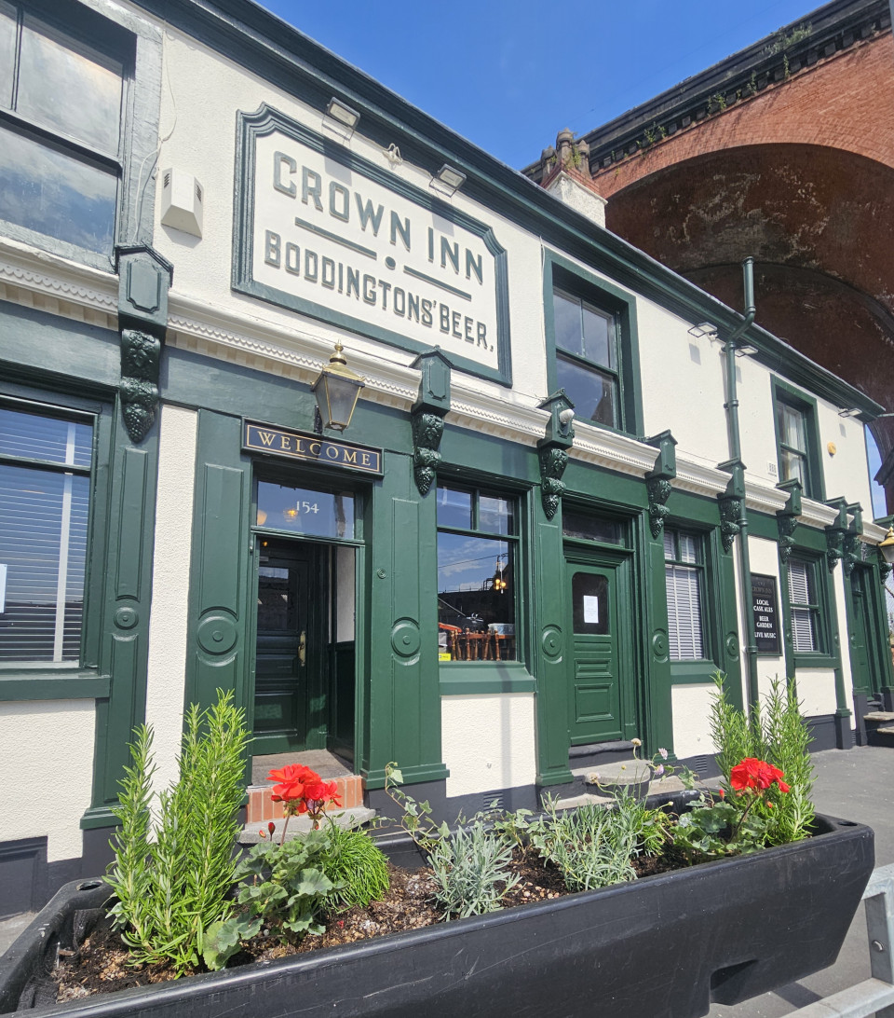
Alan and Chris Gent, owners of the Crown Inn in Stockport, are the Heritage Award runners-up. In the shadow of a railway viaduct, the Crown Inn is one of the oldest free houses in Greater Manchester and has an interior of special national historic interest. Following years of decline with churning managers, unsympathetic redecorations and lack of respect for the pub’s historic furnishings, the Crown Inn closed at the beginning of 2025. Despite having a history of CAMRA awards, Stockport locals were now worried about the pub’s future. The lease was taken on by Alan and Chris Gent of the award-winning Petersgate Tap along with pub manager Amy Barker who, as soon as they received the keys in July 2025, embarked on refurbishing both the interior and exterior of the rundown Crown, breathing new life into the pub, yet respecting its history. The etched window panels and the historic feature mirror were repaired, the glazed tilework and fireplaces were restored and the exterior repainted. The Crown Inn reopened in August 2025 and is once again a real asset to Stockport's pub and beer scene, delighting locals with a range of eight cask beers from independent brewers. Chris Gent said: “We wanted to restore the Crown Inn to how it was when it was one of the busiest, most thriving pubs in Stockport. Nice people and great beer in a timeless pub environment.” Stockport and South Manchester CAMRA branch chair John Clarke, added: “We were delighted when this iconic pub reopened after much hard work by the new team. It’s a very overused phrase, but a huge amount of hard work really has seen the pub restored to its former glory – and not only in its appearance but also its beer range too. The fact that the Crown is now regularly packed shows how much Stockport’s beer drinkers also appreciate what has been done here.” Pub Saving Award coordinator Paul Ainsworth said: “These community champions and heritage heroes deserve to be applauded. I continue to be amazed by the dedication and grit of these campaigners, who spend years or even decades campaigning to save pubs. “However, if we want more communities to be able to do this, they need support from government. The Community Ownership Fund provided cash for groups to take ownership and the running of community facilities that would otherwise be sold, converted or demolished. This was wound up by the government and has not been directly replaced. The forthcoming Right to Buy scheme must come alongside a dedicated programme of advice, guidance and funding to make sure community pubs go from strength to strength.” Main photo left to right: David Oakley, Lisa Combes and Steve Burke

