‘Disastrous’ Budget will force Scottish pubs to close
13/01/2026 by WB Reporter
Campaign

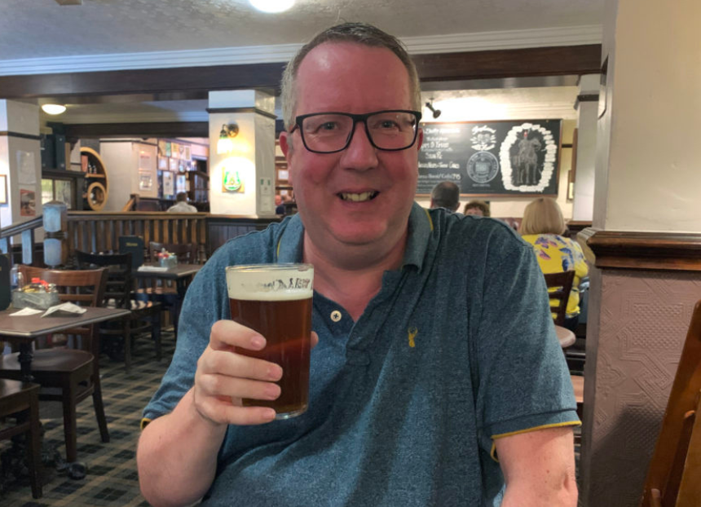

Following the Scottish government’s Budget statement which slashed the 40 per cent discount on pubs’ business rates at the same time as a revaluation, director of CAMRA Scotland Stuart McMahon (pictured) said: “Pubgoers and publicans simply won’t stand for a Budget which will force more of our locals to go to the wall by landing them with bills they simply can’t afford. “I fear that slashing the 40 per cent discount on business rates bills for pubs to just 15 per cent at the same time as these bills are increasing will be absolutely disastrous. “Transitional reliefs may sound good but if this Budget still means higher business rates bills than pubs are paying now then this will be the straw that breaks the camel’s back for many hard-pressed licensees. Pubs need permanently lower business rates bills so that they can survive, thrive and play their part as vital community hubs.”

