Do you have what it takes?
12/01/2026 by Ash Corbett-Collins
Campaign

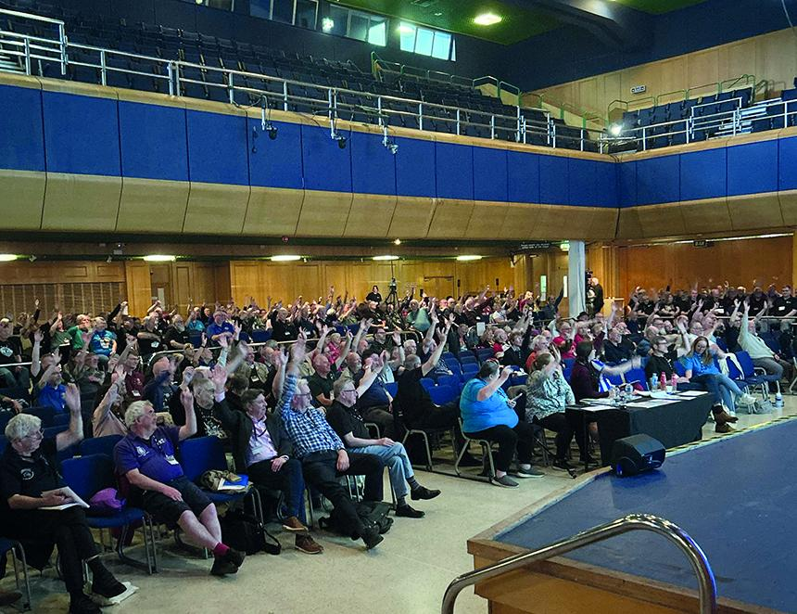

I want us to be the best Campaign we can be. I say this a lot, but it’s because it’s really important. It’s why I wanted to be your chairman, and it’s why I stood for the National Executive in the first place. To ensure a freshness of ideas and enthusiasm, every year we elect at least a quarter of our board. So, every year, we need new people to consider if they have the right skills and drive to bring to the table. 2025 was a year of tough decisions from us, your National Executive. It really brought home how vital it is to have a strong team of directors working together to achieve our goals. Our team of directors needs to be strong, diverse and bold. That means a mixed set of skills and confidence to make the decisions that we need to grow and campaign effectively. And most important, it means a team that can look past the short term and shape plans that secure our long-term future plus give the best outcomes for our wider membership. I’ve been on the board now for almost eight years and chairman for just over a year. In that time I’ve been able to use my skills, my experience, and my passion to make the Campaign stronger and more effective. I’ve spent time with members and pubgoers across the country learning what matters to them and listening to how CAMRA can support them to keep pubs and breweries open. I’ve met countless people I otherwise never would have that I can now call my friends. For me, being a director has been an amazing experience. So please, consider if you have what it takes. You don’t need to have been a member for a long time and you don’t need to have held a prominent role before. This might be your first step in getting involved with CAMRA. Or you could be a long-standing member and volunteer and you want to use your experience in a new way. Everyone with the skills and drive should think about putting themselves forward. I have aways said one of our Campaign’s biggest strengths is that we have a democratically elected board made up of our own members, rather than appointed trustees. You get to choose our board, and I want as many people as possible to use that opportunity. Standing for election isn’t for everyone and if it isn’t for you, please still vote in the election. Voting is a campaigning action in itself and means we elect a board that represents our interests and makes us a better Campaign. Ash Corbett-Collins CAMRA chairman Find out more about the election, the role of a CAMRA director and how to submit a nomination to stand for election here: members.camra.org.uk/national-executive-election The deadline to submit nominations is 3pm, Friday 13 February 2026.

