PM must listen to revolt on rates hikes for pubs
09/01/2026 by WB Reporter
Campaign

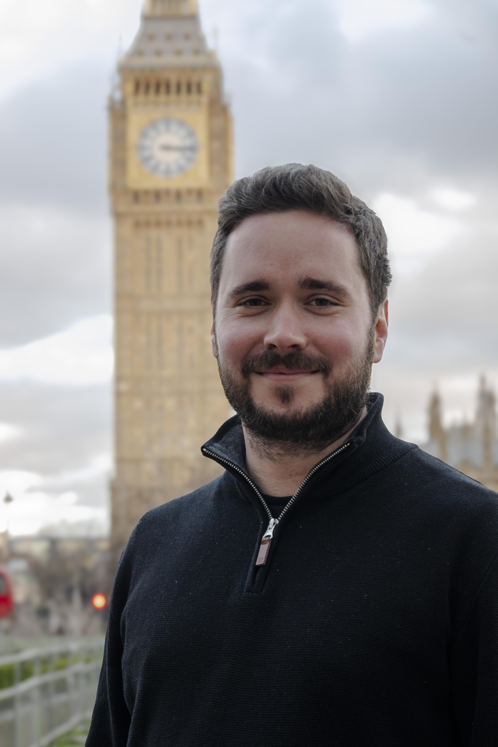

CAMRA is calling on the prime minister to rethink business rates hikes for pubs in England due to come into force on 1 April. The demand comes after a cabinet revolt on the rises was reported earlier this week and the hikes were a key theme of prime minister’s questions. Responding to a question from Labour MP Rachel Maskell, Sir Keir Starmer said the government was looking at what “further support and action” could be provided to struggling beer and pub businesses. CAMRA said pubgoers were demanding action from government and the Valuation Office Agency to avoid thousands of additional pub closures in 2026. CAMRA chairman Ash Corbett-Collins said: “Instead of months of uncertainty and the prospect of thousands of otherwise viable pubs having to close their doors for good, the prime minister and chancellor should give in to pressure, accept the inevitable and announce a rethink now. “Whether through cock-up or conspiracy the government’s promise of permanently lower business rates for pubs hasn’t happened. Instead, publicans are facing higher bills from April, which they simply can’t afford. “Pubs are a force for good in communities across the country, bringing people together and helping to tackle loneliness. But they can only survive if ministers think again about these business rates increases and come up with a plan that will save our locals.” Responding to reports that the government is set to change course and provide extra support with business rates bills for pubs in England, Ash said: “Doing nothing and letting pubs go to the wall was never going to be tolerated by pubgoers, publicans or MPs. The government must urgently end the uncertainty and announce the extra help and permanently lower bills our locals were promised and need to survive and thrive.”

