Campaign website makes it even easier to find indie beer
08/01/2026 by WB Reporter
Campaign

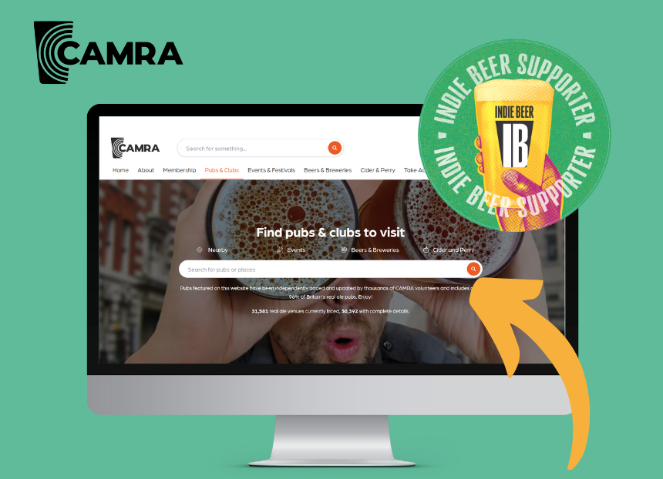

Beer drinkers can now quickly spot which breweries are independent and which pubs serve indie beer, thanks to the addition of SIBA’s INDIE BEER mark across the CAMRA website. The INDIE BEER campaign, launched by the Society of Independent Brewers and Associates (SIBA), is designed to help drinkers know who brews their beer. Research commissioned by SIBA found three-quarters of people felt the marketing of previously independent brands now in the ownership of global brewers is misleading. To combat this the campaign offers a simple brewery checker tool and an “assured” mark independent brewers can use. CAMRA chairman Ash Corbett-Collins said: “Independent breweries are the lifeblood of our beer culture, bringing flavour, variety and character to pubs and communities across the UK. That’s why CAMRA is thrilled to strengthen its support of SIBA’s INDIE BEER campaign. “Unfortunately, global brewers often market their own brands as if they were independent. They limit market access for independents, cutting consumer choice, and that’s why this campaign matters. It is vital that consumers have access to information about where their beer is being brewed, and whether it’s in independent ownership. "Next time you’re at the bar, look out for the logo and enjoy discovering something truly independent.” Indie Beer campaign spokesperson Neil Walker said: “I’d like to thank CAMRA for its continued support of the Indie Beer campaign, which continues to go from strength to strength and is now fully integrated into its website, making it even easier to find out which breweries are indie. “The demand for independent beer has never been stronger, but too many people are still being tricked by global brands masquerading as ‘craft’ – so look out for the INDIE BEER mark and you can be sure the beer you’re buying is from a genuine independent brewery.” Information about INDIE BEER, including SIBA’s brewery checker can be found here: indiebeer.uk CAMRA’s brewery and pub searches can be found at: camra.org.uk/breweries and: camra.org.uk/pubs

