Maxim makes six for Monkey group
05/01/2026 by Timothy Hampson
Industry

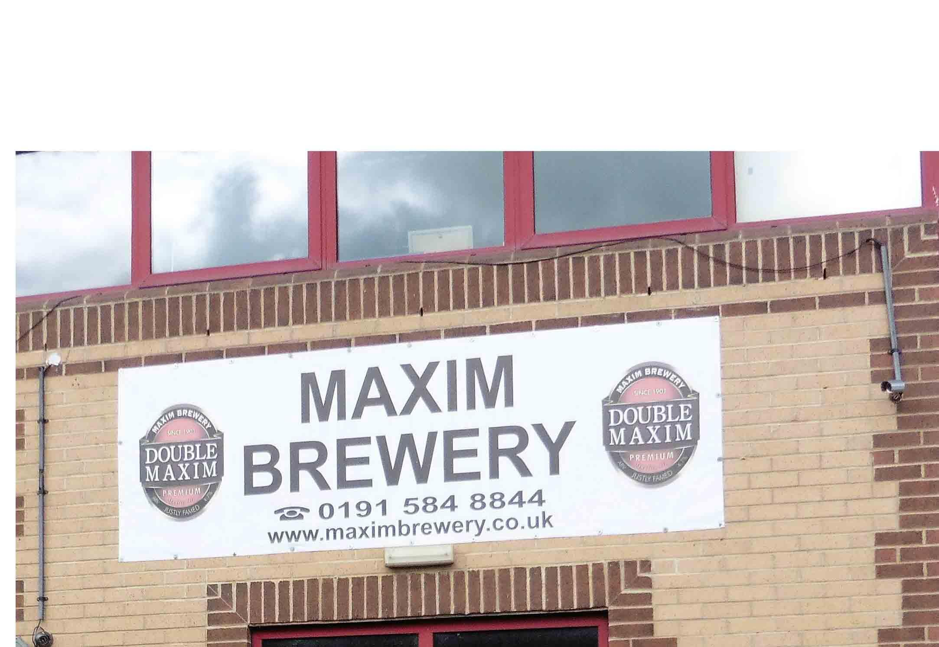

Powder Monkey Group has announced the acquisition of the Maxim brewery in Sunderland reinforcing its capability and capacity in the North East following the acquisition of Castle Eden earlier last year. This acquisition takes the Powder Monkey Group to five brands across the UK, with a physical presence in the South, Midlands and North East. The group also owns four breweries in Australia and is pouring in Hong Kong and Gibraltar. Maxim MD Mark Anderson said: “Maxim brewery was formed following the closure of Vaux in 1999. We are proud to have been brewing and serving our North East customers' favourite beers Double Maxim, Samson, Lambtons, Swedish Blonde and other seasonals from our Houghton Le Spring brewery since 2006. “We are delighted to be joining the Powder Monkey Group and this will ensure that our well-loved brands continue to be brewed in the North East for many years to come and would like to thank all our suppliers and customers for their support over the last 25 years.” Powder Monkey CEO Mark Burdon said: “It has a fiercely loyal customer base, and we will continue in this tradition. Hailing from the North East, I am all too familiar with the strength of Maxim’s brands.” In 2025 alone Powder Monkey acquired six breweries.

